CHAPTER 3 ENGINE
3.1 MAINTENANCE SPECIFICATIONS
3.1.1 SPECIFICATIONS
3.1.2 TIGHTENING TORQUES
3.2 PARTS INSPECTION AND SERVICE
3.2.1 ENGINE OIL LEVEL INSPECTION
3.2.2 ENGINE OIL CHANGE
3.2.3 ENGINE MOUNT INSPECTION
3.2.4 SPARK PLUG INSPECTION
3.2.5 VALVE CLEARANCE ADJUSTMENT
3.2.6 COMPRESSION PRESSURE
3.2.7 SPARK ARRESTOR SERVICE
3.2.8 TRANSMISSION OIL LEVEL CHECK
3.2.9 TRANSMISSION OIL CHANGE
3.3 ENGINE REMOVAL AND INSTALLATION
3.3.1 ENGINE REMOVAL
3.3.2 ENGINE INSTALLATION
3.4 CYLINDER HEAD
3.4.1 CYLINDER HEAD COVER REMOVAL
3.4.2 CYLINDER HEAD REMOVAL
3.4.3 CYLINDER HEAD INSPECTION
3.4.4 CYLINDER HEAD INSTALLATION
3.5 CAMSHAFT AND ROCKER ARMS
3.5.1 CAMSHAFT AND ROCKER ARMS
3.5.2 CAMSHAFT INSPECTION
3.5.3 ROCKER ARMS AND ROCKER ARM SHAFTS INSPECTION
3.5.4 CAMSHAFT AND ROCKER ARM INSTALLATION
3.6 VALVES AND VALVE SPRINGS
3.6.1 VALVES AND VALVE SPRINGS REMOVAL
3.6.2 VALVE AND VALVE SPRINGS INSPECTION
3.6.3 VALVE SEATS INSPECTION
3.6.4 VALVES AND VALVE SPRINGS INSTALLATION
3.7 CYLINDER AND PISTON
3.7.1 PISTON AND PISTON RINGS REMOVAL
3.7.2 CYLINDER INSPECTION
3.7.3 PISTON AND PISTON PIN INSPECTION
3.7.4 PISTON RINGS INSPECTION
3.7.5 PISTON RINGS, PISTON AND CYLINDER INSTALLATION
3.8 V-BELT, CLUTCH AND SECONDARY/PRIMARY SHEAVE
3.8.1 PRIMARY SHEAVE REMOVAL
3.8.2 SECONDARY SHEAVE AND V-BELT REMOVAL
3.8.3 SECONDARY SHEAVE DISASSEMBLY
3.8.4 CLUTCH INSPECTION
3.8.5 V-BELT INSPECTION
3.8.6 WEIGHT INSPECTION
3.8.7 SECOMDARY SHEAVE INSPECTION
3.8.8 PRIMARY SHEAVE ASSEMEBLY
3.8.9 SECOMDARY SHEAVE INSTALLATION
3.9 A.C. MAGNETO AND STARTER CLUTCH
3.9.1 A.C. MAGNETO REMOVAL
3.9.2 CRANKCASE COVER REMOVAL
3.9.3 STARTER DRIVE ONE-WAY CLUTCH REMOVAL AND INSPECTION
3.9.4 STARTER DRIVE ONE-WAY CLUTCH INSTALLATION
3.9.5 CRANKCASE COVER INSTALLATION
3.9.6 A.C. MAGNETO INSTALLATION
3.10 OIL PUMP
3.10.1 OIL PUMP REMOVAL AND INSPECTION
3.10.2 OIL PUMP INSTALLATION
3.11 CRANKCASE AND CRANKSHAFT
3.11.1 CRANKSHAFT&BALANCER REMOVAL
3.11.2 CRANKSHAFT INSPECTION
3.11.3 CRANKCASE INSTALLATION
3.12 TRANSMISSION
3.12.1 TRANSMISSION DISASSEMBLY AND INSPECTION
3.12.2 TRANSMISSION INSTALLATION
3.13 OIL COOLER
3.13.1 OIL COOLER REMOVAL
3.13.2 OIL COOLER INSTALLATION
3.14 EXHAUST
3.14.1 EXHAUST REMOVAL
3.14.2 EXHAUST INSTALLATION
3.15 AIR BOX / INTAKE SYSTEM
3.15.1 AIR BOX REMOVAL
3.15.2 AIR BOX INSTALLATION
3.16 FUEL INJECTION SYSTEM
3.16.1 ECU
3.16.1.1 Description & Working Principle
3.16.1.2 Appearance
3.16.1.3 Handling –Don’ts & Do’s
3.16.1.4 Installation requirements
3.16.1.5 Power Requirements
3.16.1.6 Operating Temperature
3.16.1.7 Maintenance service and Repair
3.16.2 INJECTOR
3.16.2.1 Appearance
3.16.2.2 Temperature Requirements :
3.16.2.3 Fuel Contamination
3.16.2.4 Injector Installation
3.16.2.5 Replacement Techniques
3.16.2.6 Interchange ability
3.16.3 THROTTLE BODY ASSEMBLY
3.16.3.1 Description and Working Principle
3.16.3.2 Throttle Body Removal
3.16.3.3 Cleaning Procedure
3.16.3.4 Throttle Body Installation
3.16.4 ENGINE TEMPERATURE SENSOR
3.16.4.1 Description and Working Principle
3.16.4.2 Installation Requirements
3.16.5 OXYGEN SENSOR
3.16.5.1 Description and Working Principle
3.16.5.2 Technical Parameters
3.16.5.3 Fuel Quality Requirements
3.16.6 IGNITION COIL
3.16.6.1 Description and Working Principle
3.16.6.2 Installation requirements
3.16.6.3 Do’s and Don’ts
3.16.7 FUEL PUMP
3.16.7.1 Description and Working Principle
3.16.7.2 Operating Conditions
3.16.7.3 Service Procedure
3.16.7.4 Fuel Pump Removal
3.16.7.5 Fuel Pump Installation
3.16.7.6 Fuel Pressure Relief Procedure
3.16.7.7 Fuel Leakage Check Procedure:
3.16.8 MOTOR SCANNER (For Motion SE08)
3.16.8.1 Precautions
3.16.8.2 Preparations Connection
3.16.8.3 Functions
3.16.8.4 SE08 ECU Malf Code

3.1 MAINTENANCE SPECIFICATIONS

3.1.1 SPECIFICATIONS
Item |  |  |  | Standard |  | Limit
Cylinder head | Surface warpage limit |  |  | ….. |  | 0.05mm
Cylinder | Surface warpage limit (mating with cylinder head) |  |  | ….. |  | 0.05mm
Cylinder | Bore size |  |  | 62.515-62.520 mm |  | 62.56mm
Cylinder | Out of round limit |  |  | ….. |  | 0.05mm
Camshaft | Cam dimensions
Camshaft | Intake "A" | 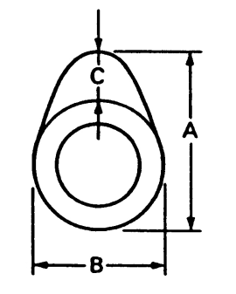 |  | 29.52-29.58mmmm |  | 29.47mm
Camshaft | "B" |  |  | 25.00-25.03mm |  | 24.95mm
Camshaft | "C" |  |  | 4.52-4.58mm |  | 4.47mm
Camshaft | Exhaust "A" |  |  | 29.32-29.38mm |  | 29.27mm
Camshaft | "B" |  |  | 25.00-25.03mm |  | 24.95mm
Camshaft | "C" |  |  | 4.32-4.38mm |  | 4.37mm
Camshaft | Camshaft runout limit |  |  | ….. |  | 0.05mm
Cam chain | Type/No. of links |  |  | CL05-5-94L |  | …
Rocker arm ,  Rocker-  armshaft | Rocker arm inside diameter |  |  | 10.000-10.015mm |  | 10.1mm
Rocker arm ,  Rocker-  armshaft | Rocker shaft outside diameter |  |  | 9.972-9.987mm |  | 9.92mm
Rocker arm ,  Rocker-  armshaft | Rocker arm - to- rocker arm shaft clearance |  |  | 0.013-0.043mm |  | …
Valve,  Valve seat,  Valve guide | Valve clearance  (cold) |  | IN | 0.04-0.06mm |  | …
Valve,  Valve seat,  Valve guide |  |  | EX | 0.05-0.07mm |  | …
Valve,  Valve seat,  Valve guide | Valve dimensions
Valve,  Valve seat,  Valve guide | 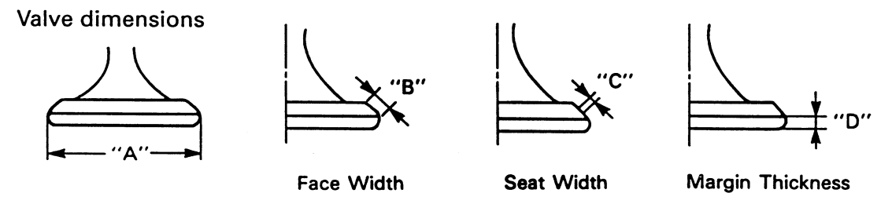
Valve,  Valve seat,  Valve guide | "A" head diameter |  | IN | 26.9-27.1mm | …
Valve,  Valve seat,  Valve guide |  |  | EX | 22.9-23.1mm | …
Valve,  Valve seat,  Valve guide | "B" face width |  | IN | 1.0-1.7mm | …
Valve,  Valve seat,  Valve guide |  |  | EX | 1.0-1.7mm | …
Valve,  Valve seat,  Valve guide | "C " seat width |  | IN | 0.6-0.8mm | …
Valve,  Valve seat,  Valve guide |  |  | EX | 0.6-0.8mm | …
Valve,  Valve seat,  Valve guide | "D" margin thickness |  | IN | 0.55-0.85mm | …
Valve,  Valve seat,  Valve guide |  |  | EX | 0.85-1.15mm | …

Item |  |  |  |  |  |  | Standard | Limit
Valve,  Valve seat,  Valve guide | Stem outside diameter |  |  |  |  | IN | 4.970-4.980mm | 4.9mm
Valve,  Valve seat,  Valve guide |  |  |  |  |  | EX | 4.955-4.970mm | 4.9mm
Valve,  Valve seat,  Valve guide | Guide inside diameter |  |  |  |  | IN | 5.000-5.012mm | 5.03mm
Valve,  Valve seat,  Valve guide |  |  |  |  |  | EX | 5.000-5.012mm | 5.03mm
Valve,  Valve seat,  Valve guide | Stem-to-guide clearance |  |  |  |  | IN | 0.02-0.032mm | 0.08mm
Valve,  Valve seat,  Valve guide |  |  |  |  |  | EX | 0.03-0.057mm | 0.10mm
Valve,  Valve seat,  Valve guide | Stem runout limit |  |  |  |  |  | ….. | 0.10mm
Valve,  Valve seat,  Valve guide | Valve seat width |  |  |  |  | IN | 0.6-0.8mm | 1.5mm
Valve,  Valve seat,  Valve guide |  |  |  |  |  | EX | 0.6-0.8mm | 1.5mm
Valve spring | Free length |  |  |  |  | IN/EX | 37mm | 36.5mm
Valve spring | Set length (valve closed) |  |  |  |  | IN/EX | 34.8mm | …
Valve spring | Com pressed pressure |  |  |  |  | IN/EX | 215-237N/97-107N
Valve spring | Tilt limit |  |  |  |  | IN/EX | ….. | 2.5°
Piston | Piston to cylinder clearance |  |  |  |  |  | 0.024-0.036mm | 0.1mm
Piston | Piston size "D" |  |  | 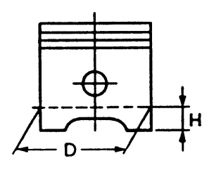 |  |  | 62.475-62.485mm | …
Piston | Measuring point "H" |  |  |  |  |  | 10mm | …
Piston | Piston pin bore inside diameter |  |  |  |  |  | 15.002-15.008mm | 15.04mm
Piston | Piston pin outside diameter |  |  |  |  |  | 14.994-15.000mm | 14.96mm
Piston rings | Top ring |  | End gap (installed) |  |  |  | 0.10-0.25mm | 0.45mm
Piston rings |  |  | Side clearance (installed) |  |  |  | 0.02-0.06mm | 0.11mm
Piston rings | 2nd ring |  | End gap (installed) |  |  |  | 0.20-0.40mm | 0.6mm
Piston rings |  |  | Side clearance (installed) |  |  |  | 0.02-0.06mm | 0.12mm
Piston rings | Oil ring |  | End gap (installed) |  |  |  | 0.20-0.70mm | …
Crankshaft | Crank width "A" |  |  |  | 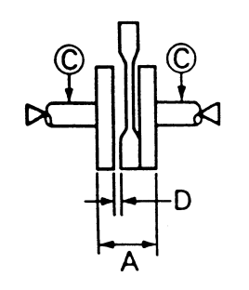 |  | 45.05-45.15mm | …
Crankshaft | Runout limit "C " |  |  |  |  |  | 0.04mm | …
Crankshaft | Big end side clearance "D" |  |  |  |  |  | 0.10-0.35mm | …
Item |  |  |  |  |  |  | Standard | Limit
Automatic centrifugal clutch |  | Clutch shoe thickness |  |  |  |  | 3.5mm | 2.0mm
 |  | Clutch hosing inside diameter |  |  |  |  | 113.5-113.8mm | 113.8mm
 |  | Clutch shoe spring free length |  |  |  |  | 156mm | 39mm
 |  | Weight outside diameter |  |  |  |  | 20mm | 19mm
 |  | Clutch- in revolution |  |  |  |  | 2600-2800r/min | …
V-belt |  | Width |  |  |  |  | 20mm | 19mm
Oil pump |  | Tip clearance |  |  |  |  | 0.15mm | 0.23mm
 |  | Side clearance |  |  |  |  | 0.15-0.22mm | 0.26mm
 |  | Housing and rotor clearance |  |  |  |  | 0.05-0.12mm | 0.14mm

3.1.2 TIGHTENING TORQUES
Part to be tightened | Part name | Thread size | Q’ty | Tightening  Torque  N.m m.kg |  | Remarks
Cylinder head cover | Bolt | M6 | 4 | 10 | 1.0
Cylinder head & cylinder | Nut | M8 | 4 | 25 | 2.5
Cylinder head & cylinder | Bolt | M6 | 2 | 10 | 1.0
Spark plug | ... | M10 | 1 | 12 | 1.2
Camshaft platen | Bolt | M6 | 1 | 10 | 1.0
Timing sprocket | Bolt | M6 | 2 | 15 | 1.5
Valve adjuster locknut | Nut | M5 | 2 | 10 | 1.0
Tensioner | Bolt | M6 | 2 | 10 | 1.0
Tensioner cap | Screw | M5 | 1 | 5 | 0.5
Balance shaft | Nut | M14 | 1 | 65 | 6.5
Crankcase bolts | Bolt | M6 | 2 | 10 | 1.0
Engine oil drain plug | Bolt | M12 | 1 | 25 | 2.5
Oil cooling pipe | Bolt | M12 | 4 | 39 | 3.9
Cover, Oil Filter Screen | ... | M30 | 1 | 14 | 1.4
Gear box cover | Bolt | M6 | 10 | 10 | 1.0
Crankcase cover(left) | Bolt | M6 | 8 | 10 | 1.0
Crankcase cover(right) | Bolt | M6 | 9 | 10 | 1.0
Crankshaft position sensor | Bolt | M6 | 2 | 10 | 1.0
Flywheel nut | Nut | M12 | 1 | 60 | 6.0
Fan bolt | Bolt | M6 | 4 | 10 | 1.0
Stator fasteners | Bolt | M6 | 3 | 10 | 1.0
Crankshaft slotted nut | Nut | M22 | 1 | 95 | 9.5
Start motor | Bolt | M6 | 2 | 10 | 1.0
Driving pulley assy | Nut | M12 | 1 | 60 | 6.0
Driven pulley assy | Nut | M12 | 1 | 60 | 6.0
Drain plug(transmission) | Bolt | M12 | 1 | 25 | 2.5
Oil pump | Bolt | M6 | 2 | 10 | 1.0
Oil pump sprocket | Nut | M6 | 1 | 10 | 1.0
Oil pump cover | Bolt | M6 | 2 | 10 | 1.0
Oil cooler | Bolt | M6 | 2 | 10 | 1.0
Part to be tightened | Part name | Thread size | Q’ty | Tightening  Torque  N.m m.kg |  | Remarks
Temperature sensor | ... | M10 | 1 | 12 | 1.2
Oxygen sensor | ... | M12 | 1 | 18 | 1.8
Spark arrestor fasteners | Bolt | M6 | 3 | 10 | 1.0
Exhaust pipe | Nut | M8 | 2 | 13 | 1.3
Exhaust mounting fastener | Bolt | M10 | 1 | 45 | 4.5
Locating Bolt | Bolt | M14 | 1 | 25 | 2.5

3.2 PARTS INSPECTION AND SERVICE

3.2.1 ENGINE OIL LEVEL INSPECTION
1. Position vehicle on a level surface and apply the parking brake. |  |  |  |  |  |  |  |  | 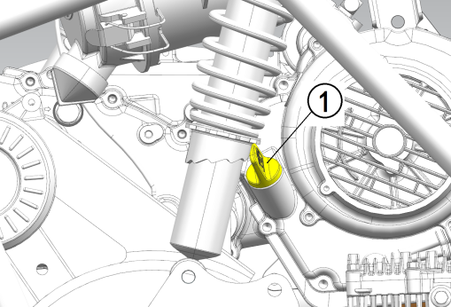
2. Start the engine and allow the engine to run for 30 seconds to properly circulate the oil.
3. Shut the vehicle off and allow engine to cool down.
4. Remove the dipstick and wipe it dry with a clean cloth.
5. Check the oil level (Do not thread dipstick in). |  |  |  |  |  |  |  |  | 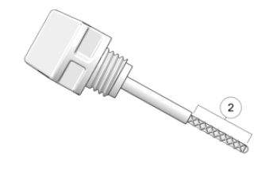
Engine oil level
Oil level should be between maximum and minimum marks.
Oil level is below the minimum mark Add oil up to the proper lever.
RECOMMENDED ENGINE OIL
Refer to the chart for selection of the oils suited to the atmospheric temperature.
 |  |  |  |  |  |  |  |  | 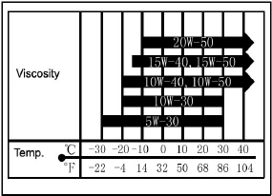
 |  |  |  |  |  | API STANDARD:
 |  |  |  |  |  | API SE or higher grade
CAUTION:
Do not put in any chemical additives or use oils with a grade of CD or higher.
Be sure not to use oils labeled
"ENERGY CONSERVING I" or higher. Engine oil also lubricates the clutch and additives could cause clutch slippage.
Be sure no foreign material enters the crankcase.
6. Add the recommended oil as necessary to bring the oil level within the SAFE range on the dipstick. Do NOT overfill.
CAUTION:
Over-filling engine crankcase will result in oil entering the air box. Maintain the recommended oil level.
7. When finished, reinstall the dipstick.
8. Start the engine and allow the engine to run for 30 seconds to properly circulate the oil.
9. Turn off the engine.
NOTE:
Wait a few minutes until the oil settles before inspecting the oil level.

3.2.2 ENGINE OIL CHANGE
Always change engine oil and filter at the intervals outlined in the Periodic Maintenance Chart. Always change the oil filter whenever changing engine oil.
The crankcase drain plug is located on the bottom of the crankcase. Access the drain plug from the bottom of the vehicle.
1.Position vehicle on a level surface and apply the parking brake.
2.Start the engine and allow the engine to run for 30 seconds to properly circulate the oil.
3.Shut the vehicle off and allow engine to cool down. |  |  |  |  |  |  |  |  | 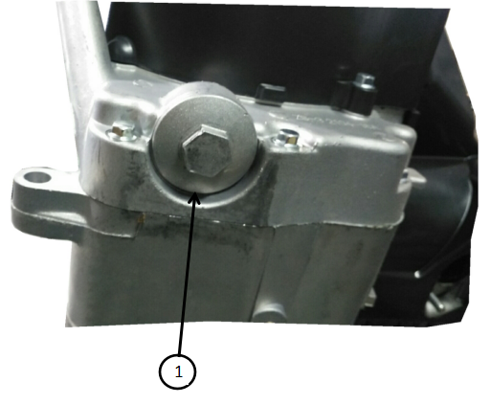
4.Place a drain pan beneath the engine crankcase.
5.Remove the drain plug and pre-filter screen and allow the oil to drain completely.
NOTE:
Wipe up any residual oil that may have collected on the chain guard or other vehicle components after oil has drained completely.
6.Wash the oil pre-filter screen with solvent to remove any debris. Allow the screen to air dry.
7.The external oil filter is located on right-hand side of rear the swingarm. The screw on oil filter should be replaced when oil is changed. With the oil drained from the crankcase, unscrew the oil filter and replace with a new one. Ensure that the oil filter gasket is properly seated, lubricated with oil and in good condition. Do not over tighten the oil filter.
8.Inspect the sealing washer on the drain plug. Replace the washer if it is damaged.
NOTE:
The sealing surfaces on the drain plug and crankcase should be clean and free of burrs, nicks or scratches.
9. Reassemble the pre-filter screen and spring to the drain plug.
10.Reinstall the drain plug, and torque to specification.
TORQUE
Engine Oil Drain Plug:
14 N.m
11.Fill the engine to the recommended specification.
 |  |  |  |  | Engine Oil quantity:
 |  |  |  |  | 0.8 L
12.Start engine and allow it to idle for 30 seconds. |  |  |  |  |  |  |  |  | 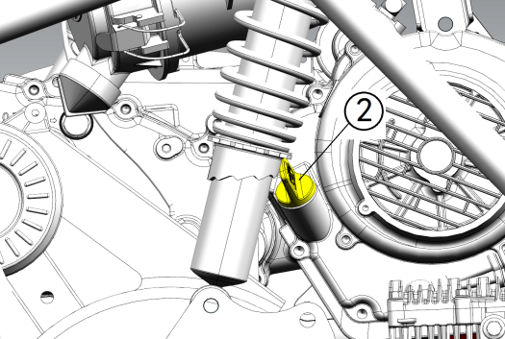
13.Stop the engine and inspect for oil leaks. Wait at least 15 seconds before removing the oil dipstick.
14.Remove the dipstick and wipe it dry with a clean cloth.
15.Check the engine oil level.
Refer to "3.2.1 ENGINE OIL LEVEL INSPECTION" section.
16. Dispose of used oil properly.
 |  |  |  |  |  |  |  |  | 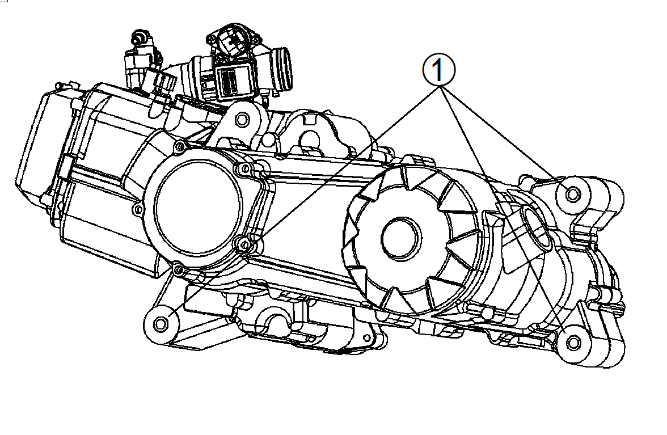

3.2.3 ENGINE MOUNT INSPECTION
Periodically inspect engine upper mounts for cracks or damage.

3.2.4 SPARK PLUG INSPECTION
1.Remove :
Spark plug cap
Spark plug
CAUTION:
Before removing the spark plug, use compressed air to blow away any dirt accumulated in the spark plug wells to prevent it from falling into the cylinder.
2. Check:
Spark plug type
Incorrect → Replace.
 |  |  | Standard spark plug:
 |  |  | CR7HSA (NGK)
3.Inspect: |  |  |  |  |  |  |  |  | 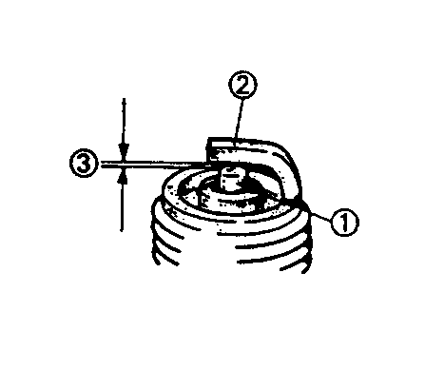
Electrode
Wear/ damage → Replace.
Insulator
Abnormal color → Replace.
Normal color is a medium - to- light tan color.
4.Clean:
Spark plug
(with spark plug cleaner or w ire brush)
5.Measure:
Spark plug gap ③
(with a wire gauge)
Out of specification → Adjust gap. |  |  |  |  |  |  |  |  | 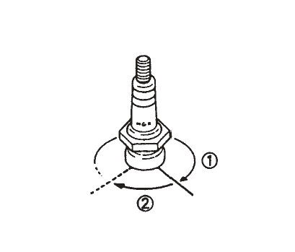
 |  | Spark plug gap :
 |  | 0.6-0.8 mm
6. Install:
Spark plug
TORQUE
Spark plug:
12N.m
NOTE:
Before installing a spark plug, clean the Gasket surface and plug surface.

3.2.5 VALVE CLEARANCE ADJUSTMENT
NOTE:
Valve clearance adjustment should be made with the engine cool, at room temperature.
When the valve clearance is to be measured or adjusted, the piston must be at Top Dead Center (T.D.C.) on the compression.
1. Remove:
Valve cover
2. Remove:
Spark plug
3. Remove:
Cooling fan cover
4. Verify cam lobes are pointed down.
5.Measure:
Valve clearance
Out of specification → Adjust.
Valve clearance (cold):
Intake valve 0.04-0.06mm
Exhaust valve 0.05-0.07mm
6. Adjust:
Valve clearance
Adjustment steps:
Insert the correct thickness feeler gauge between end of exhaust valve stem and adjuster screw.
Loosen locknut and turn adjuster screw until there is slight drag on feeler gauge.
When clearance is correct, hold adjuster screw and tighten locknut securely.
Re-check the valve clearance
Repeat adjustment procedure if necessary until clearance is correct with locknut secured.
7. Install:
Cooling fan cover
Valve cover
Spark plug
TORQUE
Spark plug:
12N.m

3.2.6 COMPRESSION PRESSURE
MEASUREMENT
NOTE :
Insufficient compression pressure will result in performance loss.
1. Check:
Valve clearance
Out of specification → Adjust.
Refer to “3.2.5VALVE CLEARANCE ADJUSTMENT” section.
2.Start the engine and let it warm up for several minutes.
3.Turn off the engine.
4. Remove:
Spark plug
NOTE :
Before removing the spark plug, use com pressed air to blow away any dirt accumulated in the spark plug well to prevent it from falling into the cylinder.
5. Attach:
Compression gauge
6. Measure: |  |  |  |  |  |  |  |  | 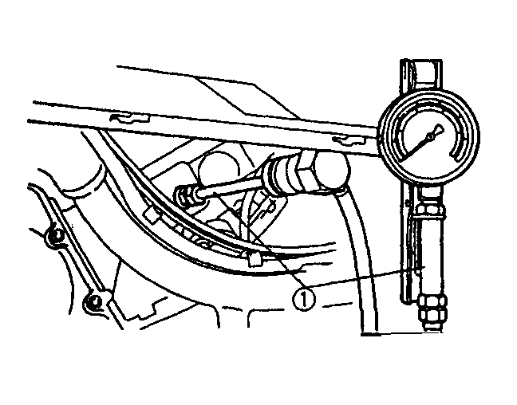
Compression pressure
If it exceeds the maximum pressure allowed→ Inspect the cylinder head, valve surfaces and piston crown for carbon deposits.
If it is below the minimum pressure →
Squirt a few drops of oil into the affected cylinder and measure again. Follow the table below.
Compression pressure
(With oil applied into cylinder)
Reading |  |  |  |  |  |  | Diagnosis
Higher than  without oil |  |  |  |  |  |  | Worn or damaged pistons
Same as without oil |  |  |  |  |  |  | Possible defective ring (s),  valves,  cylinder head gasket or  Piston →Repair.
 | Compression pressure(at sea level):
 | Standard:
1,100 kPa (11Kg/cm², 11 bar)
Minimum :
900kPa (9 kg /cm ², 9 bar)
Measurement steps :
Crank the engine with the throttle wide open until reading on the compression gauge stabilizes.
WARNING :
Before cranking the engine, ground all spark plug leads to prevent sparking.
8. Install:
Spark plug
TORQUE
Spark plug:
12N.m

3.2.7 SPARK ARRESTOR SERVICE
WARNING :
Do not clean spark arrestor immediately after the engine has been run, as the exhaust system becomes very hot. Serious burns could result from contact with the exhaust components. Allow components to cool sufficiently before proceeding.
Wear eye protection and gloves.
Never run the engine in an enclosed area. Exhaust contains poisonous carbon monoxide gas that can cause loss of consciousness or death in a very short time.
NOTE :
To remove accumulated carbon, clean the spark arrestor at the interval recommended in the Periodic Maintenance Chart. |  |  |  |  |  |  |  |  | 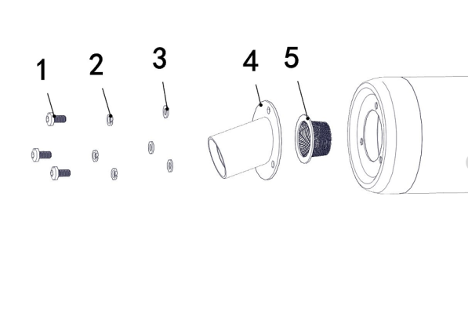
1. Remove:
Bolt
Spark arrestor
2. Use a non-synthetic brush to clean the arrestor screen . A synthetic brush may melt if components are warm.
3. Inspect:
Wear and damage → Replace.
4. Install:
Spark arrestor
Bolt
TORQUE
Spark Arrestor Fasteners:
10N.m

3.2.8 TRANSMISSION OIL LEVEL CHECK
NOTE :
To check and ensure proper transmission lubricant level, the transmission needs to be drained and filled to the proper specification.
The fill plug is located on the side of the transmission gearcase. Access the fill plug on the right-hand side of the gearcase. |  |  |  |  |  |  |  |  | 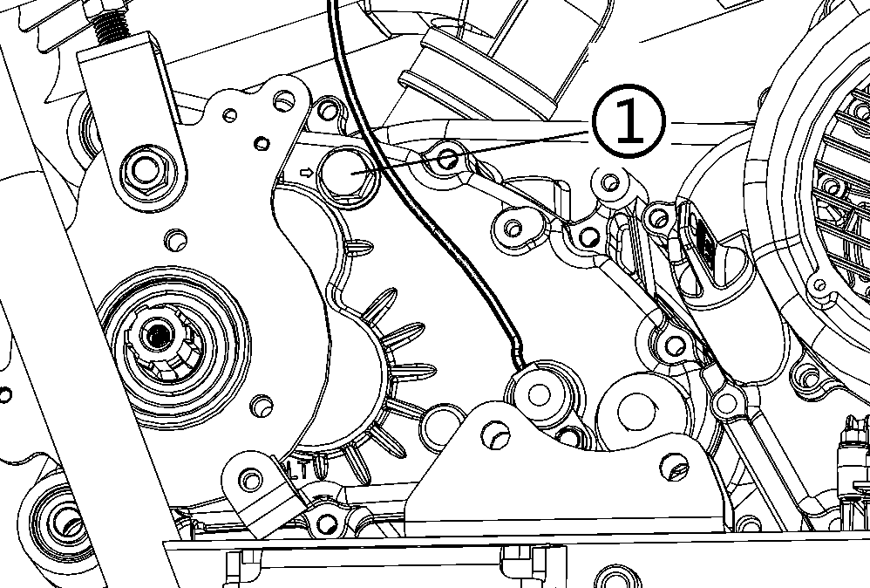

3.2.9 TRANSMISSION OIL CHANGE
The drain plug is located on the bottom of the transmission gearcase. Access the drain plug from the bottom of the vehicle.
1.Remove: |  |  |  |  |  |  |  |  | 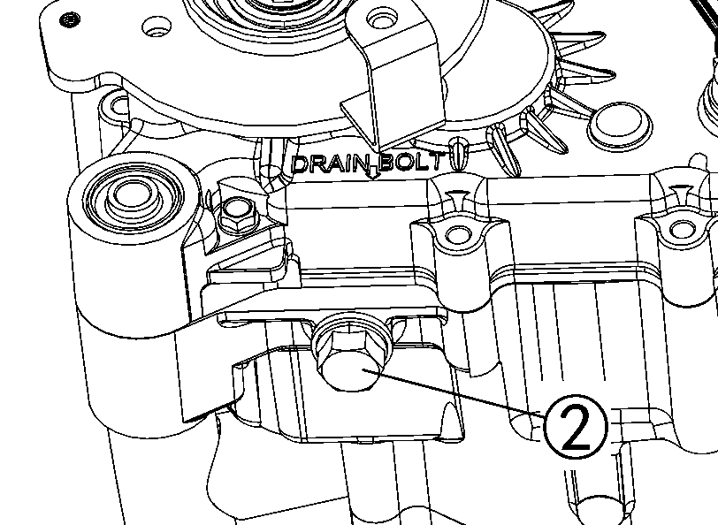
Fill plug
2.Place a drain pan under the transmission drain plug.
3.Remove:
Drain plug
4. Allow lubricant to drain completely.
5.Clean the drain plug magnetic surface.
6. Install:
Drain plug
TORQUE
Transmission Fill / Drain Plug:
25N.m
7. Add the recommended amount of lubricant through the fill plug hole. Do NOT overfill or fill to the bottom of the fill plug hole.
 |  |  |  | Transmission Oil quantity:
 |  |  |  | 0.3 L
8. Install:
Fill plug
TORQUE
Transmission Fill / Drain Plug:
25N.m
9.Check for leaks. Dispose of used lubricant properly.

3.3 ENGINE REMOVAL AND INSTALLATION

3.3.1 ENGINE REMOVAL
1.Remove side panels and pedals. |  |  |  |  |  |  |  |  | 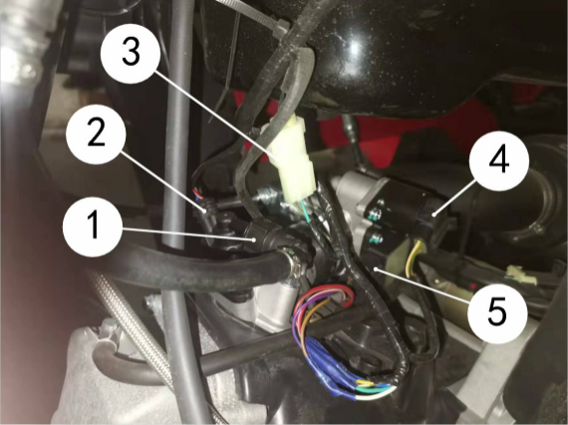
2.Remove axle.
3.Remove air box and muffler from the engine.
4.Remove the fuel supply line.
5.Disconnect the following electrical components:
Injector
Engine Temperature Sensor
Stepper motor (throttle body)
Sensor (throttle body)
6.Loosen nut and remove accelerator cable. |  |  |  |  |  |  |  |  | 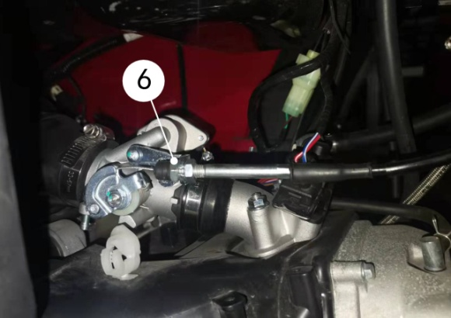
7.Disconnect the following electrical components: |  |  |  |  |  |  |  |  | 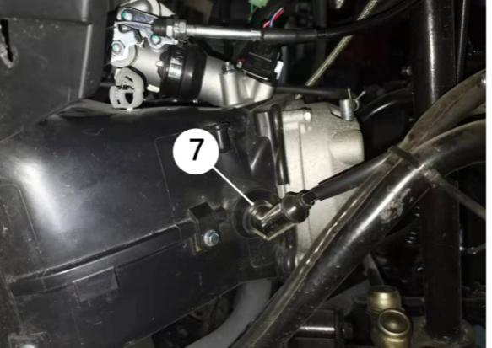
Spark Plug Lead
Gear Indicator Switch |  |  |  |  |  |  |  |  | 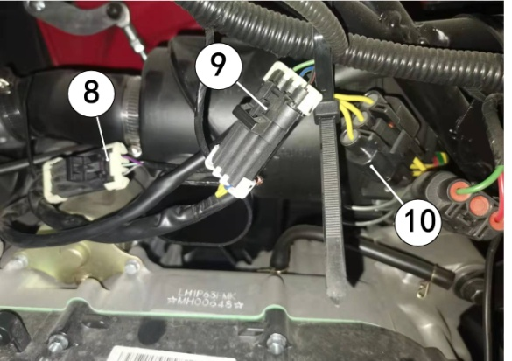
CPS
Charging coil
Engine Ground |  |  |  |  |  |  |  |  | 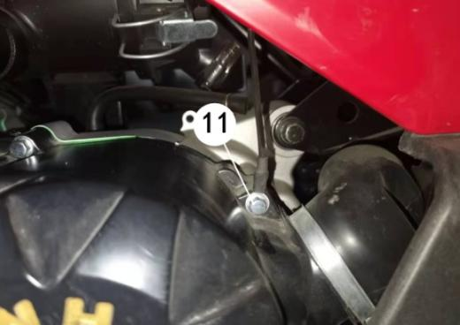
Oxygen Sensor |  |  |  |  |  |  |  |  | 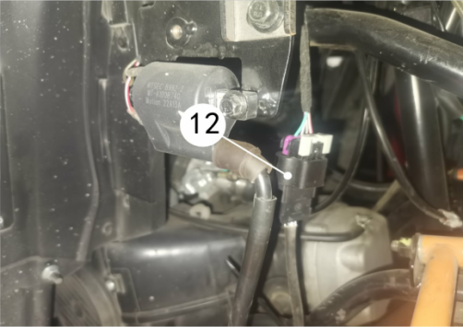
8.Remove starter cable. |  |  |  |  |  |  |  |  | 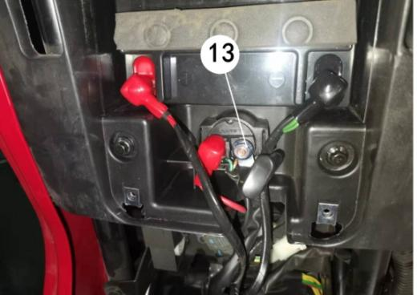
9.Remove the Shifting rocker arm from the transmission. |  |  |  |  |  |  |  |  | 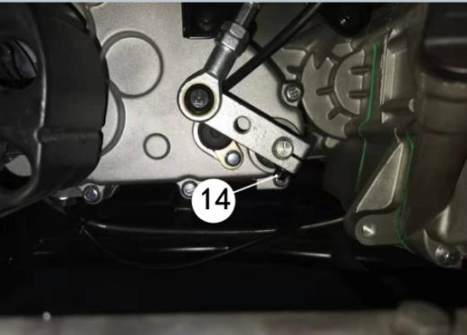
10.Remove engine mounting bolt . |  |  |  |  |  |  |  |  | 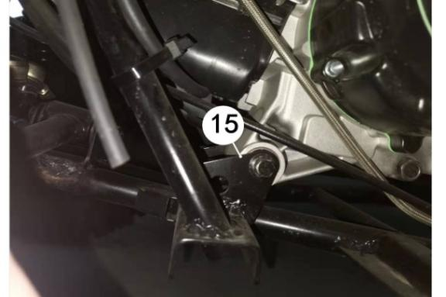
 |  |  |  |  |  |  |  |  | 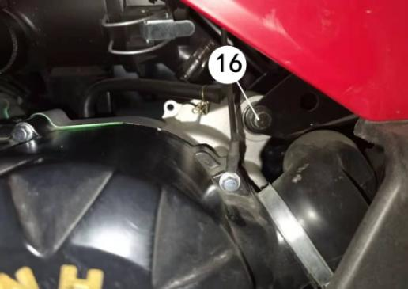
 |  |  |  |  |  |  |  |  | 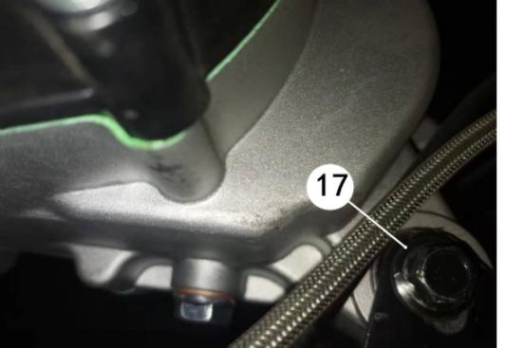
11.Remove small sprocket and protective cover.
12.Remove engine out vehicle.
3.3.2 ENGINE INSTALLATION |  |  |  |  |  |  |  |  | 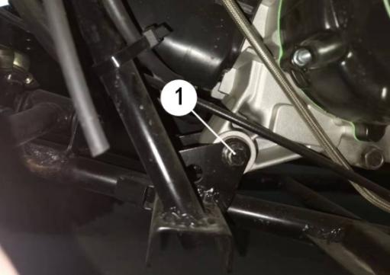
1.Install the engine into the frame.
2.Install the engine mounting bolt .
Torque to specification
TORQUE
Engine Mounting Bolt:
50N.m
 |  |  |  |  |  |  |  |  | 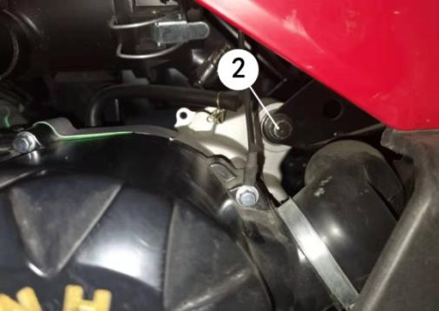
 |  |  |  |  |  |  |  |  | 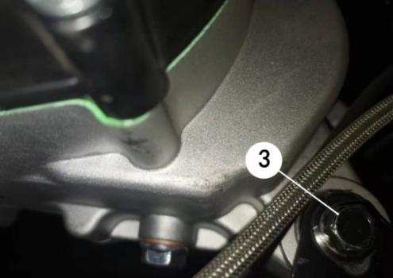
3.Install the Shifting rocker arm to the transmission. |  |  |  |  |  |  |  |  | 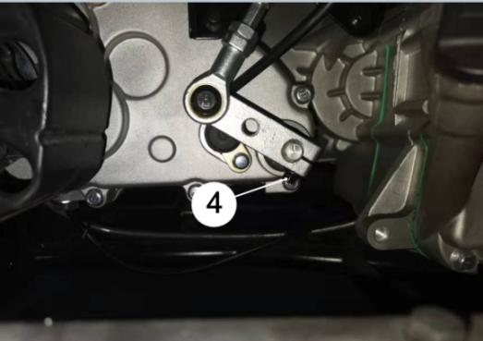
TORQUE
Shifting rocker arm Bolt:
10N.m
4.Install starter cable. |  |  |  |  |  |  |  |  | 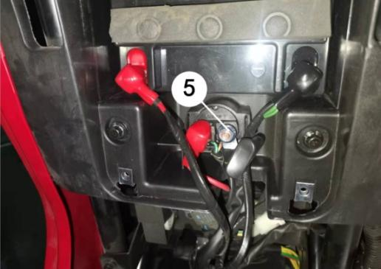
TORQUE
Starter cable nut:
10N.m
5. Connect the following electrical components: |  |  |  |  |  |  |  |  | 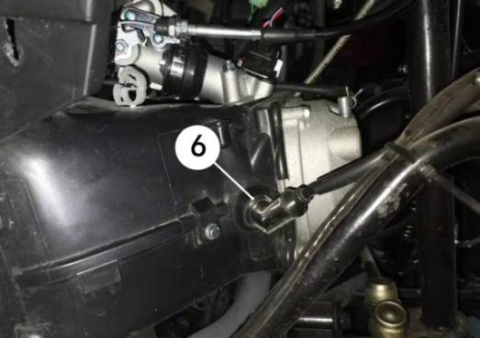
Spark Plug Lead
Gear Indicator Switch |  |  |  |  |  |  |  |  | 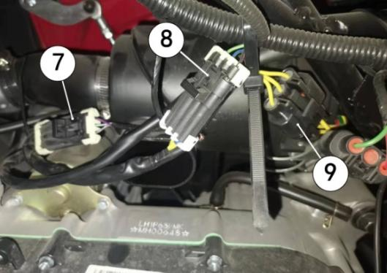
CPS
Charging coil
Engine Ground |  |  |  |  |  |  |  |  | 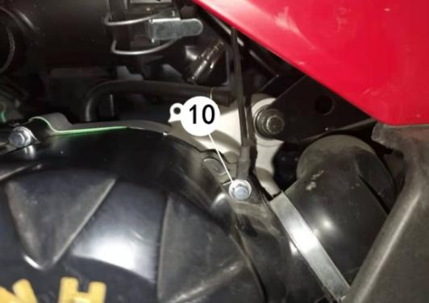
Oxygen Sensor |  |  |  |  |  |  |  |  | 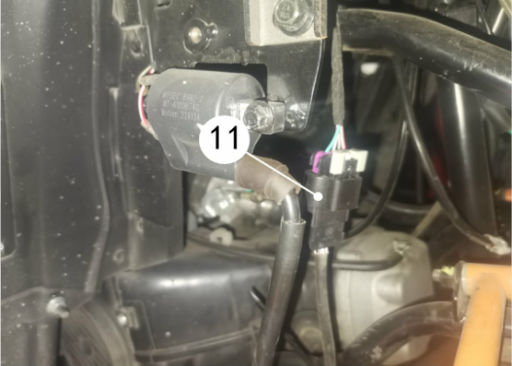
6.Install accelerator cable into the carburetor, adjust accelerator cable and tighten nut . |  |  |  |  |  |  |  |  | 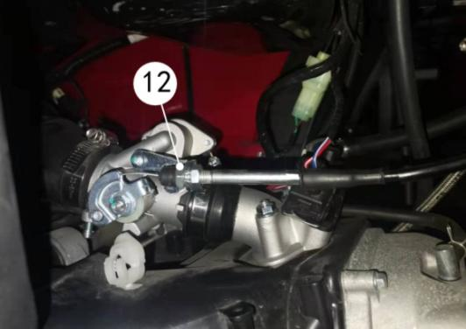
7. Connect the following electrical components: |  |  |  |  |  |  |  |  | 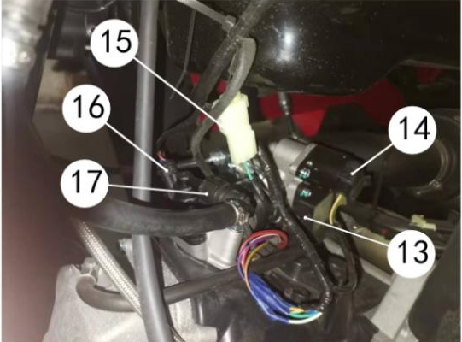
Sensor (throttle body)
Stepper motor (throttle body)
Engine Temperature Sensor
Injector
8.Connect the fuel supply line to the fuel rail.
9.Install air box and muffler into the engine
10.Install axle.
11.Properly adjust the chain.
12.Install side panels and pedals.

3.4 CYLINDER HEAD
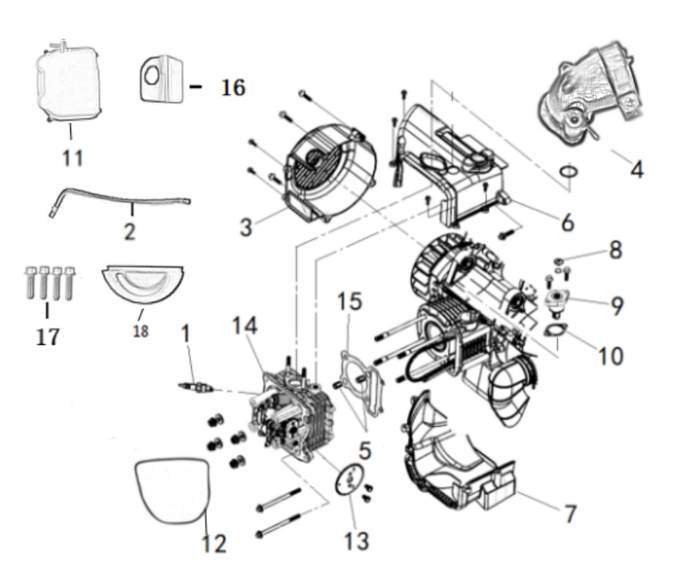
Order |  | Job/Parts to remove | Q’ty | Remarks
 |  | Exhaust pipe |  | Disconnect.
 |  | Engine oil |  | Disconnect.
1 |  | Spark plug | 1
2 |  | Cylinder head breather hose | 1
3 |  | Cooling fan cover | 1
4 |  | Intake pipe | 1
5 |  | Dowel pin | 2
6 |  | Shroud comp b | 1
7 |  | Shroud comp a | 1
8 |  | Timing chain tensioner cap bolt | 1
9 |  | Timing chain tensioner | 1
10 |  | Gasket | 1
11 |  | Cylinder head cover | 1
12 |  | Valve cover seal | 1
13 |  | Timing sprocket | 1
14 |  | Cylinder head | 1
15 |  | Cylinder head gasket | 1
16 |  | Intake Valve rocker shaft baffle | 1
17 |  | Cover Bolt | 4
18 |  | Block of cylinder head | 1

3.4.1 CYLINDER HEAD COVER REMOVAL
1. Loosen: |  |  |  |  | 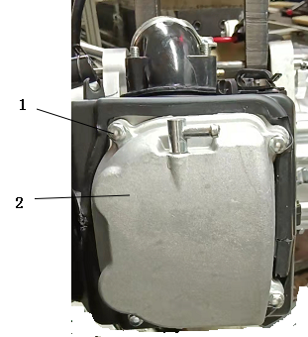
Bolts ①
2. Remove:
Cylinder head cover ②

3.4.2 CYLINDER HEAD REMOVAL
1. Loosen: |  |  |  |  | 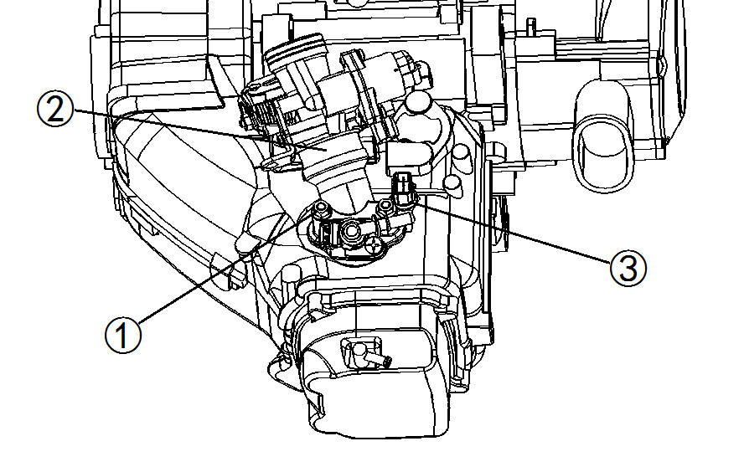
Nuts ①
2. Remove:
Throttle body adapter ②
3. Remove:
Engine temperature sensor ③
4. Remove:
Cooling fan cover
Upper shroud
Lower shroud
5. Align: |  |  |  |  | 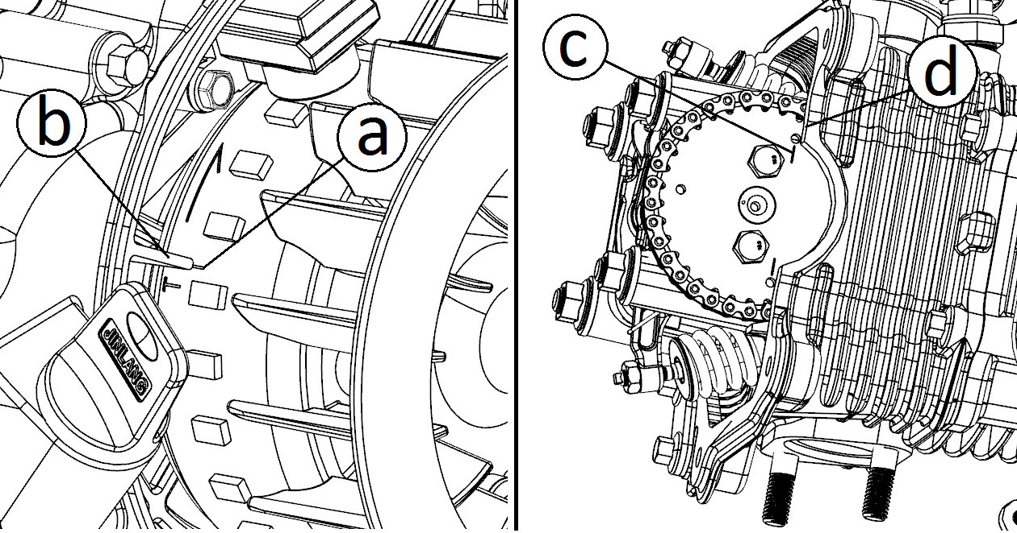
"T" mark on the rotor
(with stationary pointer on the crankcase)
NOTE:
If any special mark found, contact the UTV manufacture via the agent for the parts and special instruction.
NOTE:
Turn the cooling fan clockwise and align the "I" mark with the cylinder head match mark when the piston is at TDC on the compression
6. Loosen: |  |  |  |  | 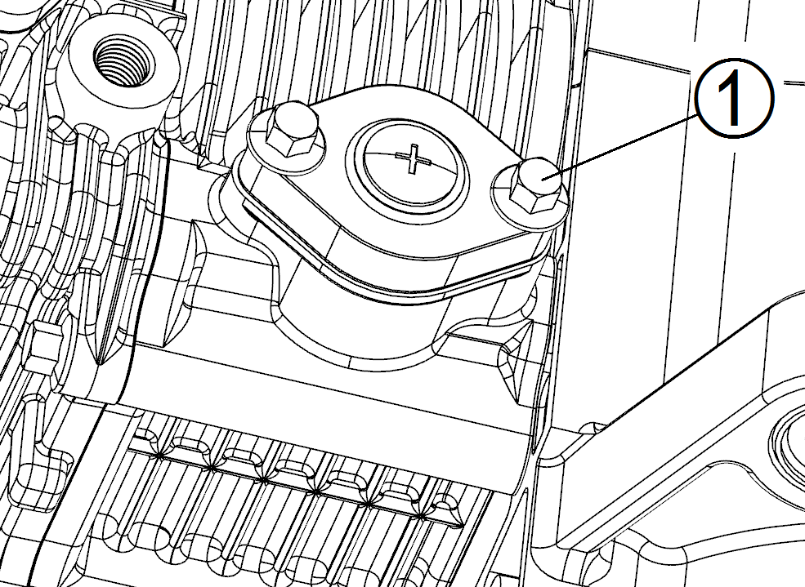
Bolts ①
7. Remove:
Timing chain tensioner assembly
Timing chain tensioner gasket
NOTE:
The plunger is under spring tension. Maintain inward pressure on the tensioner body while removing.
 |  |  |  |  | 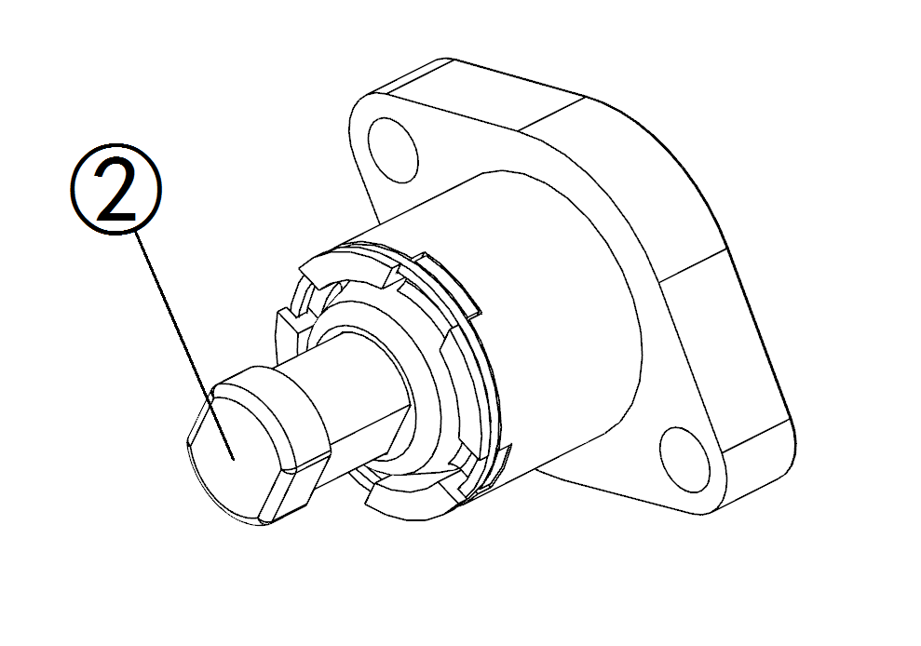
8.Inspect:
Tensioner and plunger ②
Wear/ damage → Replace.
NOTE:
Using a small flat blade screwdriver, turn the tensioner clockwise to retract the plunger. The plunger should move smoothly in and out of the tensioner body.
9. Loosen: |  |  |  |  | 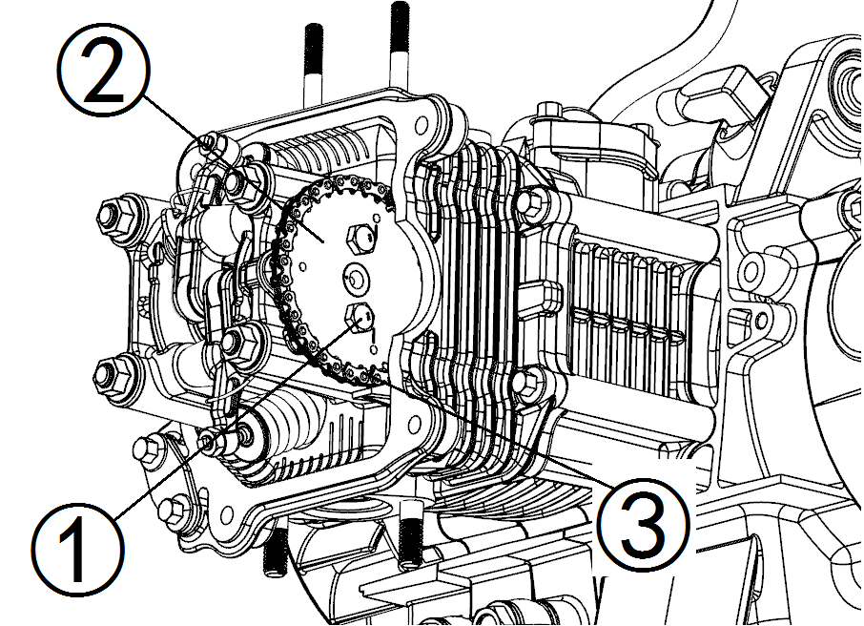
Bolts ①
10. Remove:
Cam sprocket ②
Timing chain ③
NOTE:
Fasten a safety w ire to the timing chain to prevent it from falling into the crankcase.
11. Inspect:
Cam sprocket
Wear/ damage → Replace.
12. Remove: |  |  |  |  | 
Cylinder head
NOTE:
Loosen the nuts in their proper loosening sequence.
Start by loosening each nut 1/2 turn until all are loose.

3.4.3 CYLINDER HEAD INSPECTION
1. Eliminate: |  |  |  |  | 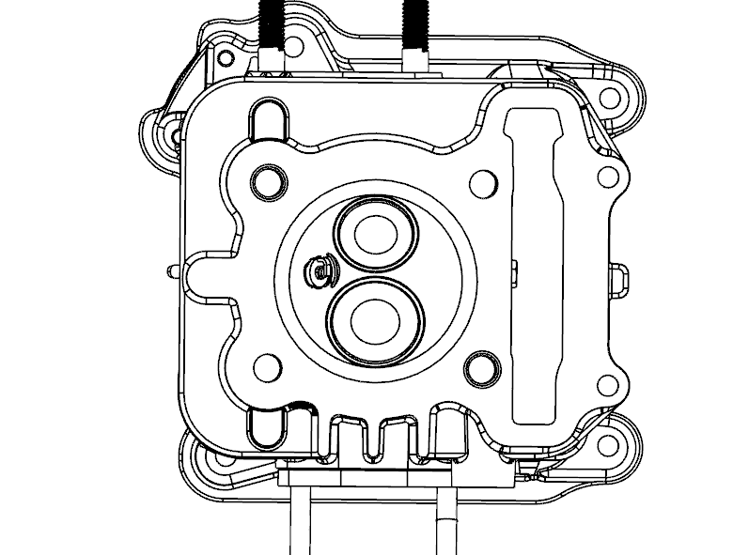
Carbon deposits
(from combustion chambers)
Use a rounded scraper.
NOTE:
Do not use a sharp instrument to avoid damaging or scratching:
Spark plug threads
Valve seats
2. Inspect: |  |  |  |  | 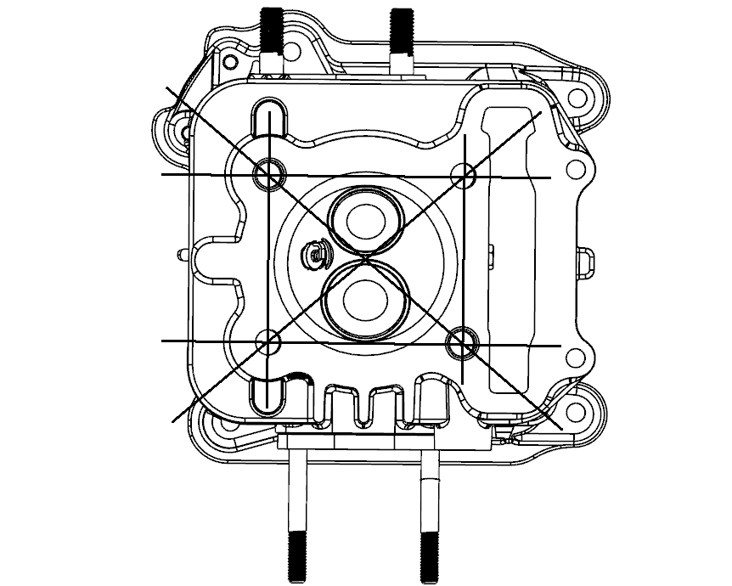
Cylinder head
Scratches/damage → Replace.
3. Measure:
Cylinder head warpage
Out of secification → Resurface.
 | Cylinder head warpage :
 | Less than 0.05 mm
Warpage measurement and resurfacement steps:
Place a straight edge and a feeler gauge across the cylinder head.
Measure the warpage.
If the warpage is out of specification, resurface the cylinder head.
Place a 400 ~ 600 grit wet abrasive paper on the surface plate, and resurface the head using a figure eight sanding patten.
NOTE:
Rotate the cylinder head several times for an even resurfacement.
 |  |  |  |  | 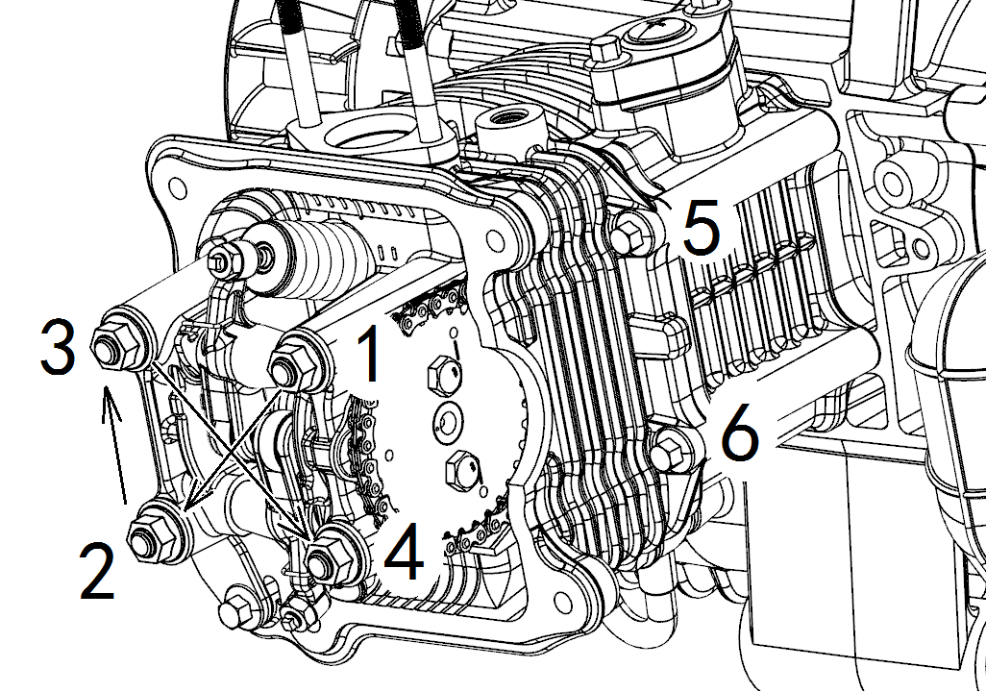

3.4.4 CYLINDER HEAD INSTALLATION
1. Install:
Gasket (cylinder head) NEW
Dowel pins
Cylinder head
NOTE:
Apply engine oil onto the nut threads.
Tighten the nuts in a crisscross pattern.
2. Tighten:
Nuts (cylinder head)
TORQUE
Cylinder head Nuts:
25N.m
Bolts (cylinder)
TORQUE
Cylinder Bolts:
10N.m
3. Install:
Cam sprocket
Timing chain
Installing steps :
Turn the cooling fan clockwise until the TDC mark matches the stationary pointer .
Align the "T" mark on the cam sprocket with the stationary pointer on the cylinder head.
NOTE:
If any special mark found, contact the UTV manufacture via the agent for the parts and special instruction.
Fit the timing chain onto the cam sprocket and install the cam sprocket on the camshaft.
NOTE:
When installing the cam sprocket, keep the timing chain as tense as possible on the exhaust side.
Align the match mark on the cam sprocket with the stationary pointer on the cylinder head.
Align the hole in the cam shaft with the hole in the cam sprocket.
CAUTION:
Do not turn the crankshaft during installation of the cam shaft. Dam age or improper valve timing will result.
While holding the camshaft, temporarily tighten the bolts.
Remove the safety wire from the timing chain.
4. Tighten:
Bolts (cam sprocket)
TORQUE
Cam sprocket Bolts:
15N.m
5. Install:
Timing chain tensioner
Installing steps:
Using a small flat blade screwdriver, turn the tensioner clockwise to retract the plunger ② all the way into the tensioner body.
Keeping the plunger retracted, install the tensioner assembly with a new gasket and tighten the bolts ① to specification.
TORQUE
Tensioner Bolts:
10N.m
Release the tensioner and install the tensioner cap.
TORQUE
Tensioner Cap:
5N.m
Slowly rotate engine two to three revolutions and recheck cam timing once chain is tight.
6. Check:
Valve timing
Out of alignment → Adjust.
7. Check:
Valve clearance
Out of specification → Adjust.
Refer to the "3.2.5VALVE CLEARANCE ADJUSTMENT" section.

3.5 CAMSHAFT AND ROCKER ARMS
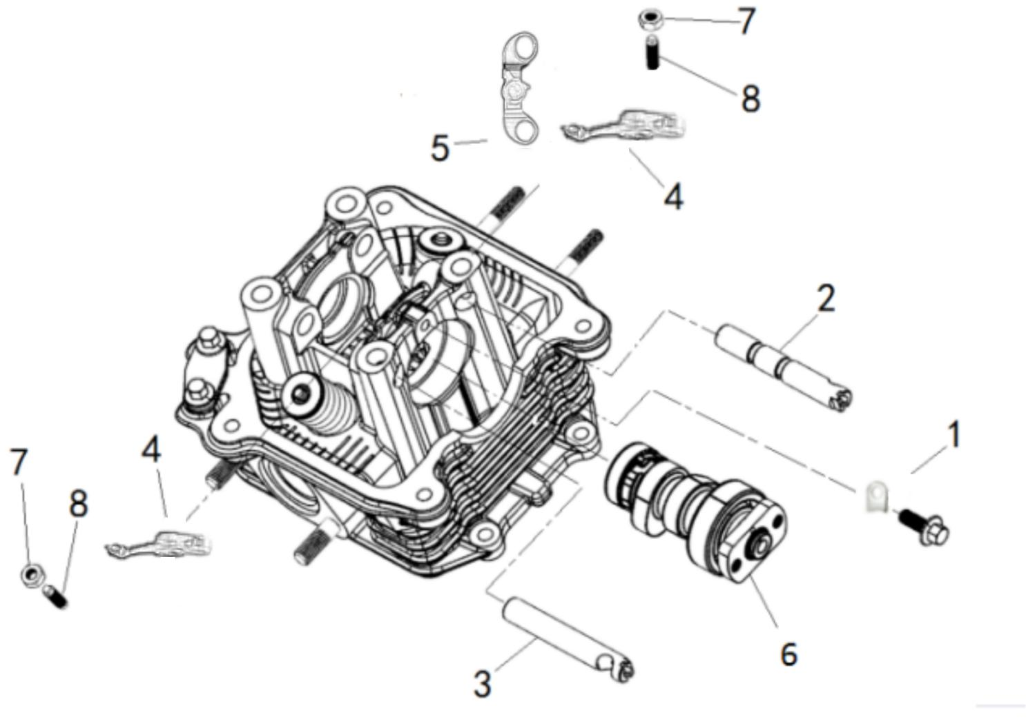
Order |  |  |  |  | Job/Parts to remove | Q’ty |  | Remarks
 |  |  |  |  | Cylinder head |  |  | Refer to “CYLINDER HEAD”
1 |  |  |  |  | Camshaft bearing pressure platen | 1
2 |  |  |  |  | Intake rocker shaft | 1
3 |  |  |  |  | Exhaust rocker shaft | 1
4 |  |  |  |  | Rocker arm assembly | 1
5 |  |  |  |  | Pressure reducing valve stop plate | 1
6 |  |  |  |  | Camshaft | 1
7 |  |  |  |  | Locknut | 2
8 |  |  |  |  | Valve adjusting screw | 2

3.5.1 CAMSHAFT AND ROCKER ARMS
REMOVAL
1.Loosen: |  |  |  |  |  |  | 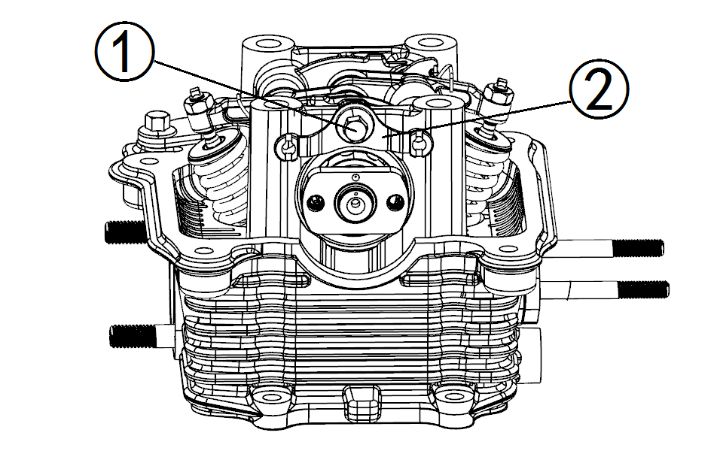
Bolt ①
2. Remove:
Camshaft bearing platen ②
Rocker arm shaft (intake)
Rocker arm shaft (exhaust)
3. Remove:
Rocker arm (intake)
Rocker arm (exhaust)
Camshaft

3.5.2 CAMSHAFT INSPECTION
1. Inspect:
Camshaft lobes
Pitting/Scratches/Blue discoloration →Replace. |  |  |  |  |  |  | 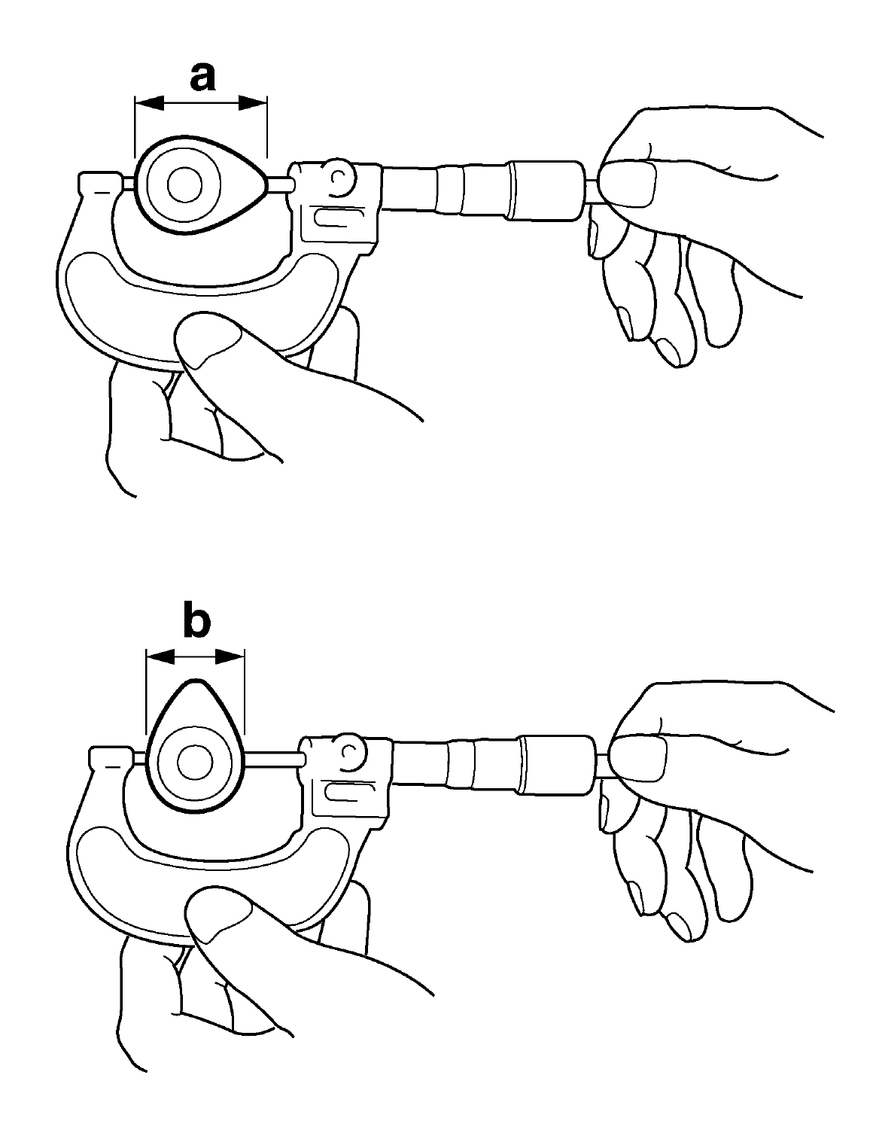
2. Measure:
Camshaft lobes length “a” and “b”
Out of specification → Replace.
 |  |  |  | Camshaft lobes length:
 |  |  |  | Intake:
 |  |  |  | A 29.52-29.58mmmm
 |  |  |  | <Lim it: 29.47 mm>
 |  |  |  | B 25.00-25.03mm
 |  |  |  | <Lim it: 24.95 mm>
 |  |  |  | Exhaust:
 |  |  |  | A 29.32-29.38mm
 |  |  |  | <Lim it: 29.27 mm>
 |  |  |  | B 25.00-25.03mm
 |  |  |  | <Lim it: 24.95 mm>
3. Inspect: |  |  |  |  |  |  | 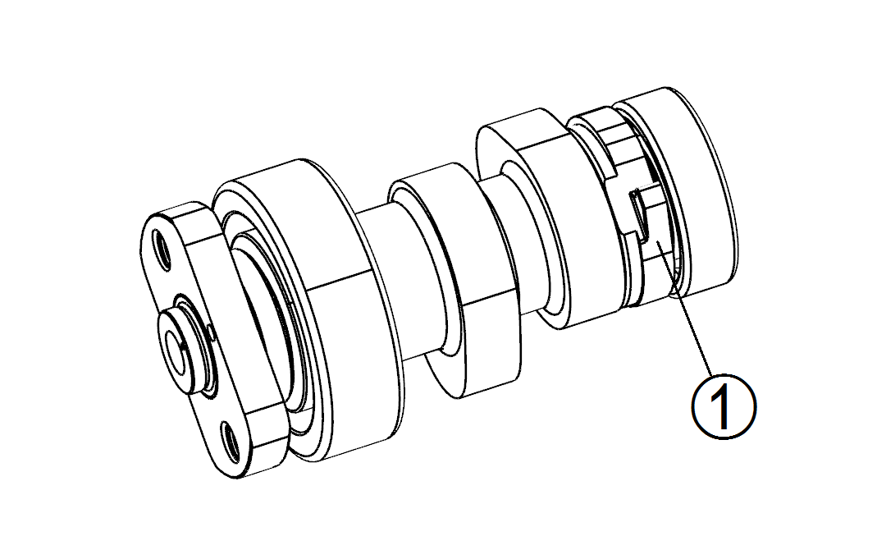
Compression release mechanism 1
Excessive wear → Replace.
NOTE:
This is a one-way rotating shoulder that lifts the exhaust valve slightly during start-up. If the one-way mechanism is not functioning, replace the cam. Verify the stop bracket and spring is functioning correctly.

3.5.3 ROCKER ARMS AND ROCKER ARM SHAFTS INSPECTION
1. Inspect: |  |  |  |  |  |  | 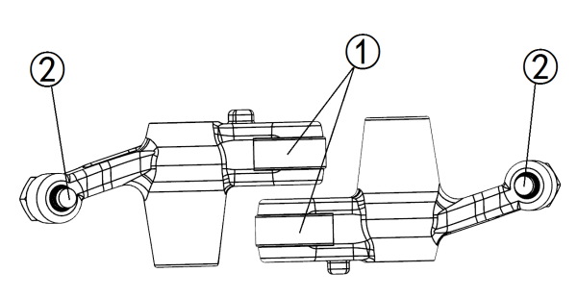
Camshaft lobe contact surface
Excessive wear → Replace.
Adjuster surface
Wear/Pitting/Scratches/Blue discoloration→Replace.
2. Inspect:
Rocker arm shaft hole.
Excessive wear → Replace.
3. Inspect:
The surface condition of the rocker arm shafts. |  |  |  |  |  |  | 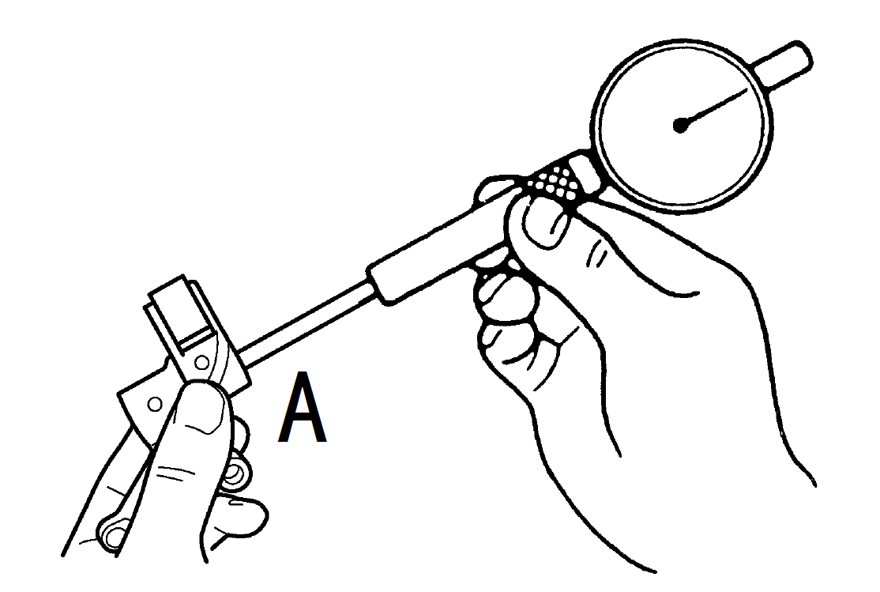
Pitting/scratches/blue discoloration → Replace or check lubrication.
4. Measure:
Measure the inside diameter A of the rocker arm holes.
Out of specification → Replace.
 |  |  | Inside diameter (rocker arm ):
 |  |  | 10.000-10.015mm
< Lim it: 10.100 mm > |  |  |  |  |  |  | 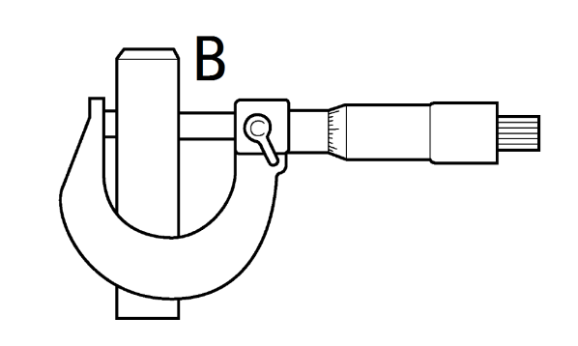
5. Measure:
Measure the outside diameter B of the rocker arm shafts.
Out of specification → Replace.
 | Outside diameter(rocker arm shaft):
 | 9.972-9.987 mm
<Lim it: 9.920 mm>
6. Calculate:
Rocker-arm-to-rocker-arm-shaft clearance
Out of specification → Replace.
 | Rocker-arm-to-rocker-arm-shaft clearance:
 | 0.013-0.043 mm

3.5.4 CAMSHAFT AND ROCKER ARM INSTALLATION
1. Lubricate:
Cam shaft
 |  | Camshaft:
 |  | Molybdenum disulfide oil
Camshaft bearing:
Engine oil
2. Install:
Cam shaft
3. Apply:
Molybdenum disulfide oil onto the rocker arm and rocker arm shaft.
 |  | Molybdenum disulfide oil
4. Install:
Exhaust rocker arm
Exhaust rocker arm shaft
Exhaust rocker arm return spring
Intake rocker arm
Intake rocker arm shaft
Intake rocker arm plate
Intake rocker arm return spring
5. Install:
Camshaft bearing platen
6. Tighten:
Bolt
TORQUE
Camshaft bearing platen Bolt:
10N.m
CAUTION:
Do not confuse the installation direction of rocker arm shaft. Be sure to install the threaded part facing outward.

3.6 VALVES AND VALVE SPRINGS
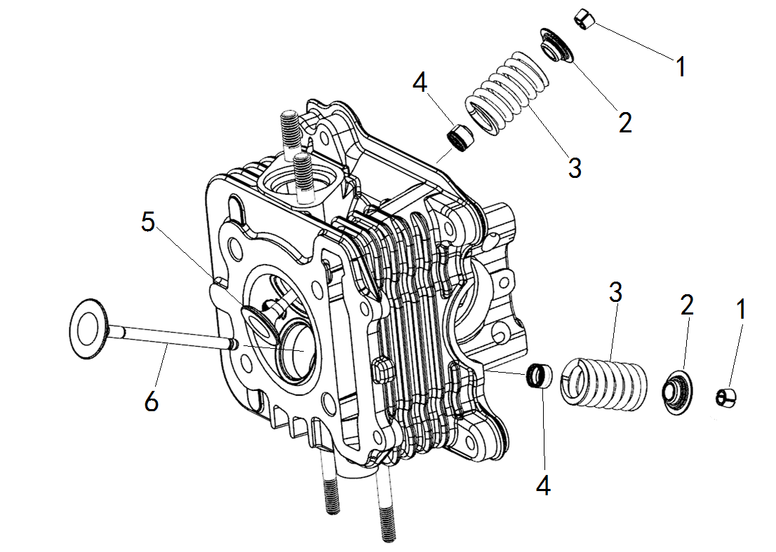
Order |  |  |  |  | Job/Parts to remove |  | Q’ty | Remarks
 |  |  |  |  | Cylinder head |  |  | Refer to “CYLINDER HEAD”
 |  |  |  |  | Camshaft |  |  | Refer to “CAMSHAFT AND ROCKER ARMS”
1 |  |  |  |  | Valve cotter |  | 4
2 |  |  |  |  | Valve spring retainer |  | 2
3 |  |  |  |  | Valve spring |  | 2
4 |  |  |  |  | Valve stem seal |  | 2
5 |  |  |  |  | Exhaust valve |  | 1
6 |  |  |  |  | Intake valve |  | 1

3.6.1 VALVES AND VALVE SPRINGS REMOVAL
NOTE:
Before removing the internal parts of the cylinder head (e.g., valves, valve springs, valve seats), make sure the valves properly seal.
1. Inspect:
Valve sealing
Leakage at the valve seat → Check the valve face, valve seat, and valve seat width. |  |  |  |  |  | 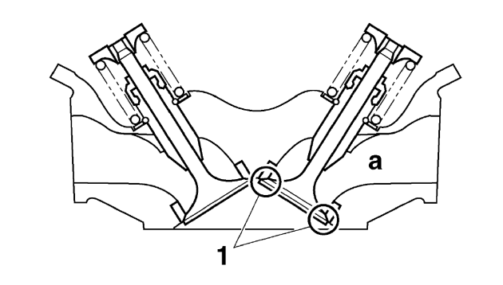
Inspection steps:
a. Pour a clean solvent “a” into the intake and exhaust ports.
b. Check that the valves properly seal.
NOTE:
There should be no leakage at the valve seat “1”.
2. Remove:
Valve cotters |  |  |  |  |  | 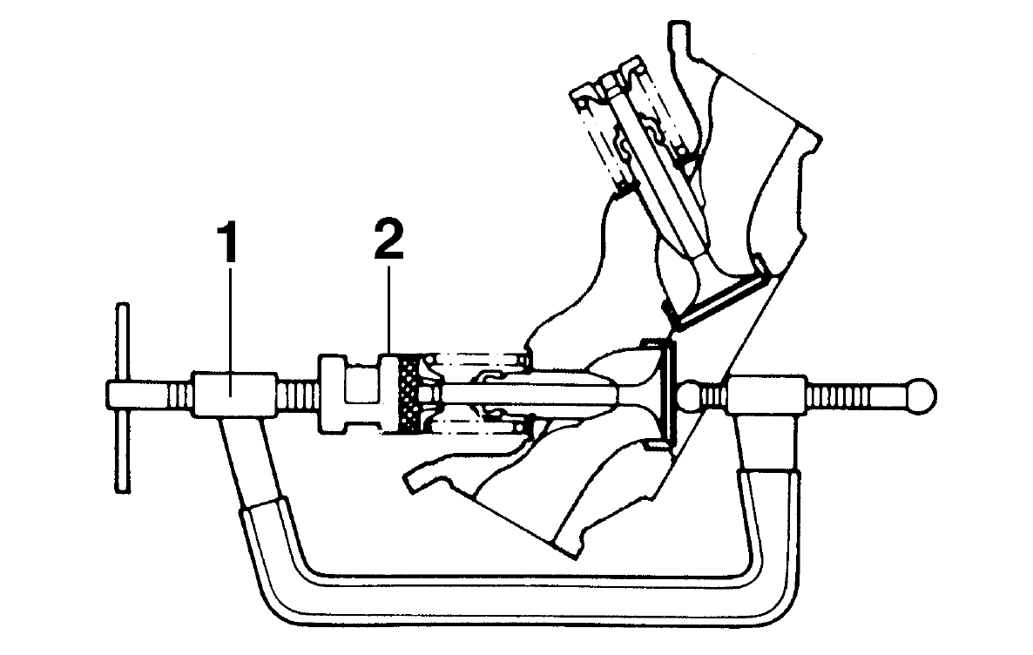
NOTE:
Remove the valve cotters by compressing the valve spring with the valve spring compressor “1” and the valve spring compressor attachment “2”.
CAUTION:
Do not compress so much as to avoid damage to the valve spring.
3. Remove: |  |  |  |  |  | 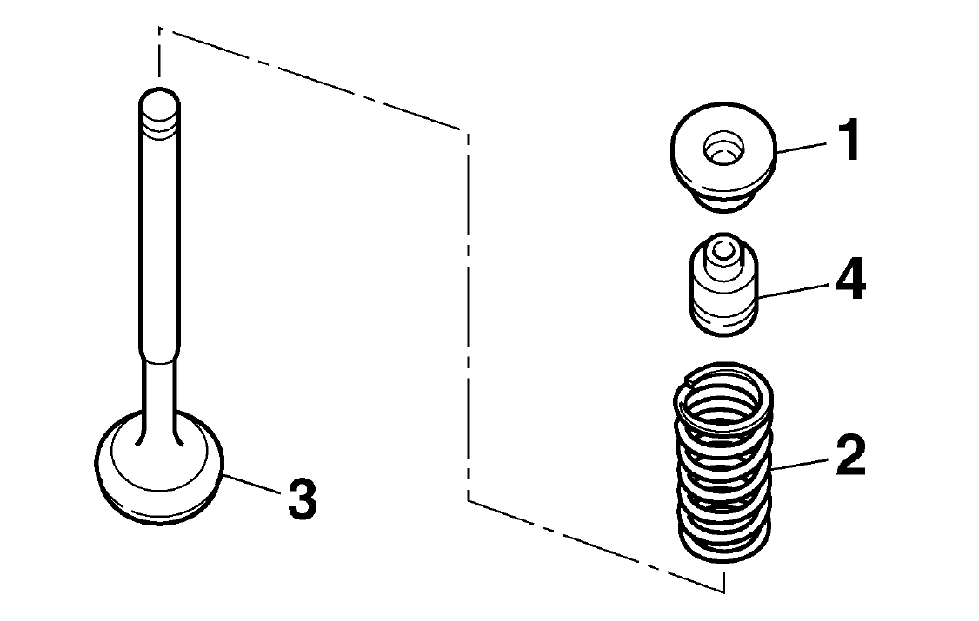
Valve spring retainer “1”
Valve spring “2”
Valve “3”
Valve stem seal “4”
NOTE:
Identify the position of each part very carefully so that it can be reinstalled in its original place.

3.6.2 VALVE AND VALVE SPRINGS INSPECTION
1. Measure:
Valve stem diameter
Out of specification → Replace.
 |  |  | Valve stem diameter: |  |  | 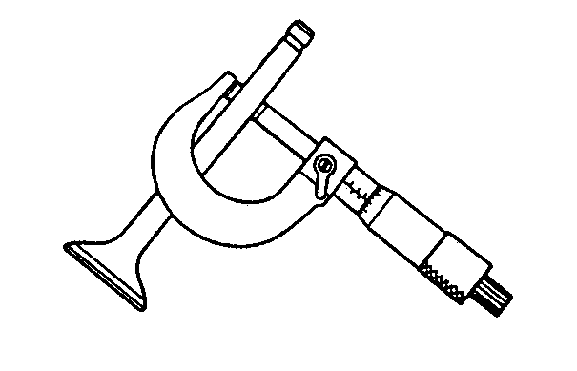
 |  |  | Intake:
4.970-4.980mm
<Limit: 4.90mm>
Exhaust:
4.955-4.970mm
<Limit: 4.90mm>
2. Measure:
Valve guide inside diameter |  |  |  |  |  | 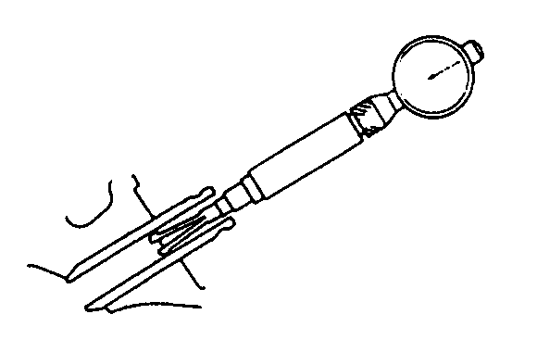
Out of specification → Replace.
 |  |  | Valve guide inside diameter:
 |  |  | Intake:
5.000-5.012mm
<Limit: 5.03mm>
Exhaust:
5.000-5.012mm
<Limit: 5.03mm>
3. Measure:
Valve-stem-to-valve-guide clearance
Out of specification → Replace.
 |  |  | Stem-to-guide clearance limit:
 |  |  | Intake:
0.08 mm
Exhaust:
0.10 mm
4.Measure: |  |  |  |  |  | 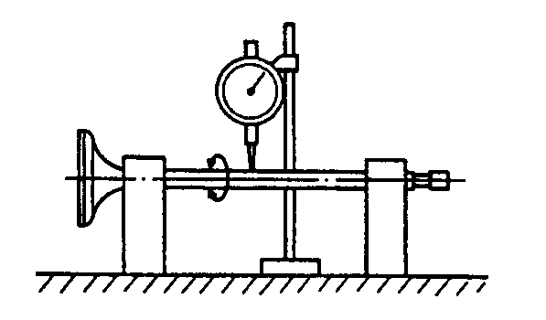
Runout (valve stem )
Out of specification → Replace.
 |  |  | Runout limit:
 |  |  | 0.10 mm
NOTE:
When installing a new valve, always replace the valve guide.
If the valve is removed or replaced, always replace the valve stem seal.
5. Inspect:
Valve stem end
Mushroom shape or diameter larger than the body of the valve stem → Replace the valve.
6. Measure:
Free length (valve spring) |  |  |  |  |  | 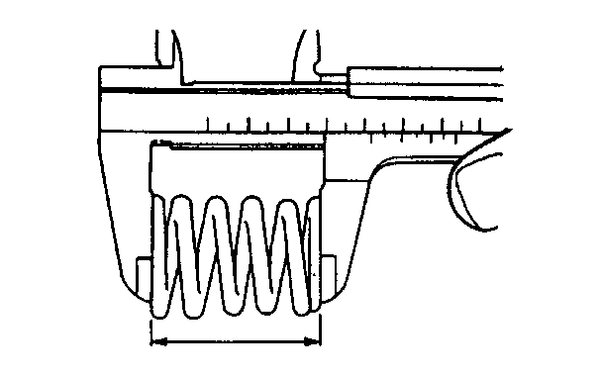
Out of specification → Replace.
 |  | Valve spring free length:
 |  | Intake:
37 mm
<Limit: 35 mm>
Exhaust:
34.8 mm
<Limit: 32.8 mm>
7. Measure: |  |  |  |  |  | 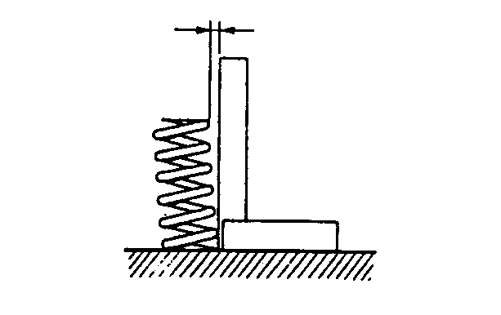
Spring tilt
Out of specification → Replace.
 |  | Spring tilt (intake)
 |  | 2.5°/ 1.60mm
Spring tilt (exhaust)
2.5°/ 1.60mm
8. Inspect:
Spring contact face
Wear/Pitting/Scratches → Replace.

3.6.3 VALVE SEATS INSPECTION
1. Eliminate:
Carbon deposits
(from the valve face and valve seat)
2. Inspect:
Valve face
Pitting/wear → Grind the valve face.
3. Measure:
Valve seat width
Out of specification → Reface the valve seat.
 | Valve seat width: |  |  |  |  | 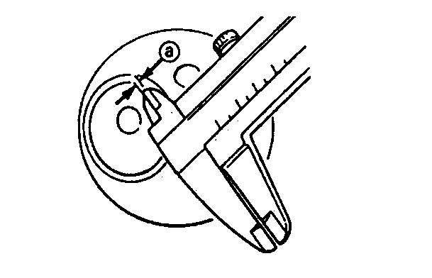
 | Intake:
0.6-0.8mm
<Limit:1.5mm>
Exhaust:
0.6-0.8mm
<Limit:1.5mm>
Measurement step:
Apply Mechanic’s blueing dye (Dykem) to the valve face. |  |  |  |  |  | 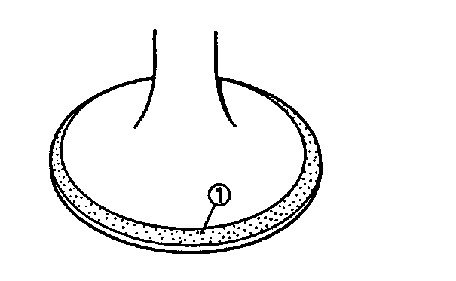
Install the valve into the cylinder head.
Press the valve through the valve guide and onto the valve seat to make a clear pattern.
Measure the valve seat width. Where the valve seat and valve face made contact, blueing will have been removed.
If the valve seat is too wide, too narrow, or the seat is not centered, the valve seat must be replaced.
4. Lap:
Valve face
Valve seat
NOTE:
After replacing the cylinder head or replacing the valve and valve guide, the valve seat and valve face should be lapped. |  |  |  |  |  | 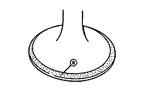
Lapping steps:
Apply a coarse lapping com pound to the valve face.
CAUTION:
Do not let compound enter the gap between the valve stem and the guide.
Apply molybdenum disulfide oil to the valve stem. |  |  |  |  |  | 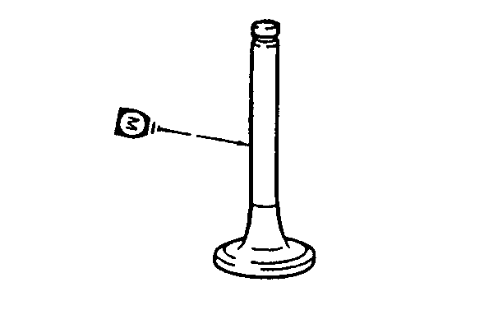
Install the valve into the cylinder head.
Turn the valve until the valve face and valve seat are evenly polished, then clean off al com pound.
NOTE:
For best lapping results, lightly tap the valve seat while rotating the valve back and forth between your hand.
Apply a fine lapping compound to the valve face and repeat the above steps. |  |  |  |  |  | 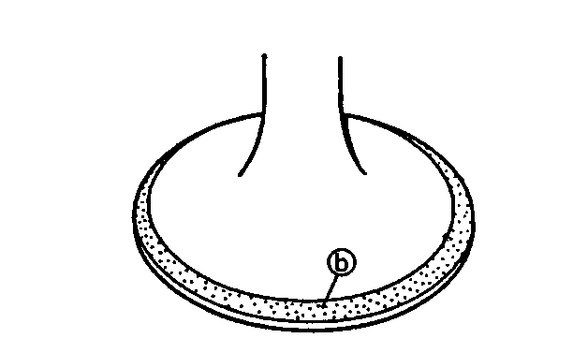
NOTE:
Make sure to clean off all compound from the valve face and valve seat after every lapping operation.
Apply Mechanic’s blueing dye (Dykem) to the valve face.
Install the valve into the cylinder head.
Press the valve through the valve guide and onto the valve seat to make a clear pattern. |  |  |  |  |  | 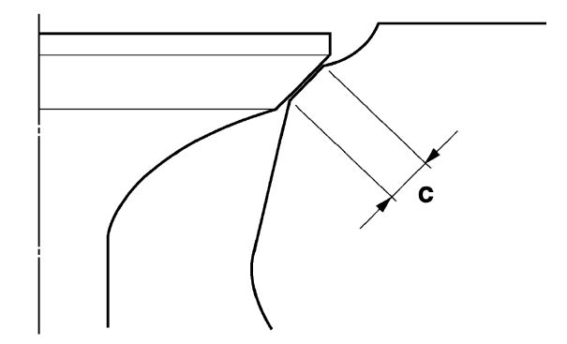
Measure the valve seat with “c” again.

3.6.4 VALVES AND VALVE SPRINGS INSTALLATION
1. Deburr: |  |  |  |  |  | 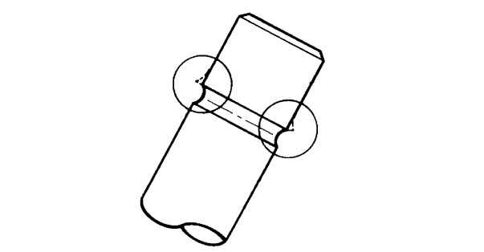
Valve stem end
Use an oilstone to smooth the stem end.
2.Lubricate: |  |  |  |  |  | 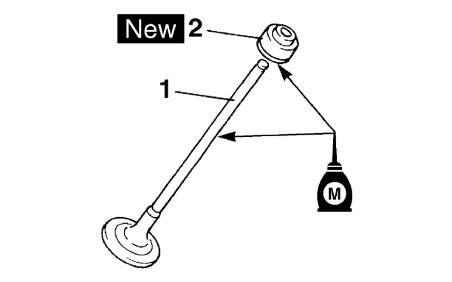
Valve stem “1”
Valve stem seal “2” New
(with the recommended lubricant)
 |  |  |  | Recommended lubricant
 |  |  |  | Molybdenum disulfide oil
3. Install: |  |  |  |  |  | 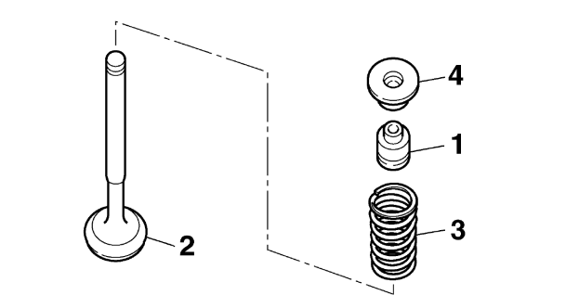
Valve stem seal “1” New
Valve “2”
Valve spring “3”
Valve spring retainer “4”
(into the cylinder head)
NOTE: |  |  |  |  |  | 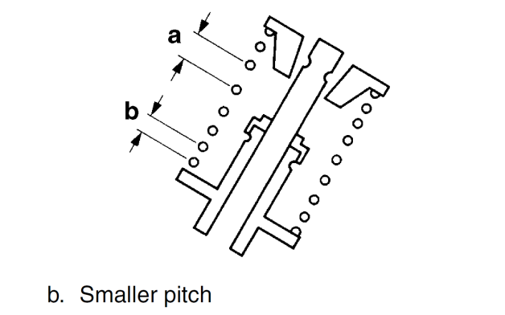
Make sure each valve is installed in its original place.
Install the valve springs with the larger pitch “a” facing up.
4. Install:
Valve cotters
NOTE:
Install the valve cotters by compressing the valve spring with the valve spring compressor “1” and the valve spring compressor attachment “2”.
5. To secure the valve cotters onto the valve stem, lightly tap the valve tip with a soft-face hammer.
CAUTION:
Hitting the valve tip with excessive force could damage the valve.

3.7 CYLINDER AND PISTON
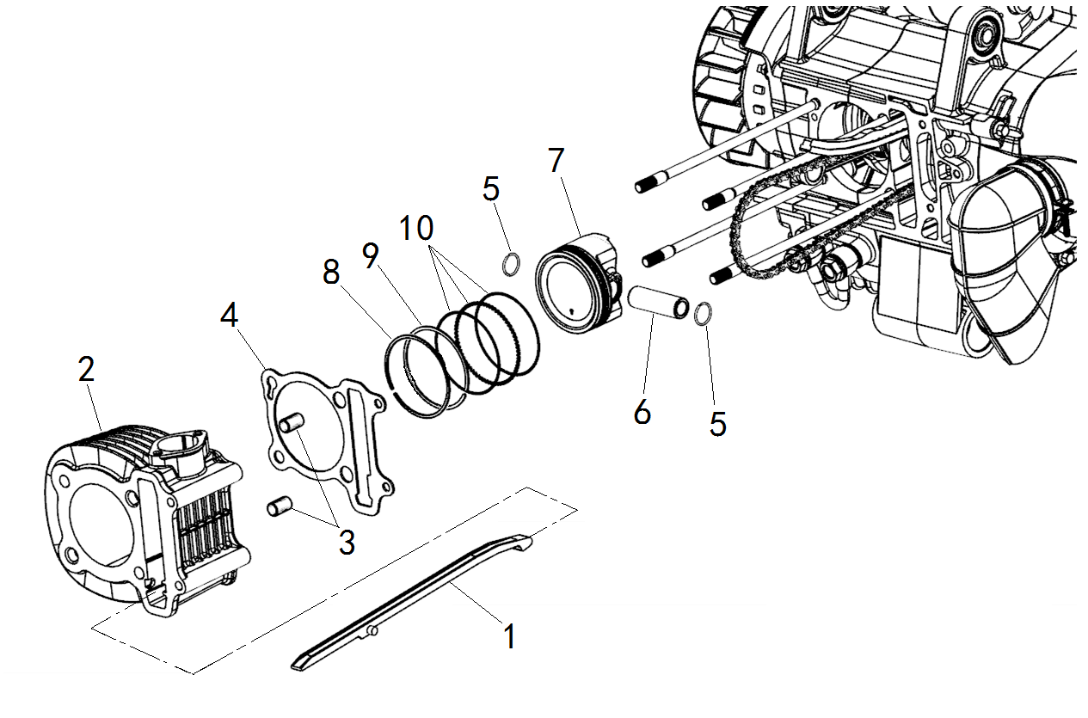
Order | Job/Parts to remove | Q’ty | Remarks
 | Cylinder head |  | Refer to “CYLINDER HEAD”
1 | Timing chain guide (exhaust side) | 1
2 | Cylinder | 1
3 | Dowel pin | 2
4 | Cylinder gasket | 1
5 | Piston pin clip | 2
6 | Piston pin | 1
7 | Piston | 1
8 | Top ring | 1
9 | 2nd ring | 1
10 | Oil ring | 1

3.7.1 PISTON AND PISTON RINGS REMOVAL
1. Remove:
Piston pin circlip |  |  |  | 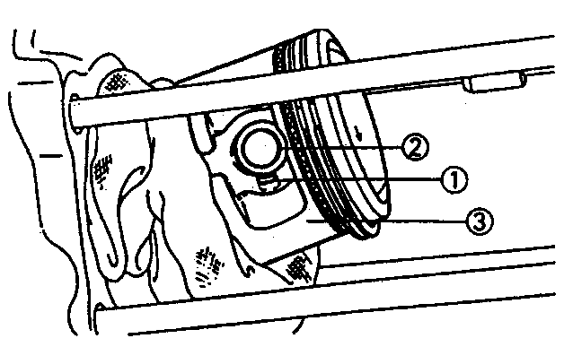
Piston pin
Piston
NOTE:
Before removing the piston pin circlip, cover the crankcase opening with a clean tow el or rag to prevent the circlip from falling into the crankcase cavity.
2. Remove: |  |  |  | 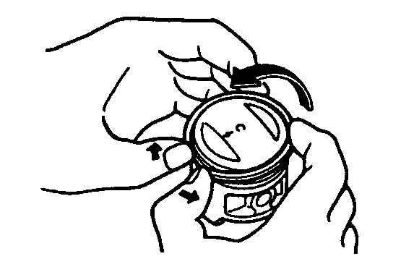
Top ring
2nd ring
Oil ring
NOTE:
When removing a piston ring, open the end gap with your fingers and lift the other side of the ring over the piston crown.

3.7.2 CYLINDER INSPECTION
1. Check:
Piston wall
Cylinder wall
Vertical scratches → Replace the cylinder, and replace the piston and piston rings as a set.
2. Measure:
Cylinder bore |  |  |  | 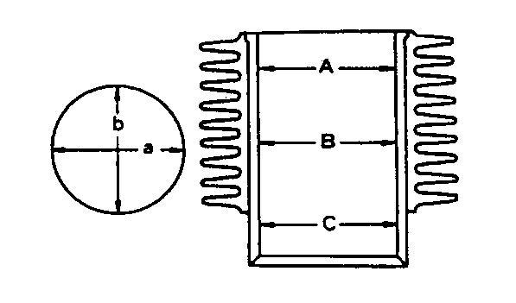
Out of specification → Rebore or replace.
NOTE:
Measure cylinder bore with the cylinder bore gauge.
Measure cylinder bore by taking side-to-side and front-to-back measurements of the cylinder. Then, find the average of the measurements.
 |  | Cylinder bore:
 |  | 62.515-62.520
< Limit:62.600mm>
< Difference limit between A,B and
C :0.03mm >
 |  |  |  | 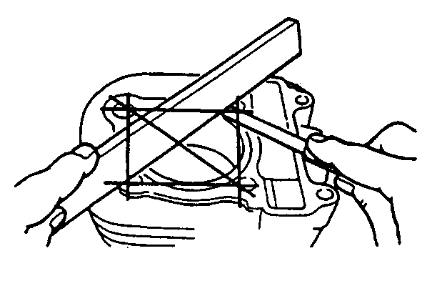
3. Measure:
Warpage
Out of specification → Replace.
 |  | Cylinder warpage limit:
 |  | 0.05mm

3.7.3 PISTON AND PISTON PIN INSPECTION
1. Measure:
Piston skirt diameter “a” |  |  |  | 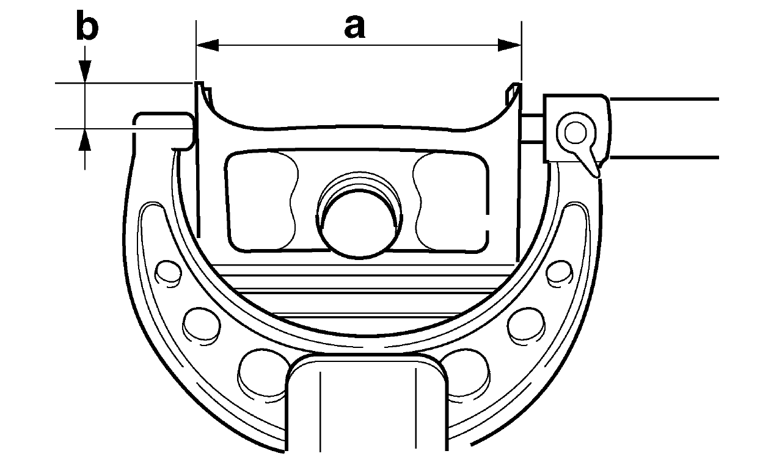
Out of specification → Replace .
“b” 7.0mm from the piston bottom edge.
 | Piston skirt diameter:
 | 62.475-62.485mm
2. Calculate:
Piston-to-cylinder clearance
Piston-to-cylinder clearance=
Cylinder bore-Piston skirt diameter
Refer to “CYLINDER” section for cylinder bore measurement.
Out of specification → Replace the piston and piston rings as a set.
 | Piston-to-cylinder clearance:
 | 0.025-0.045mm
<Limit: 0.10mm>
 |  |  |  | 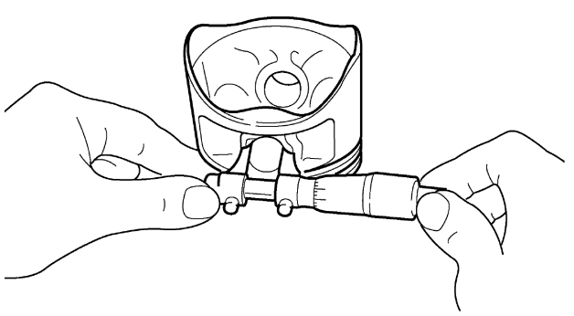
3. Measure:
Piston pin bore diameter
Out of specification → Replace.
 | Piston pin bore diameter:
 | 15.002-15.008mm
<Limit:15.04mm>
4. Measure: |  |  |  | 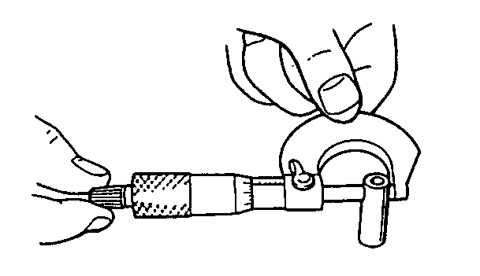
Piston pin outside diameter
Out of specification → Replace.
 | Piston pin bore diameter:
 | 14.994-15.000mm
<Limit:14.960mm>
5. Inspect:
Piston pin
Blue discoloration/groove → Clean or replace.

3.7.4 PISTON RINGS INSPECTION
1. Measure: |  |  |  | 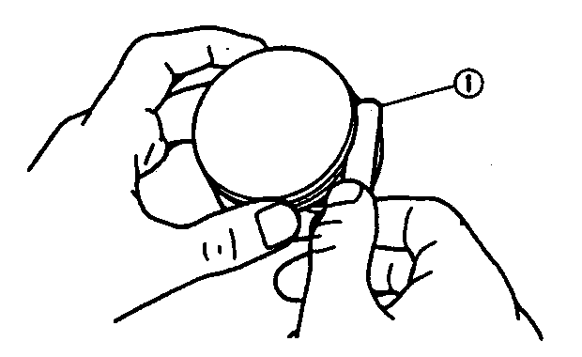
Side clearance
Out of specification → Replace the piston and the piston rings as a set.
NOTE:
Eliminate the carbon deposits from the piston ring grooves and rings before measuring the side clearance.
 | Side clearance (piston ring):
 | Top ring:
0.02-0.06mm
<Limit: 0.11mm>
2nd ring:
0.02-0.06mm
<Limit: 0.12mm>
2. Install: |  |  |  | 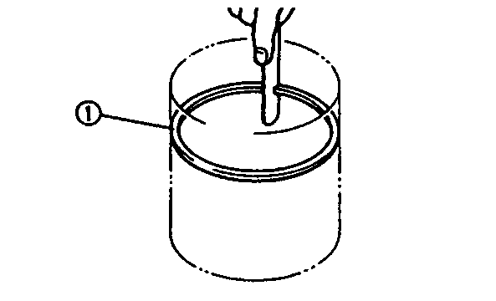
Piston ring
(into the cylinder)
NOTE :
Level the piston ring into the cylinder with the piston crown.
50mm
3. Measure:
Piston ring end gap
Out of specification → Replace.
NOTE :
The oil ring expander spacer end gap cannot be measured. If the oil ring rail gap is excessive, replace all three piston rings.
 | Piston ring end gap:
 | Top ring:
0.10-0.25mm
<Limit:0.45mm>
2nd ring:
0.20-0.40mm
<Limit:0.60mm>
Oil ring:
0.20-0.70mm

3.7.5 PISTON RINGS, PISTON AND CYLINDER INSTALLATION
1. Install:
Lower oil ring rail “1” |  |  |  | 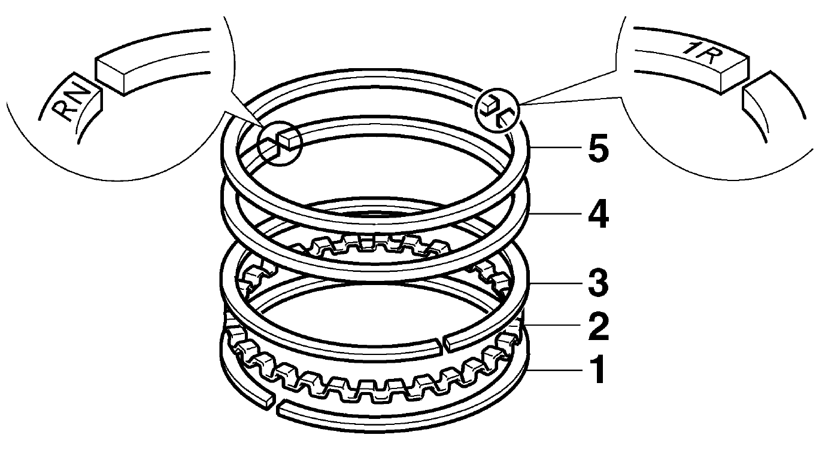
Oil ring expander “2”
Upper oil ring rail “3”
2nd ring “4”
Top ring “5”
NOTE:
Be sure to install the piston rings so that the manufacturer’s marks or numbers face up.
Lubricate the pistons and piston rings liberally with engine oil.
2.Install:
Piston |  |  |  | 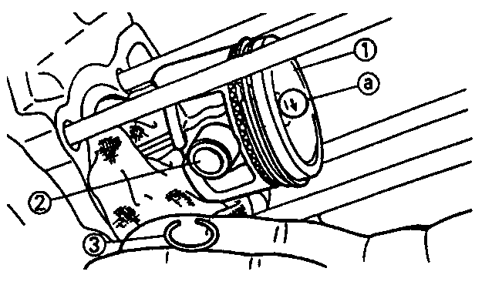
Piston pin
Piston pin clip NEW
NOTE:
Apply engine oil to the piston pins.
The " △ " mark on the piston must face the exhaust side of the cylinder.
Before installing the piston pin clip, cover the crankcase opening with a clean rag to prevent the piston pin clip from falling into the crankcase.
3. Install:
Gasket (cylinder) NEW
Dowel pins
4. Position:
Piston rings
NOTE: |  |  |  | 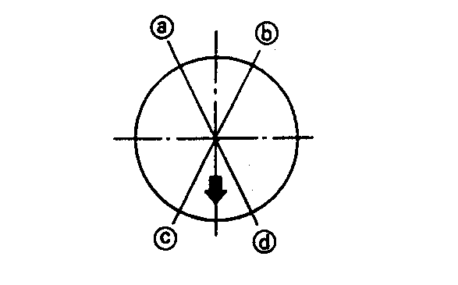
Offset the piston ring end gaps as shown.
Top ring end
Oil ring end (lower)
Oil ring end (upper)
2nd ring end
5. Lubricate:
Piston outer surface
Piston ring
Cylinder inner surface
(with the recommended lubricant)
 |  |  | Recommended lubricant
 |  |  | Engine oil
6. Install:
Cylinder
NOTE:
Install the cylinder with one hand while com pressing the piston rings with the other hand.
Pass the timing chain and timing chain guide (exhaust side) through the timing chain cavity.

3.8 V-BELT, CLUTCH AND SECONDARY/PRIMARY SHEAVE
CRANKCASE COVER (LEFT)
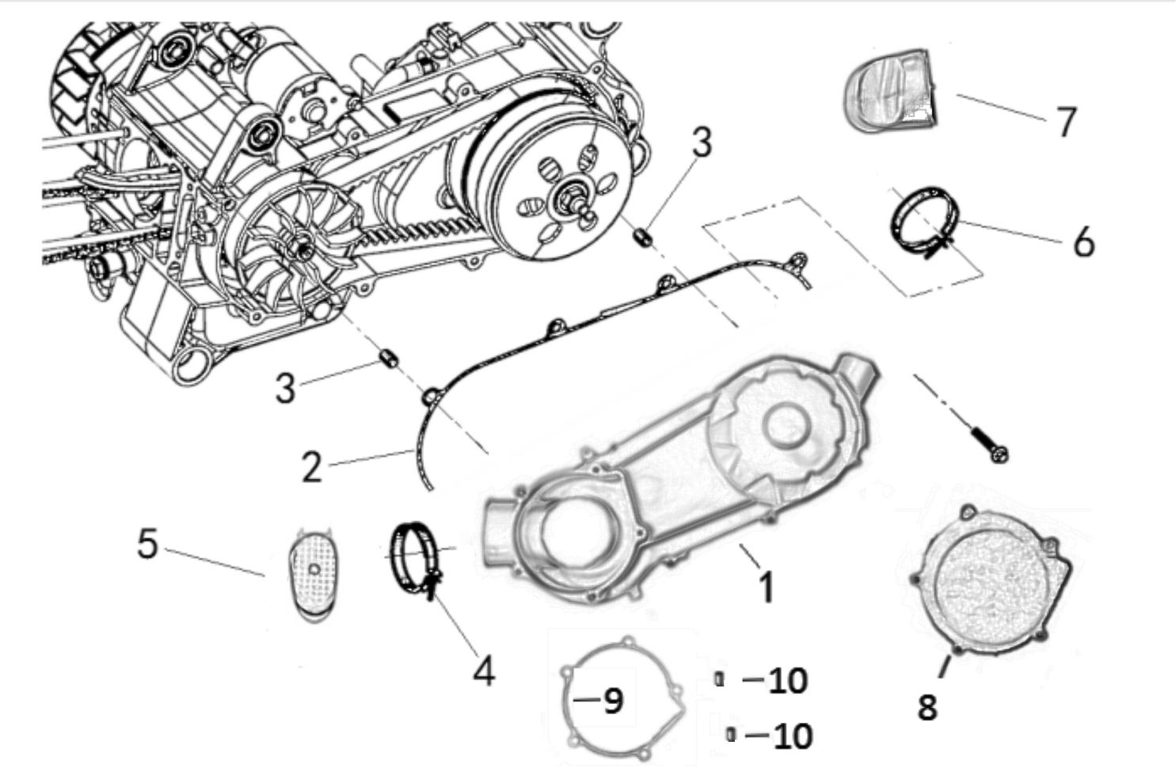
Order | Job/Parts to remove | Q’ty | Remarks
1 | Crankcase cover (left) | 1
2 | Crankcase cover (left) gasket | 1
3 | Dowel pin | 2
4 | Hose clamp A | 1
5 | Joint A | 1
6 | Hose clamp B | 1
7 | Joint B | 1
8 | Left Little Guy | 1
9 | Left Little Guygasket | 1
10 | Dowel pin | 2

PRIMARY SHEAVE
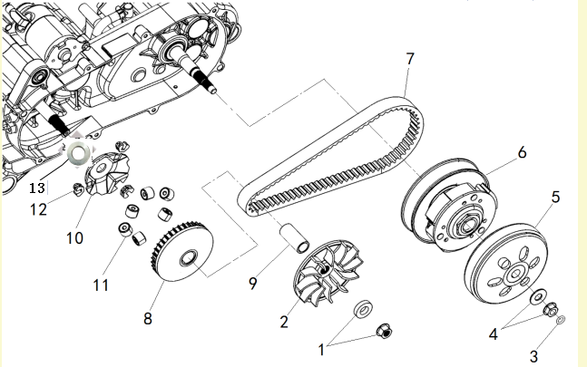
Order | Job/Parts to remove | Q’ty | Remarks
1 | Nut/Plain washer | 1/1
2 | Primary fixed sheave | 1
3 | O-ring | 1
4 | Nut/Plain washer | 1/1
5 | Clutch housing | 1
6 | Clutch assembly | 1
7 | V-belt | 1
8 | Primary sliding sheave | 1
9 | Collar | 1
10 | Cam | 1
11 | Weight | 6
12 | Slider | 3
13 | Starting driven gasket | 1

SECONDARY SHEAVE
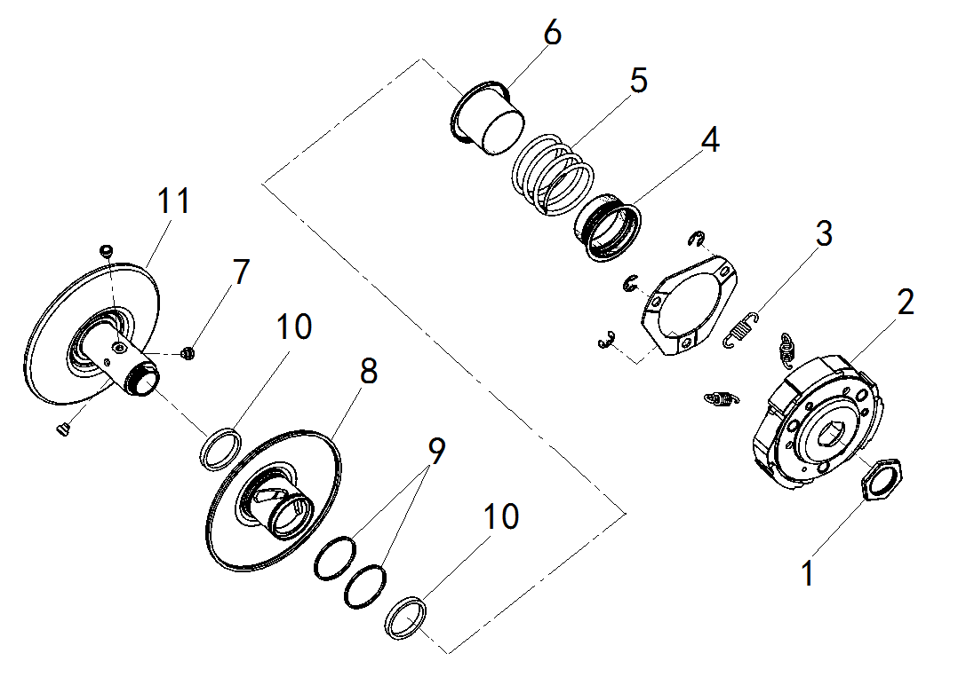
Order | Job/Parts to remove | Q’ty | Remarks
1 | Nut | 1
2 | Clutch carrier | 1
3 | Clutch shoe spring | 3
4 | Spring seat A | 1
5 | Compression spring | 1
6 | Spring seat B | 1
7 | Guide pin | 3
8 | Secondary sliding sheave | 1
9 | O-ring | 2
10 | Oil seal | 2
11 | Secondary fixed sheave | 1

3.8.1 PRIMARY SHEAVE REMOVAL
1. Loosen: |  |  |  | 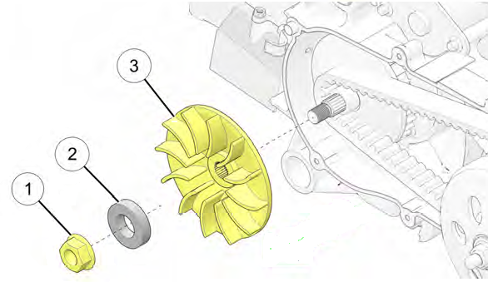
Nut (primary sheave)
2. Remove:
Plate washer
Primary fixed sheave

3.8.2 SECONDARY SHEAVE AND V-BELT REMOVAL
1. Remove: |  |  |  | 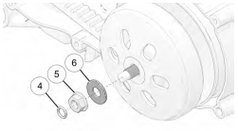
Seal
2. Loosen:
Nut
3. Remove:
Washer
 |  |  |  | 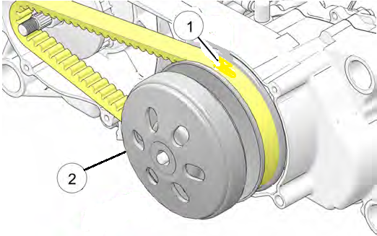
4. Remove:
V-belt
Clutch assembly
NOTE:
Remove the V-belt from the primary sheave side with clutch assembly.

3.8.3 SECONDARY SHEAVE DISASSEMBLY
1. Remove: |  |  |  | 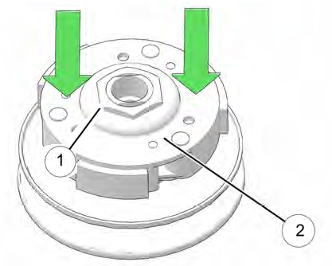
Nut (secondary sheave)
NOTE:
Secure driven clutch assembly in a soft jaw vise or clamp.
Loosen retaining nut (counterclockwise) about 1 turn.
Hold downward pressure on friction shoe plate , then remove nut.
Release pressure on plate and remove friction shoe assembly and driven spring.

3.8.4 CLUTCH INSPECTION
1.Measure: |  |  |  | 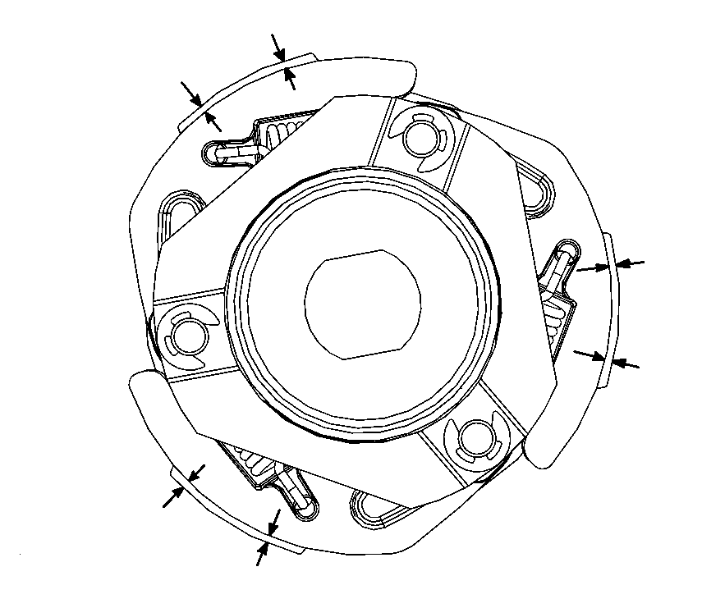
Clutch shoe thickness
Scratches → Glaze using coarse sandpaper.
Wear /Damage → Replace.
 | Clutch shoe thickness:
 | 3.5mm
<Limit:2.0mm>
NOTE:
After using the sandpaper, clean off the polished particles.
Inspect the other clutch shoes.
Replace all three as a set.

3.8.5 V-BELT INSPECTION
1.Inspect:
V-belt |  |  |  | 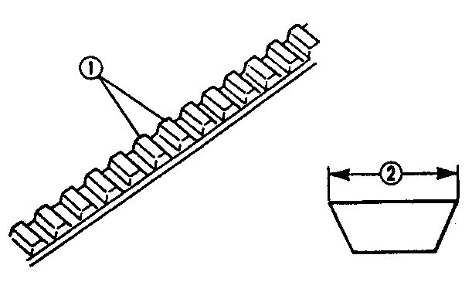
Cracks/Wear /Scaling /Chipping → Replace.
Oil/Grease → Check primary sheave and secondary sheave.
2. Measure:
V-belt width
Out of specification → Replace.
 |  | V-belt width:
 |  | 20mm
<Limit:19.0mm>

3.8.6 WEIGHT INSPECTION
1. Inspect: |  |  |  | 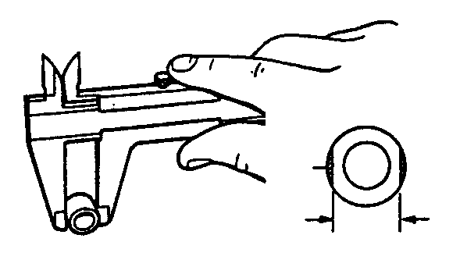
Weight minimum outside diameter
Cracks/Wear /Scaling /Chipping → Replace.
Out of specification → Replace.
 |  |  | Weight out side diameter:
 |  |  | 20.0 mm
<Limit:19mm>

3.8.7 SECOMDARY SHEAVE INSPECTION
1. Inspect:
Secondary fixed sheave smooth operation
Secondary sliding sheave smooth operation
 |  |  |  | 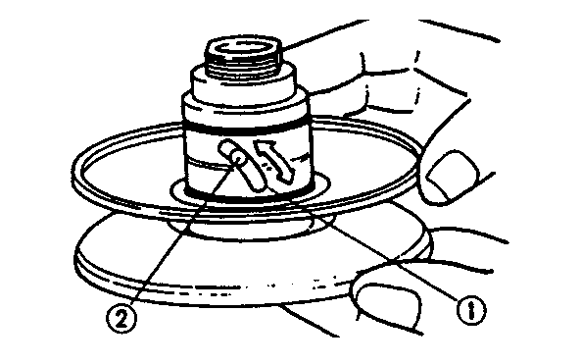
2. Inspect:
Torque cam groove
Wear /Damage → Replace.
3. Inspect:
Guide pin
Wear /Damage → Replace.

3.8.8 PRIMARY SHEAVE ASSEMEBLY
1. Clean: |  |  |  | 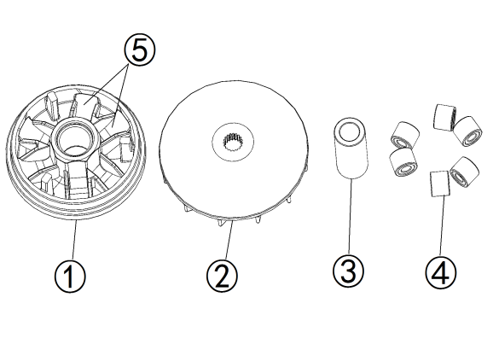
Primary sliding sheave face ①
Primary fixed sheave face ②
Collar ③
Weight ④
Primary sliding sheave cam face ⑤
2. Install: |  |  |  | 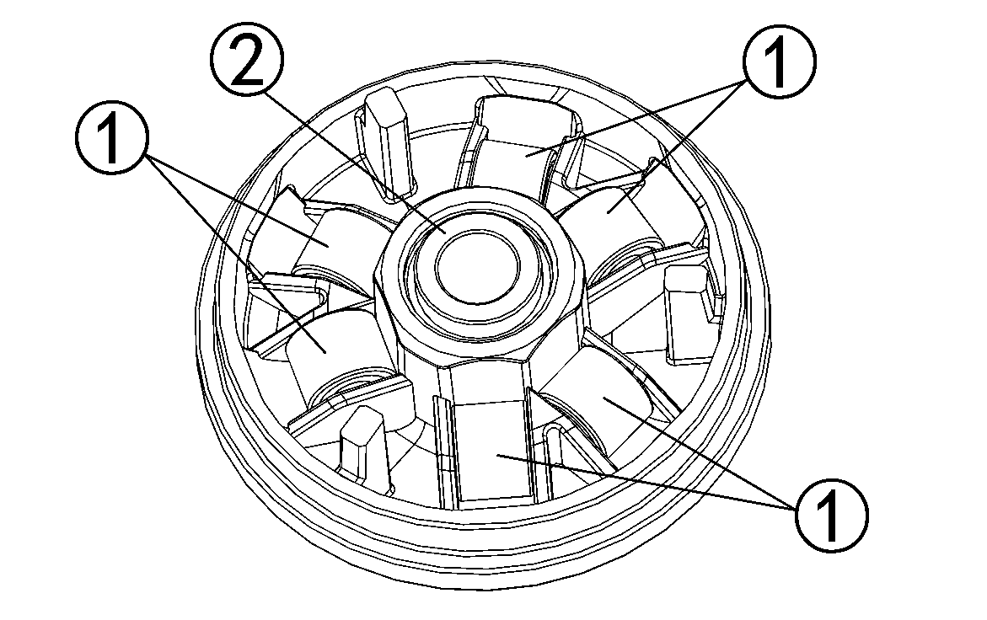
Weight ①
Collar ②
3. Install: |  |  |  | 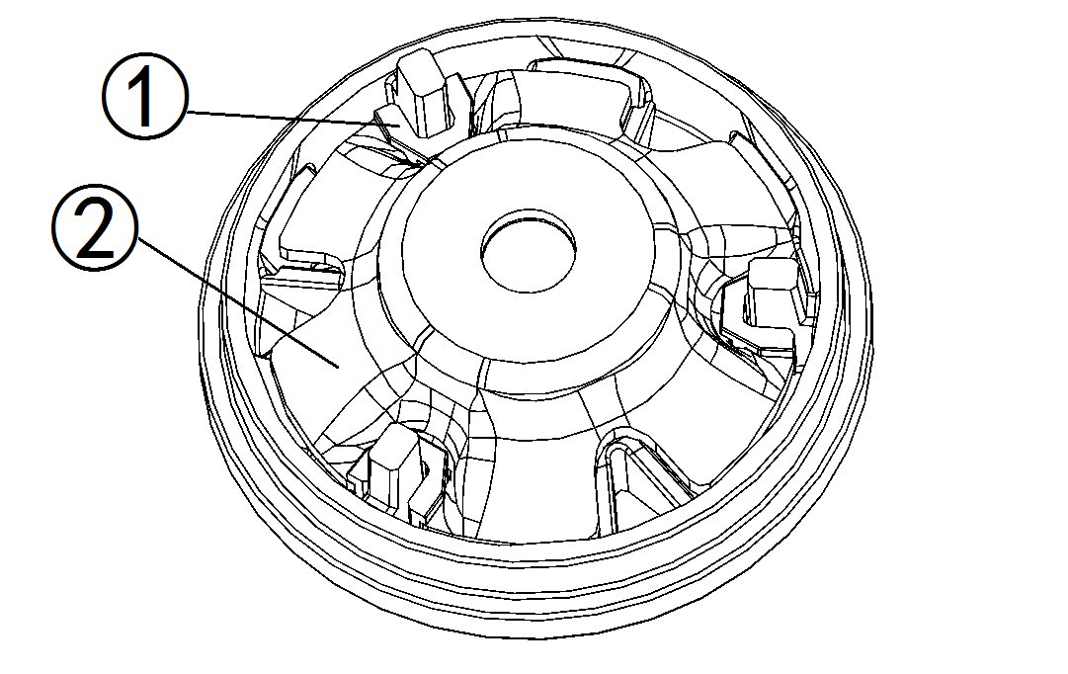
Slider ①
Cam ②

3.8.9 SECOMDARY SHEAVE INSTALLATION
1. Apply: |  |  |  | 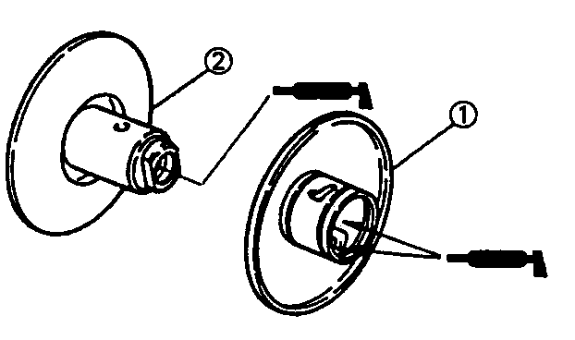
Lightweight lithium-soap base grease
(to the secondary sliding sheave inner surface, grease nipple groove, and oil seals)
Lightweight lithium-soap base grease
(to the bearings, oil seals and inner surface of
the secondary fixed sheave )
2. Install: |  |  |  | 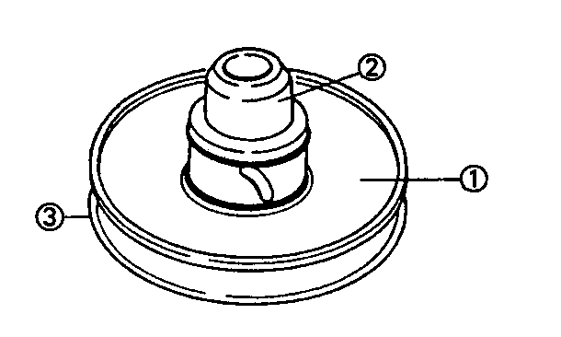
Secondary sliding sheave ①
NOTE:
Install the secondary sliding sheave ①using the oil seal guide to the secondary fixed sheave③.
3. Install: |  |  |  | 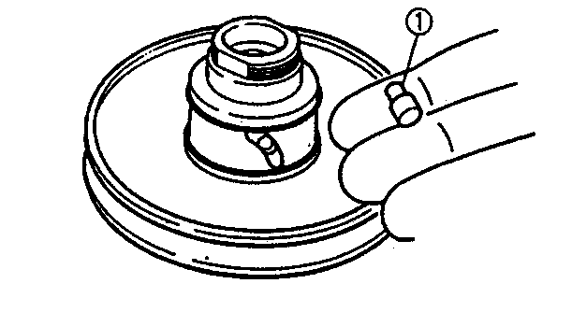
Guide pin
4. Apply: |  |  |  | 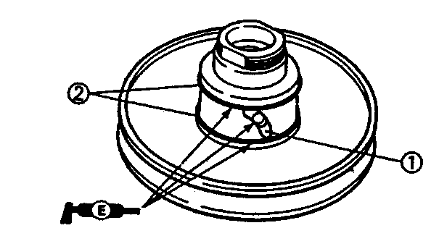
Lightweight lithium-soap base grease
(to the guide pin sliding groove ①, and oil seal ②NEW）
5. Install: |  |  |  | 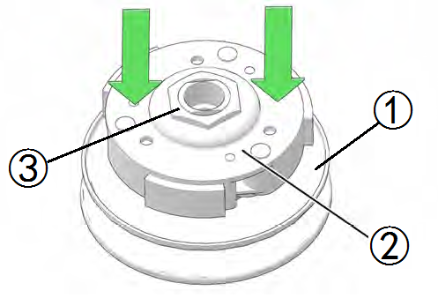
Secondary sheave complete ①
Compression spring
Clutch carrier ②
6. Tighten:
Nut ③
NOTE:
Have an assistant available for final assembly. Install spring. Place centrifugal hub over the spring and compress assembly together with both hands, aligning flats of hub with flats on threaded shaft. With assembly compressed and threads exposed, have assistant thread a new nut onto shaft.
7. Install:
V-belt
Clutch assembly
NOTE:
Install the V-bet with clutch assembly to the primary sheave side.
CAUTION:
Never smear grease to the V-belt, secondary sheave and clutch.
8. Install: |  |  |  | 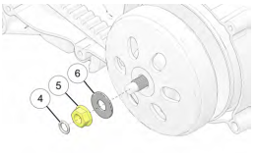
Seal
Nut
Washer
TORQUE
Driven pulley assy nut:
60N.m
9. Install:
Nut (primary sheave)
Plate washer
Primary fixed sheave
TORQUE
Driving pulley assy nut:
60N.m
NOTE:
Move the V-belt to minimum diameter of the primary sheave, maximum diameter of the secondary sheave and make the V-belt tense.

3.9 A.C. MAGNETO AND STARTER CLUTCH
A.C. MAGNETO
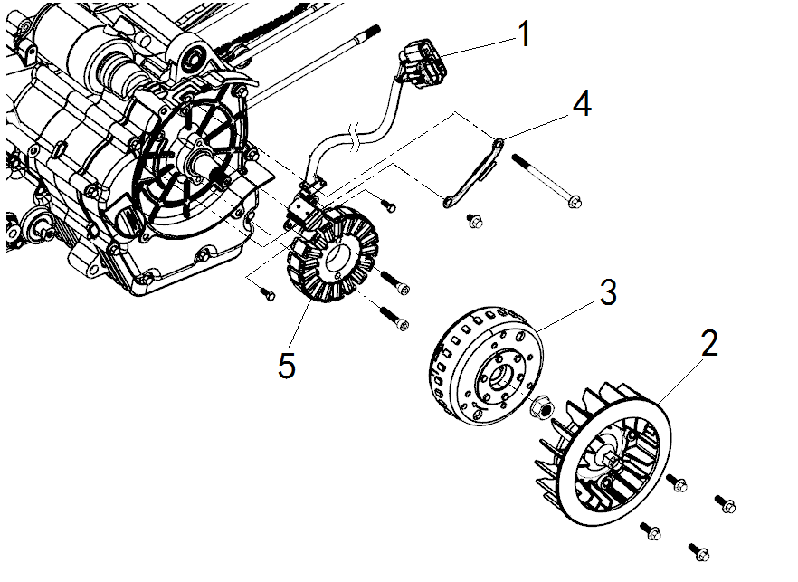
Order | Job/Parts to remove | Q’ty | Remarks
 | Cooling fan cover |  | Refer to “CYLINDER HEAD”
1 | Couplers (A.C. magneto lead) | 1 | Disconnect the couplers.
2 | Cooling fan | 1
3 | Magneto flywheel | 1
4 | Clamper (A.C. magneto cord) | 1
5 | Magneto coil | 1

STARTER CLUTCH AND STARTER MOTOR
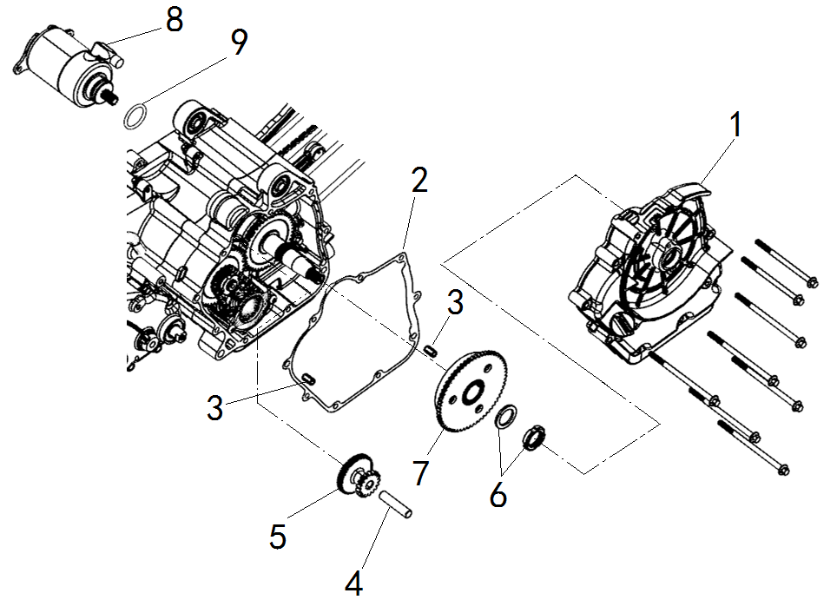
Order | Job/Parts to remove | Q’ty | Remarks
 | Engine oil |  | Disconnect.
1 | Crankcase cover (right) | 1
2 | Crankcase cover (right) gasket | 1
3 | Dowel pin | 2
4 | Shaft (idle gear) | 1
5 | Idler gear | 1
6 | Nut/Plain washer | 1
7 | Starter one way clutch assembly | 1
8 | Starter motor | 1
9 | O-ring | 1

3.9.1 A.C. MAGNETO REMOVAL
CAUTION:
Avoid damage to the flywheel or crankshaft end. Do not strike components or special tools with hammers or heavy objects.
1. Loosen: | 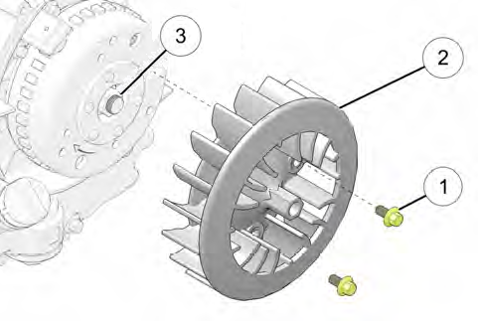
Bolts
2. Remove:
Cooling fan
3. Loosen:
Nut
4. Remove: | 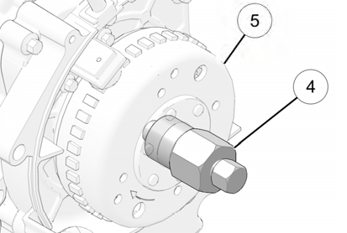
Rotor
NOTE:
Remove the rotor using the flywheel puller.
5. Loosen: | 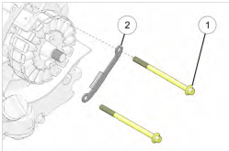
Bolt
6. Remove:
Cord clamp
7. Loosen:
Bolts
Bolts
8. Remove:
Crankshaft position sensor and stator coil
9. Check:
Stator coil
Crankshaft position sensor
Damage →Replace the crankshaft position sensor/stator assembly.

3.9.2 CRANKCASE COVER REMOVAL
1. Loosen: | 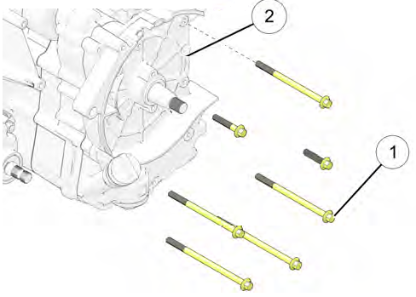
Bolts
2. Remove:
Crankcase cover
NOTE:
Pay attention to location and length of each fastener for assembly purposes.

3.9.3 STARTER DRIVE ONE-WAY CLUTCH REMOVAL AND INSPECTION
1. Remove: | 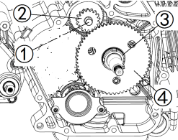
Shaft
Start drive gear
2. Inspect:
Start drive gear
Burrs /chips /roughness /wear → Replace.
3. Loosen:
Slotted nut ③
Washer
NOTE:
Remove the slotted nut ③ using the Slotted Nut Socket .
Slotted nut ③ is left-hand thread.
4. Remove:
Starter wheel gear ④
5. Inspect: | 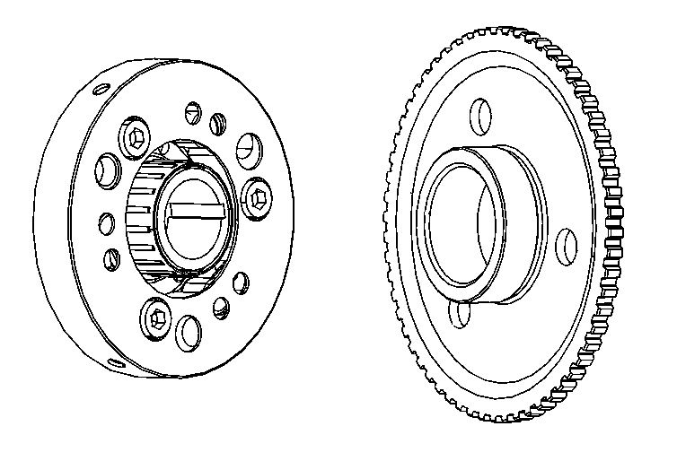
Starter wheel gear
Burrs /chips /roughness /wear → Replace.
Starter clutch gear contact surfaces
Damage /pitting /wear → Replace.
Starter clutch operation
Unsmooth operation → Replace.
NOTE:
Assembly should turn in one direction only.

3.9.4 STARTER DRIVE ONE-WAY CLUTCH INSTALLATION
1. Install:
Starter wheel gear | 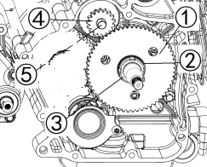
Washer
2.Tighten:
Slotted nut ③
TORQUE
Slotted nut:
95N.m
NOTE:
Install the slotted nut ③ using the Slotted Nut Socket .
Slotted nut ③ is left-hand thread.
3. Install:
Start drive gear ④
Shaft ⑤

3.9.5 CRANKCASE COVER INSTALLATION
1. Clean all the gasket mating surface and crankcase mating surface thoroughly.
2. Install:
Dowel pins
Gasket (crankcase cover) NEW
Crankcase cover
3.Tighten:
Bolts (crankcase cover)
TORQUE
Bolts(crankcase cover):
10N.m

3.9.6 A.C. MAGNETO INSTALLATION
1. Install:
Crankshaft position sensor and stator coil | 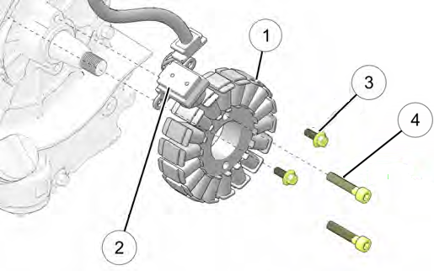
2.Tighten:
Bolts (crankshaft position sensor) ③
TORQUE
Bolts(crankshaft position sensor):
10N.m
Bolts (stator coil) ④
TORQUE
Bolts(stator coil):
10N.m
3. Install: | 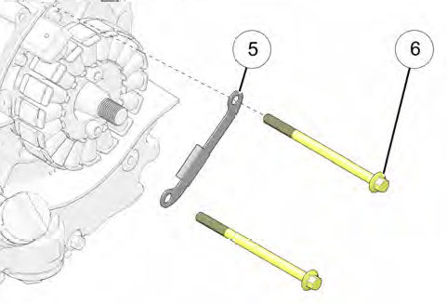
Cord clamp
4.Tighten:
Bolts (cord clamp) ⑥
TORQUE
Bolts(cord clamp):
10N.m
NOTE:
Route the wires appropriately to avoid contact with any moving parts.
Apply a small amount of Crankcase Sealant to the stator wire grommet and install into the housing cavity.
5. Install:
Rotor
6. Tighten:
Nut ②
TORQUE
Nut (rotor):
60N.m
7. Install:
Cooling fan
8. Tighten:
Bolts (cooling fan) ④
TORQUE
Bolts (cooling fan):
10N.m

3.10 OIL PUMP
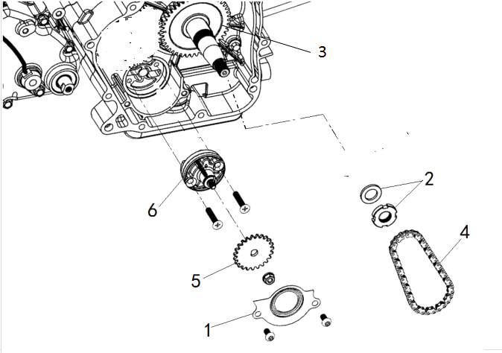
Order | Job/Parts to remove | Q’ty | Remarks
 | A.C. magneto |  | Refer to “A.C. MAGNETO AND STARTER CLUTCH”
1 | Cover | 1
2 | Nut/Plain washer | 1
3 | Overrunning Clutch | 1
4 | Chain | 1
5 | Oil pump driven sprocket | 1
6 | Oil pump | 1

3.10.1 OIL PUMP REMOVAL AND INSPECTION
1. Loosen: |  | 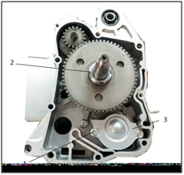
Bolts
Nut ②
2. Remove:
Oil pump cover
3. Loosen: |  | 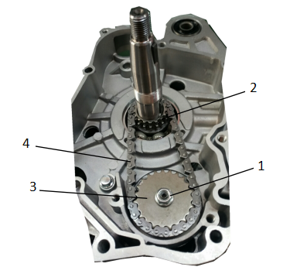
Nut
4. Remove:
Oil pump drive sprocket ②
Oil pump driven sprocket
Oil Pump chain ④
5. Inspect:
Oil pump drive sprocket
Oil pump driven sprocket
Wear/ Damage → Replace. |  | 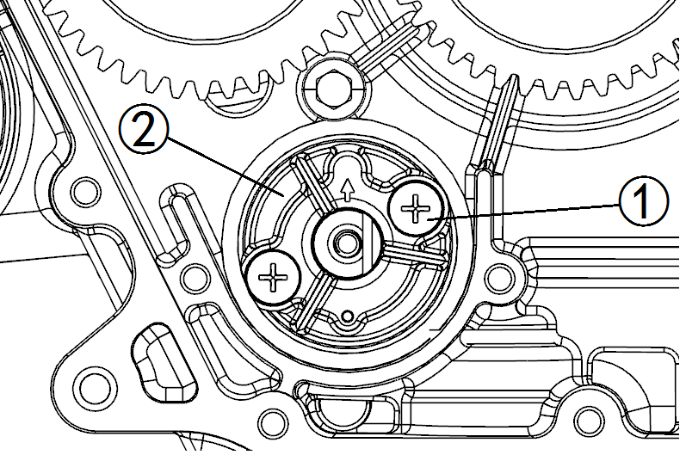
6. Loosen:
Bolts
7. Remove:
Oil pump ②
8. Inspect:
Oil pump housing
Cracks/damage/wear → Replace.
9. Measure:
Inner-rotor-to-outer-rotor-tip clearance “a”
Outer-rotor-to-oil-pump-housing clearance “b”
Oil-pump-housing-to-inner-rotor-and-outerrotor clearance “c”
Out of specification → Replace the oil pump.
 | Tip clearance “a” : |  |  |  | 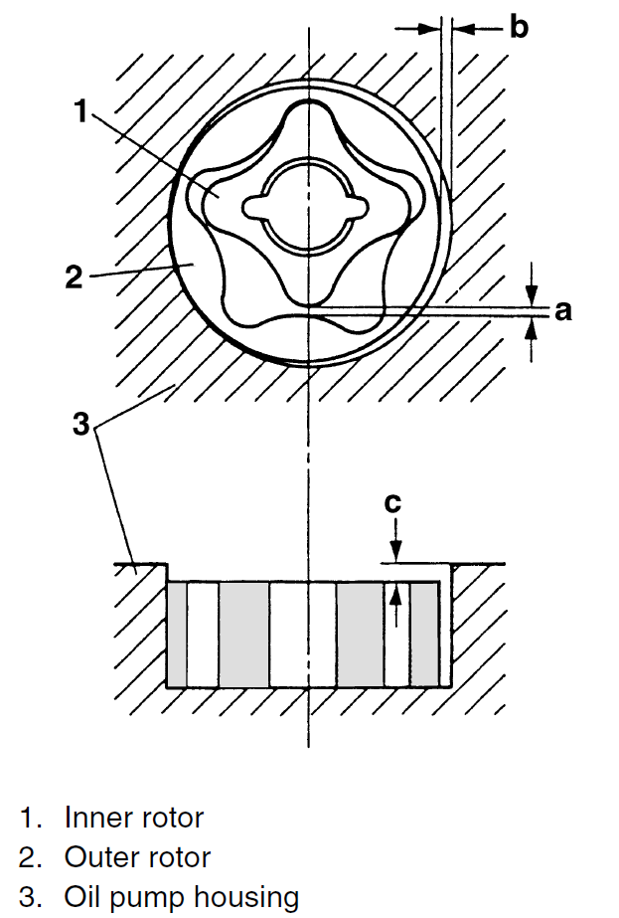
 | 0.15-0.20 mm
<Limit: 0.23mm>
Side clearance “b” :
0.15-0.22 mm
<Limit:0.26mm>
Housing and rotor clearance “c” :
0.05-0.12 mm
<Limit: 0.14mm>

3.10.2 OIL PUMP INSTALLATION
1. Install: |  |  |  |  | 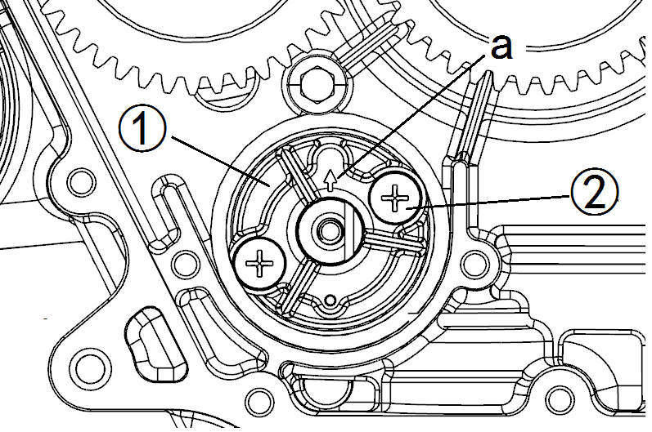
Oil pump
NOTE:
Install a new pump with the oil galley "a" pointed up as shown.
2. Tighten:
Bolts ②
TORQUE
Oil pump bolts:  10N.m |  |  |  |  | 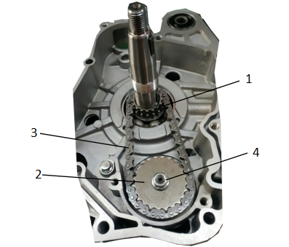
3. Install:
Oil pump drive sprocket
Oil pump driven sprocket ②
Oil Pump chain
4. Tighten:
Nut ④
TORQUE
Oil pump driven sprocket nut:
10N.m
5. Install: |  |  |  |  | 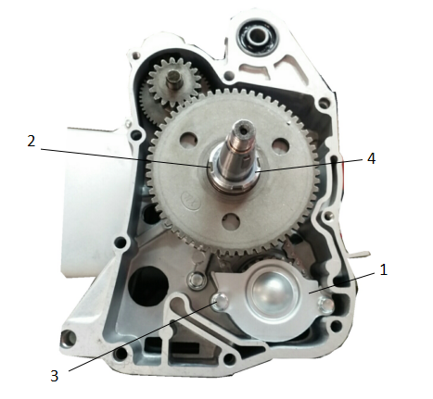
Oil pump cover
Washer ②
6. Tighten:
Bolts
TORQUE
Oil pump cover bolts:
10N.m
Nut ④
TORQUE
Oil pump drive sprocket nut:
65N.m

3.11 CRANKCASE AND CRANKSHAFT
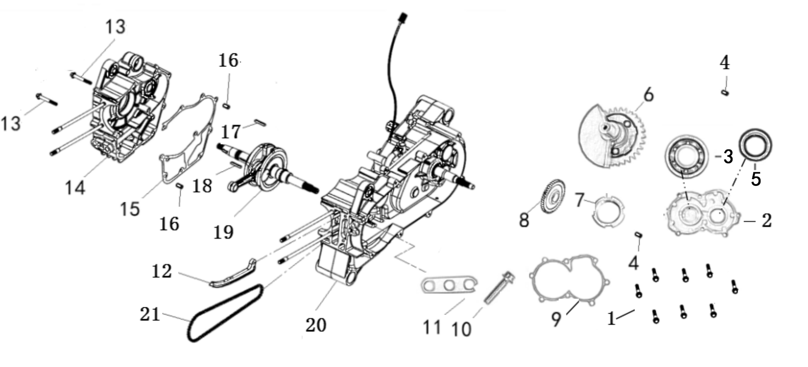
Order | Job/Parts to remove |  | Q’ty | Remarks
 | Engine removal |  |  | Refer to "ENGINE REMOVAL".
 | Cylinder head |  |  | Refer to "CYLINDER HEAD"
 | Cylinder, and piston |  |  | Refer to "CYLINDER AND PISTION"
 | V-belt, clutch, secondary/ primary sheave |  |  | Refer to "V-BELT, CLUTCH AND SECONDARY/ PRIMARY SHEAVE"
 | A.C. magneto and starter clutch |  |  | Refer to "A.C. MAGNETO AND STARTER CLUTCH"
 | Oil pump |  |  | Refer to "OIL PUMP"
1 | Bolt |  | 8
2 | Small cap for balancing shaft |  | 1
3 | Balance left bearing |  | 1
4 | Dowel pin |  | 2
5 | Oil seal |  | 1
6 | Balance shaft Assembly |  | 1
7 | Nut |  | 1
8 | Balance drive gear |  | 1
9 | Balance Shaft Small Cover gasket |  | 1
Order |  | Job/Parts to remove | Q’ty |  | Remarks
10 |  | Bolt
11 |  | Pressure Plate | 1
12 |  | Timing chain guide (intake) | 1
13 |  | Bolt | 2
14 |  | Crankcase (right) | 1
15 |  | Crankcase (right) gasket | 1
16 |  | Dowel pin | 2
17 |  | Flat key | 1
18 |  | Flat key | 1
19 |  | Crankshaft assembly | 1
20 |  | Crankcase (left) | 1
21 |  | Timing chain | 1

3.11.1 CRANKSHAFT&BALANCER REMOVAL
1. Remove: |  |  | 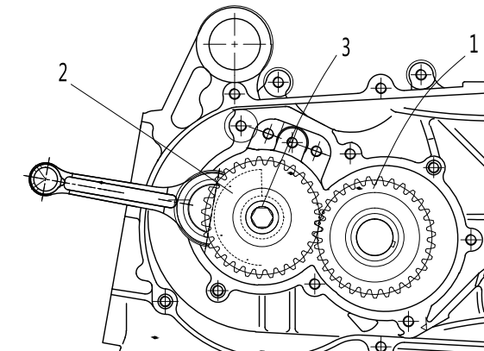
NUT ③
Balancer drive gear②
Balancer shaft ①
2.Loosen: |  |  | 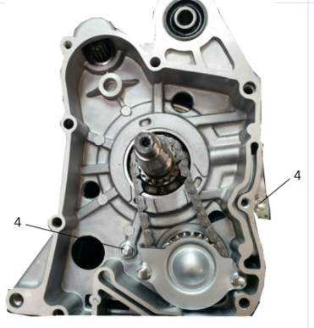
Bolts ④
3. Remove:
Crankcase RH
Crankshaft assembly
Balancer |  |  | 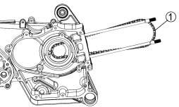
Timing chain ①
NOTE:
Before removing the crankshaft assembly, remove the timing chain from the crankshaft sprocket.
If the timing chain hooks to the crankshaft sprocket, the crankshaft cannot be removed.

3.11.2 CRANKSHAFT INSPECTION
1. Measure:
Crankshaft runout |  |  | 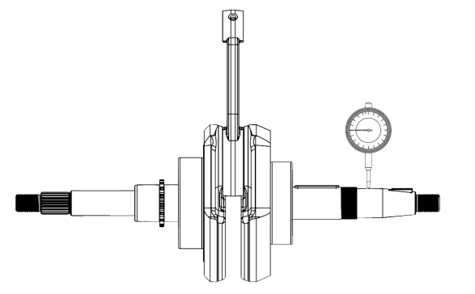
Out of specification → Replace crankshaft and/ or bearing.
NOTE:
Measure the crankshaft runout with the crankshaft assembly running slowly.
 |  | Runout limit:
 |  | 0.04 mm
2. Measure: |  |  | 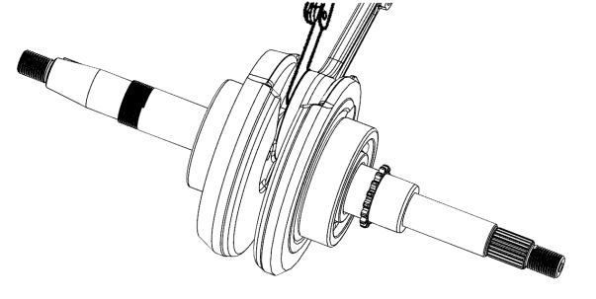
Big end side clearance
Out of specification → Replace big end bearing, crank pin and/or connecting rod.
 |  | Big end side clearance:
 |  | 0.10-0.35mm
3. Measure: |  |  | 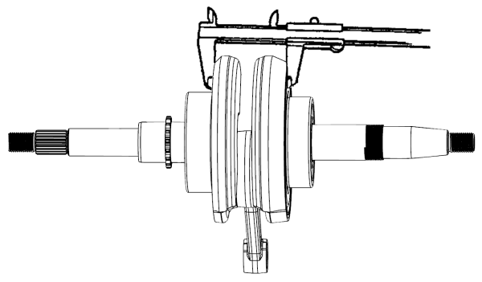
Crank width
Out of specification → Replace crankshaft.
 | Crank width:
 | 45.05-45.15mm
4. Inspect: |  |  | 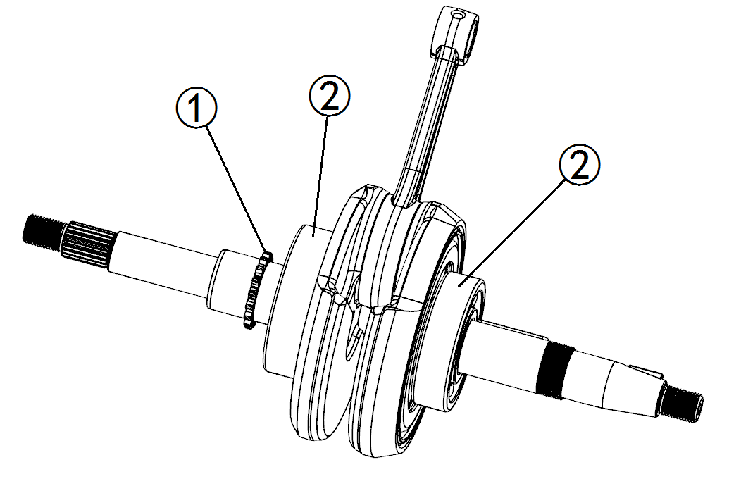
Crankshaft sprocket
Wear/ Damage → Replace crankshaft.
Bearing
Wear/ Crack /Damage → Replace crankshaft.

3.11.3 CRANKCASE INSTALLATION
1. Clean all the gasket mating surface and crankcase mating surface thoroughly. |  |  | 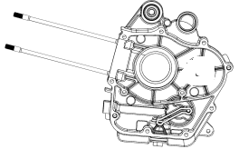
2. Install:
Dowel pins
Timing chain
NOTE:
Install the timing chain not to be seen through the crankshaft hole on the crankcase (left). |  |  | 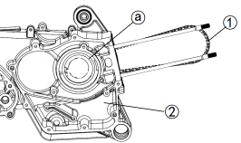
3. Install:
Crankshaft assembly
Balancer
Gasket (crankcase) NEW
Crankcase RH
4. Tighten:
Bolts (Crankcase RH)
TORQUE
Crankcase RH Bolts:
10N.m
5. Install: |  |  | 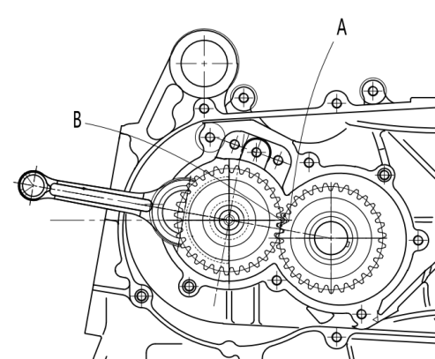
Balancer drive gear
nut
Balancer shaft
NOTE:
Align the punch mark “a” on the balancer drive gear with the punch mark “b” on the balancer driven gear.
TORQUE
Nut:
65N.m

3.12 TRANSMISSION
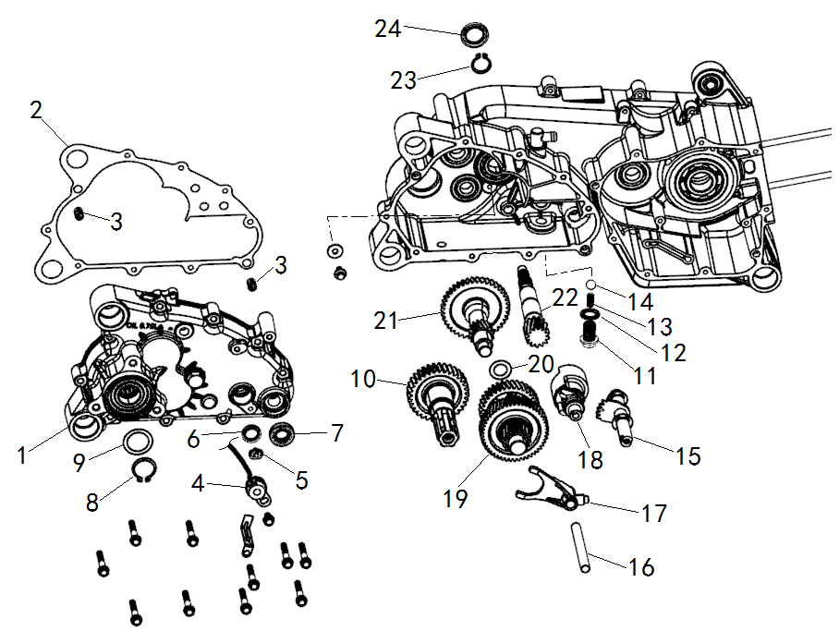
Order | Job/Parts to remove | Q’ty | Remarks
 | Engine removal |  | Refer to "ENGINE REMOVAL".
1 | Transmission cover | 1
2 | Transmission cover gasket | 1
3 | Dowel pin | 2
4 | Shift indicator cable | 1
5 | Shift indicator contact | 1
6 | Oil seal | 1
7 | Oil seal | 1
8 | Circlip | 1
9 | Washer | 1
10 | Output shaft assembly | 1
11 | Bolt | 1
12 | Washer | 1
13 | Positioning spring | 1
14 | Steel ball | 1
15 | Transmission shaft assembly | 1

Order | Job/Parts to remove | Q’ty | Remarks
16 | Shift fork shaft | 1
17 | Shift fork | 1
18 | Gearshift drum | 1
19 | Gearshift shaft assembly | 1
20 | Washer | 1
21 | Reverse gear shaft assembly | 1
22 | Drive shaft | 1
23 | Circlip | 1
24 | Oil seal | 1

GEARSHIFT SHAFT ASSEMBLY
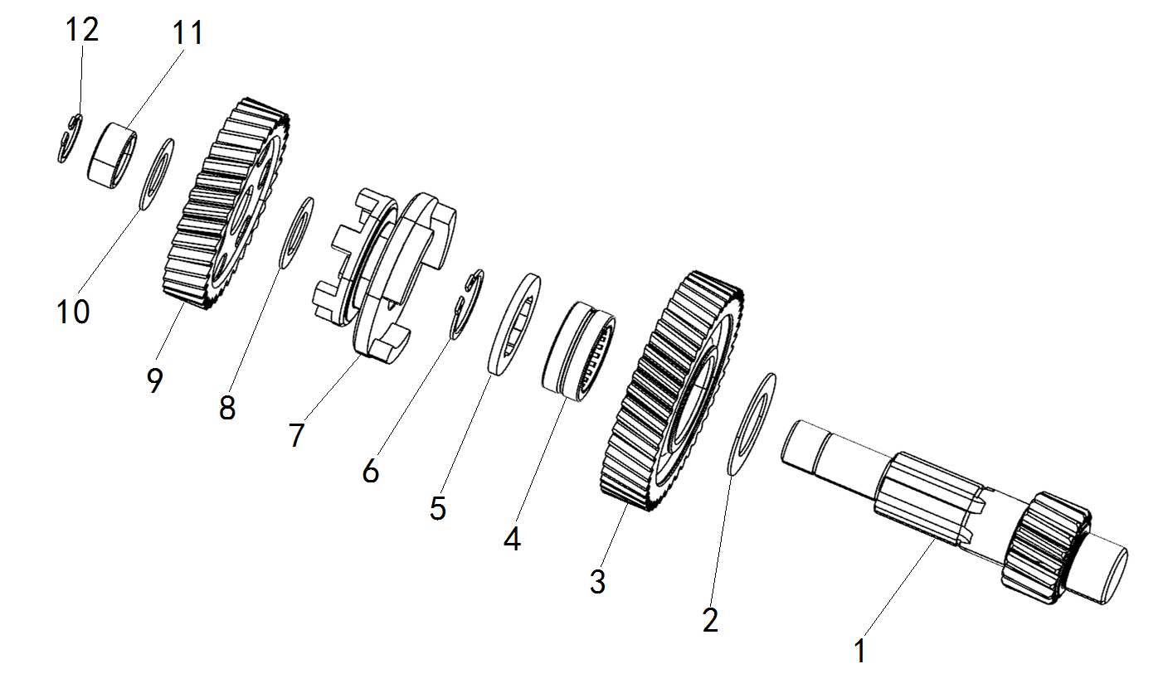
Order | Job/Parts to remove | Q’ty | Remarks
 | Transmission removal
1 | Main shaft | 1
2 | Washer | 1
3 | Gear | 1
4 | Bearing | 1
5 | Splined washer | 1
6 | Circlip | 1
7 | Sliding dog gear | 1
8 | Washer | 1
9 | Gear | 1
10 | Washer | 1
11 | Shaft collar | 1
12 | Circlip | 1

3.12.1 TRANSMISSION DISASSEMBLY AND INSPECTION
1. Remove: | 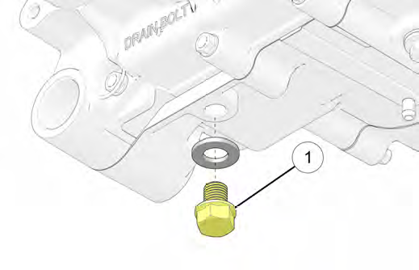
Drain plug ①
Washer
2. Drain
Transmission oil
3. Loosen: | 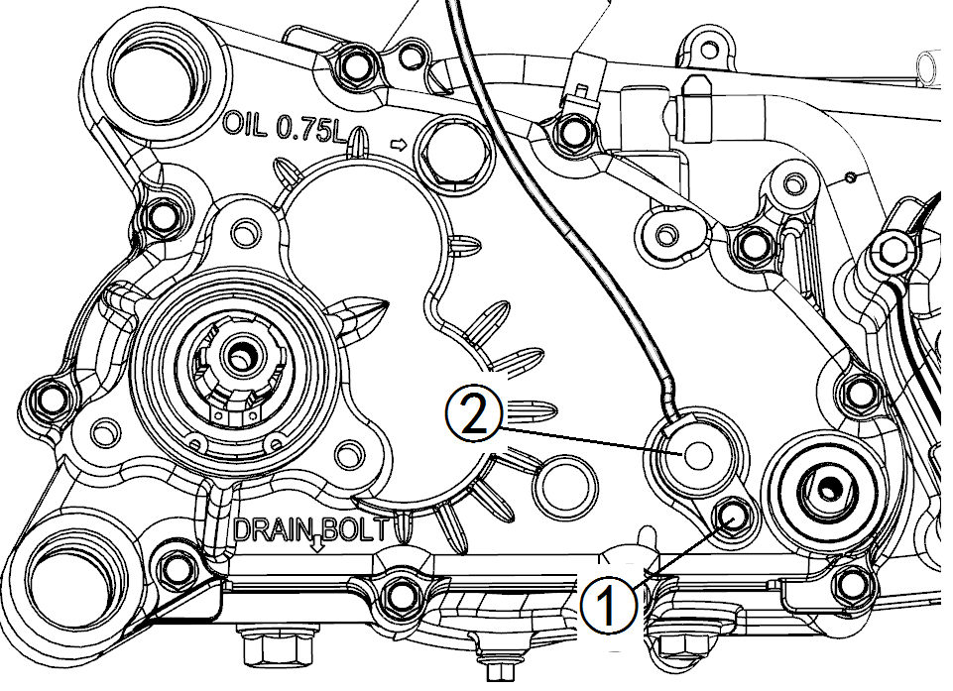
Bolt ①
4. Remove:
Shift indicator cable ②
Shift indicator contact ③
5. Loosen: | 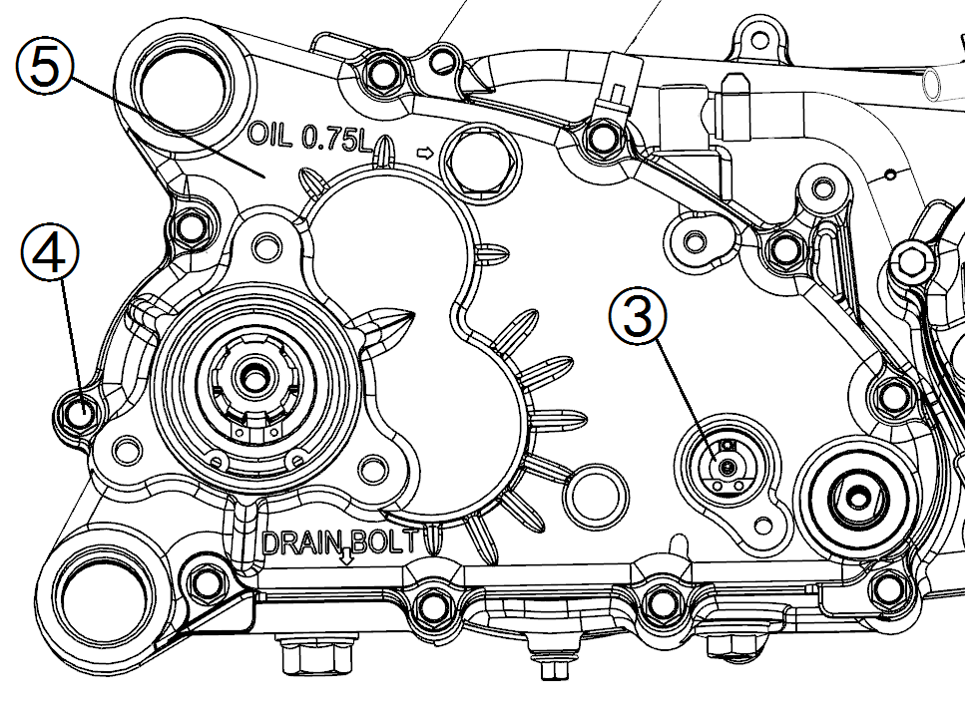
Bolts ④
6. Remove:
Transmission cover assembly ⑤
7. Remove: | 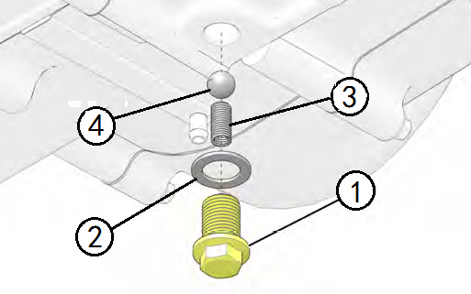
Detent bolt ①
Washer ②
Spring ③
Ball ④
8. Remove: | 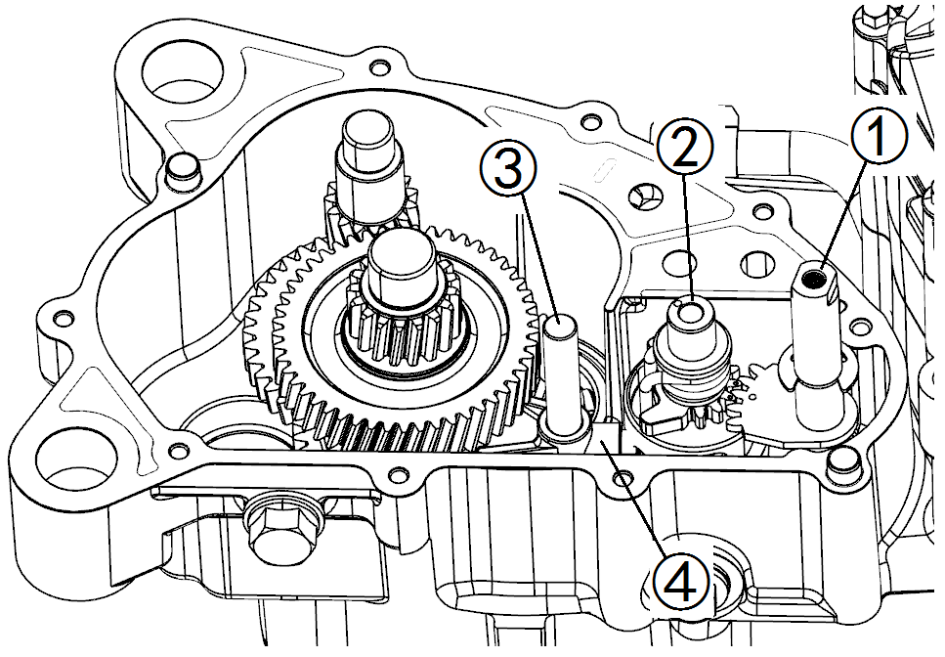
Shift lever shaft ①
Shift drum ②
Shift fork guide bar ③
Shift fork ④
9. Inspect: | 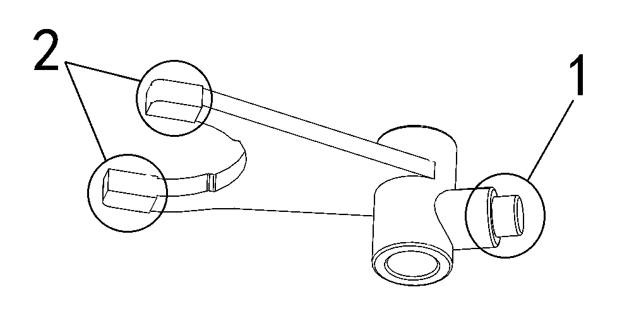
Shift fork cam follower “1”
Shift fork pawl “2”
Bends/damage/scoring/wear → Replace the shift fork.
10. Inspect: | 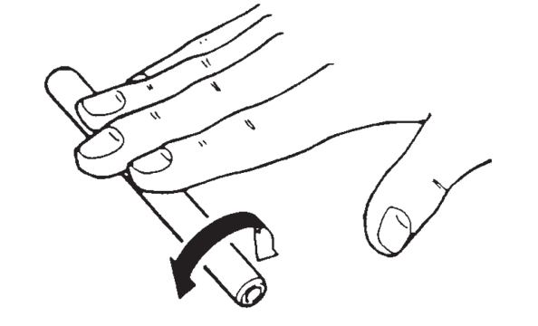
Shift fork guide bar
Roll the shift fork guide bar on a flat surface.
Bends → Replace.
WARNING :
Do not attempt to straighten a bent shift fork guide bar.
 | 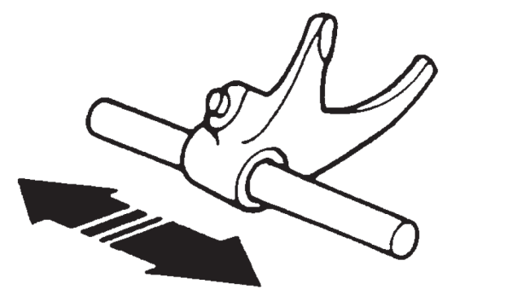
11. Inspect:
Shift fork movement
(along the shift fork guide bar)
Rough movement → Replace the shift forks and shift fork guide bar as a set.
12. Inspect: | 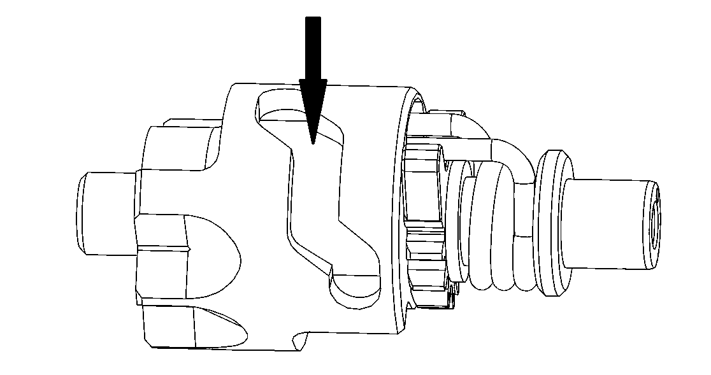
Shift drum grooves
Damage /scratches /wear → Replace the shift drum.
13. Remove: | 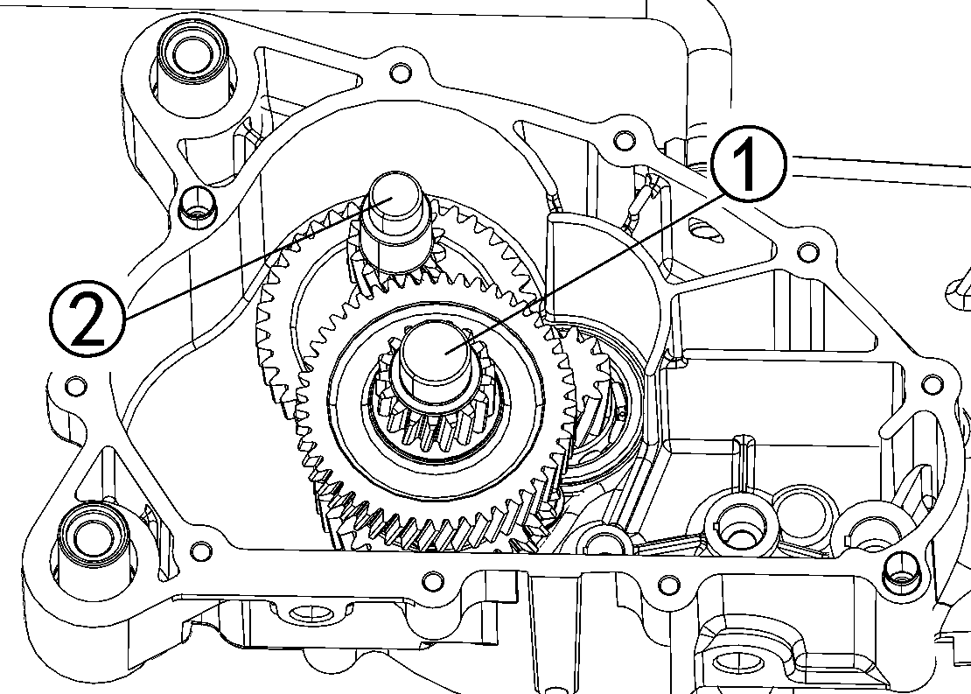
Gearshift shaft assembly ①
Washer
Reverse gear shaft ②
14. Loosen: | 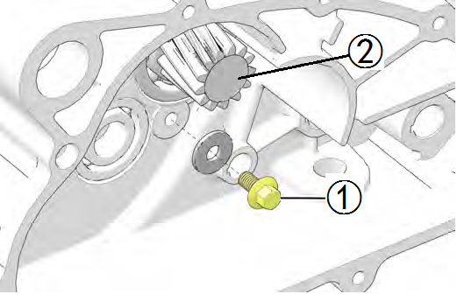
Bolt ①
15. Remove:
Drive shaft ②
16. Remove: | 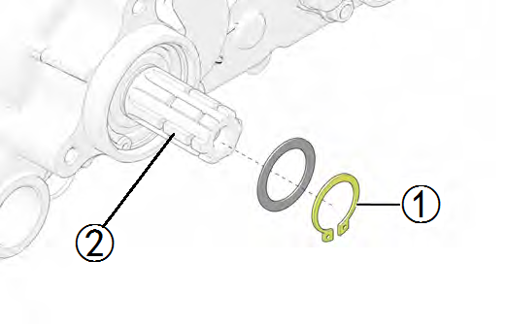
Circlip ①
Output shaft ②
17. Inspect:
Transmission gears
Blue discoloration /pitting /wear → Replace the defective gear(s).
Transmission gear engagement
(each pinion gear to its respective wheel gear)
Incorrect → Reassemble the transmission axle assemblies.
Transmission gear movement | 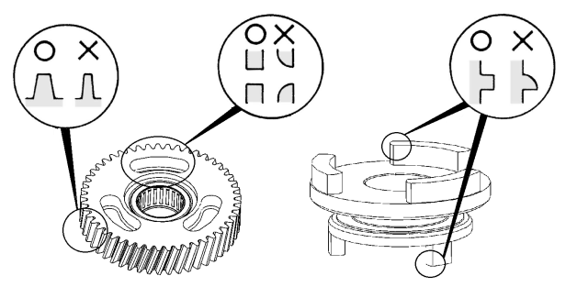
Rough movement → Replace the defective part(s).
Transmission gear dogs
Cracks /damage /rounded edges → Replace the defective gear(s).
Circlips
Bends/damage/looseness → Replace.
18. Inspect:
Bearings
Wear/ Crack /Damage → Replace.
NOTE:
All bearings should rotate freely without binding. Bearing inner race should have no detectable radial (up and down) movement of inner race.

3.12.2 TRANSMISSION INSTALLATION
1. Clean all the gasket mating surface and transmission mating surface thoroughly. | 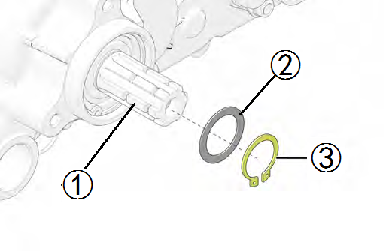
2. Install:
Output shaft ①
Washer ②
Circlip ③
3. Install: | 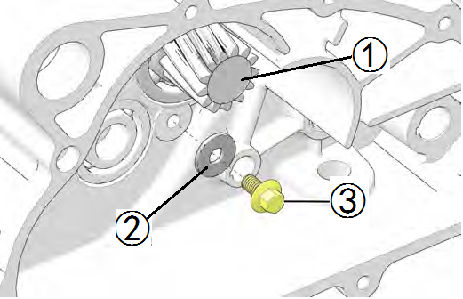
Drive shaft ①
Washer ②
4.Tighten:
Bolt ③
TORQUE
Drive shaft bolt:
10N.m
5. Install: | 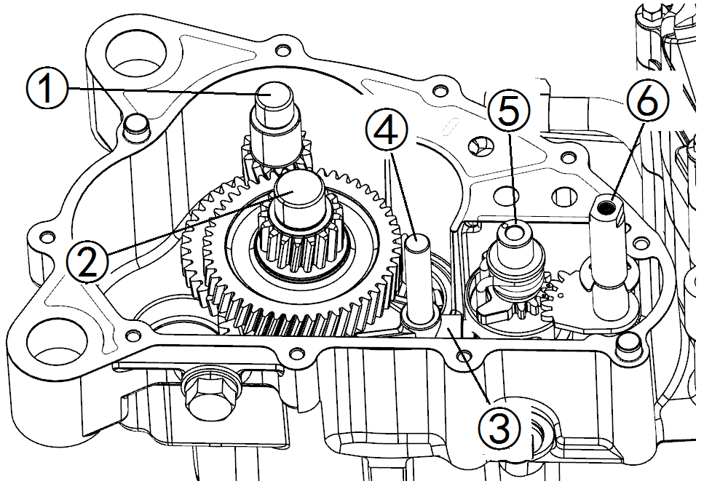
Reverse gear shaft ①
Washer (gearshift shaft)
Gearshift shaft assembly ②
Shift fork ③
Shift fork guide bar ④
Shift drum ⑤
Shift lever shaft ⑥
NOTE: | 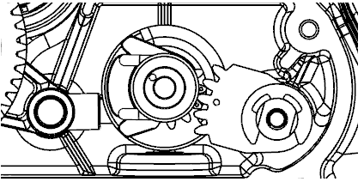
Use the alignment marks on the shift shaft and drum to achieve proper alignment.
6. Install: | 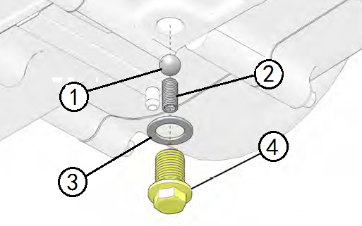
Ball ①
Spring ②
Washer ③
Detent bolt ④
TORQUE
Detent bolt:
19N.m
7. Install: | 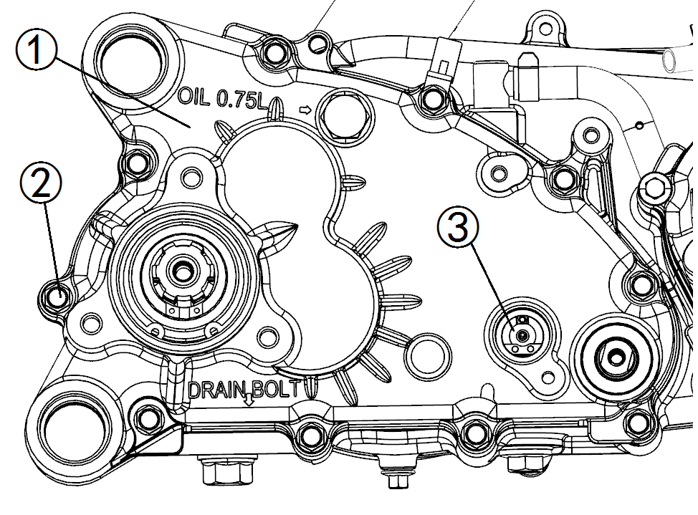
Dowel pins
Gasket (transmission cover) NEW
Transmission cover assembly ①
8. Tighten:
Bolts ②
TORQUE
transmission cover bolts:
10N.m
9. Install: | 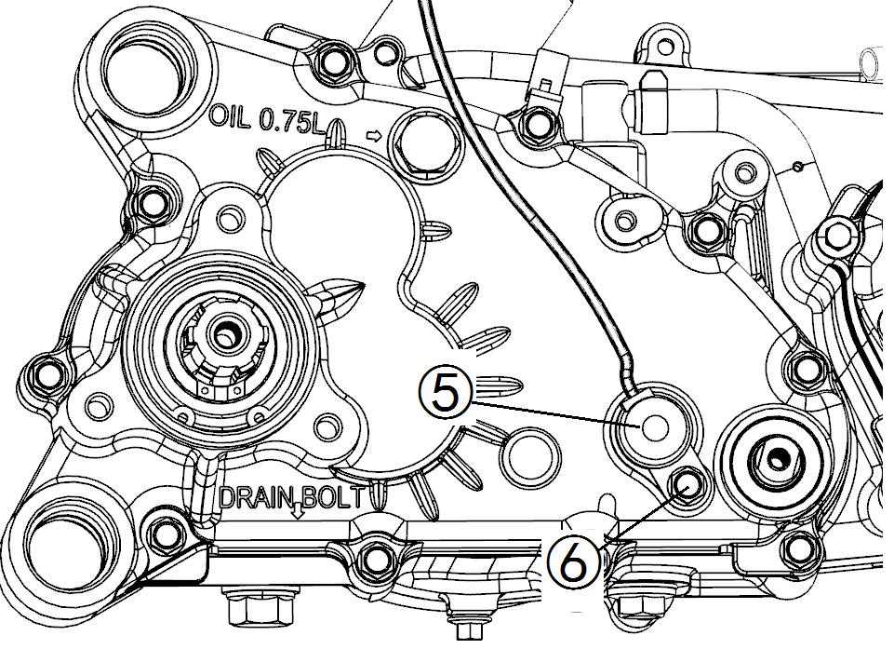
Shift indicator contact ③
Shift indicator cable ④
10. Tighten:
Bolt ⑤
TORQUE
Shift indicator cable bolt:
10N.m
11. Install:
Washer
Drain plug ①
TORQUE
Drain plug:
25N.m
12. Add:
Transmission oil
Refer to “3.2.9TRANSMISSION OIL CHANGE” section.

3.13 OIL COOLER

3.13.1 OIL COOLER REMOVAL
1.Position vehicle on a level surface and apply the parking brake. | 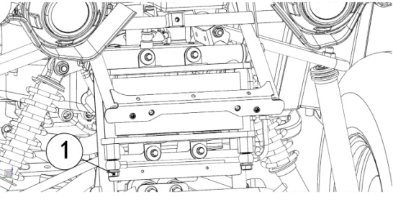
2.Place a drain pan beneath the oil line connections.
3.Remove the banjo bolt ① and two crush washers securing the oil supply or return hose to the oil cooler.
4.Remove the banjo bolt ② and two crush washers securing the oil supply or return hose to the engine. | 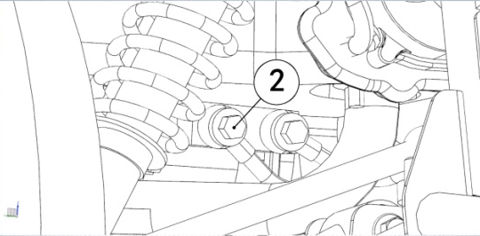
CAUTION:
Wipe up any residual oil that may have collected on any vehicle components.
5.Remove the oil supply or return hose from the vehicle.
NOTE:
Note the orientation of the oil line fittings and oil line routing during removal.

3.13.2 OIL COOLER INSTALLATION
1.Install the bolts ① and ② retaining the oil cooler to the vehicle. | 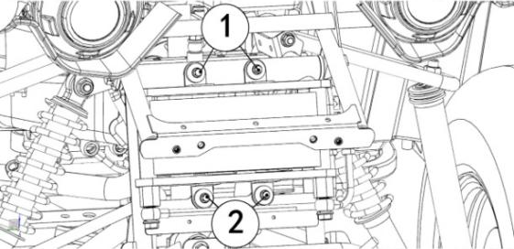
2.Carefully install new oil supply or return hose into vehicle.
CAUTION:
The oil return line fittings ③ will attach to the left engine port when viewed head on and the rear port on the engine cooler. | 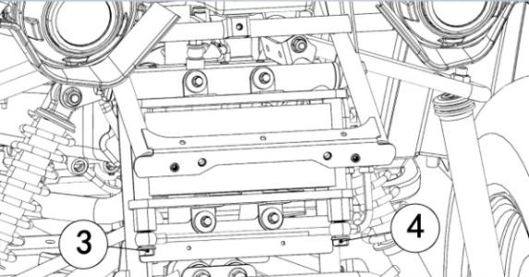
The oil supply line fittings ④will attach to the right engine port when viewed head on and the front port on the engine cooler.
 | 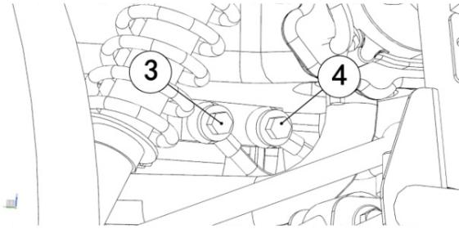
3.Install two new crush washers and banjo bolt to secure the oil supply or return hose to the oil cooler.
Torque banjo bolt to specification.
TORQUE
Oil Hose Banjo Bolt:
39N.m
4.Install two new crush washers and banjo bolt to secure the oil supply or return hose to the engine.
Torque banjo bolt to specification.
TORQUE
Oil Hose Banjo Bolt:
39N.m
5.Start engine and allow it to idle for 30 seconds.
6.Stop the engine and inspect for oil leaks. Wait at least 15 seconds before removing the oil dipstick.
7.Remove the dipstick and wipe it dry with a clean cloth.
8.Reinstall the dipstick to fully seat it.
CAUTION:
Make certain the dipstick is inserted all the way down to ensure an accurate reading.
9.Remove the dipstick and check the oil level.
10.Add the recommended oil as necessary to bring the oil level within.
CAUTION:
Over-filling engine crankcase will result in oil entering the air box. Maintain the recommended oil level.
NOTE:
Rising oil level between checks in cool weather driving, can indicate moisture collecting in the oil reservoir. If the oil level is over the full mark, change the oil.
11.When finished, reinstall the dipstick.

3.14 EXHAUST

3.14.1 EXHAUST REMOVAL
1.Remove the bolt ①. | 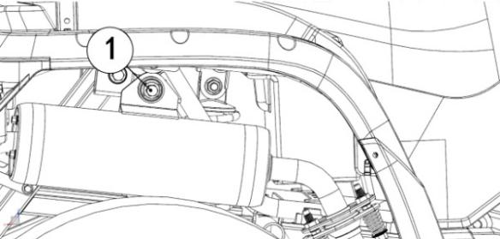
2.Remove the nuts ② retaining the exhaust to the engine. | 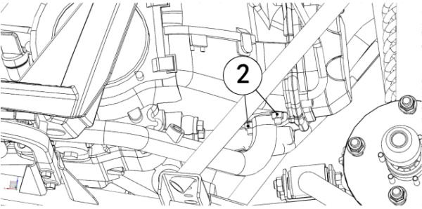

3.14.2 EXHAUST INSTALLATION
1.Install nuts ①retaining the exhaust to the engine. Torque to specification. | 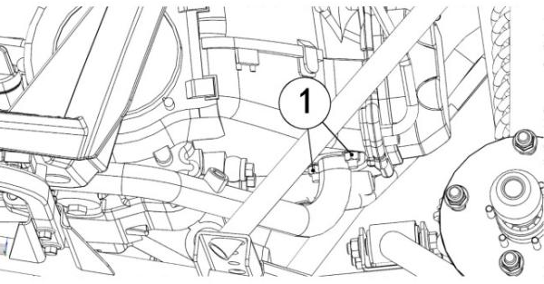
TORQUE
Exhaust Nuts:
13N.m
2.Install the bolts ②. | 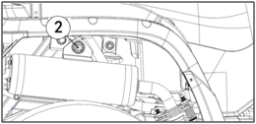
Torque fastener to specification.
TORQUE
Exhaust Mounting Fastener:
40-50N.m

3.15 AIR BOX / INTAKE SYSTEM
CAUTION:
Make sure the air box cover is properly seated upon installation or severe engine damage could occur.

3.15.1 AIR BOX REMOVAL
1.Remove the side plate ①. | 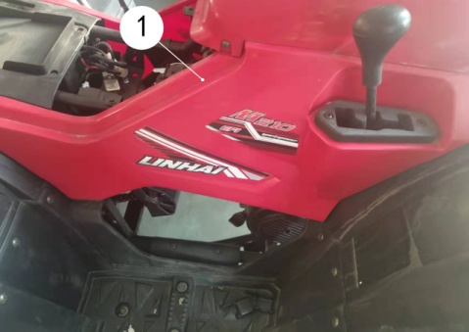
2.Loosen the gear clamp ②. | 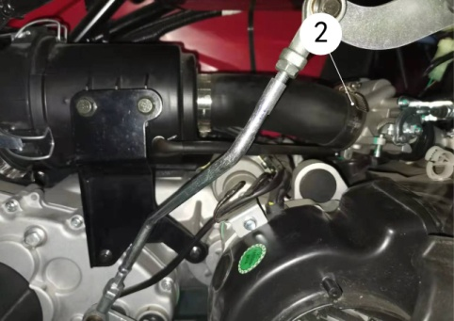
3.Remove fasteners ③ ④ ,then remove the plate ⑤ | 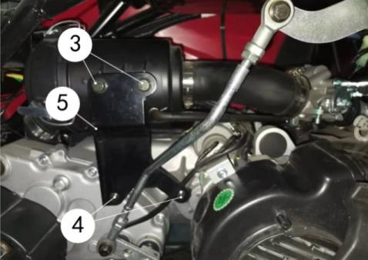
4.Carefully remove the air box from the vehicle.

3.15.2 AIR BOX INSTALLATION
1.Install the air box assembly back onto the vehicle , Install the gear clamp ① and tighten to specification. | 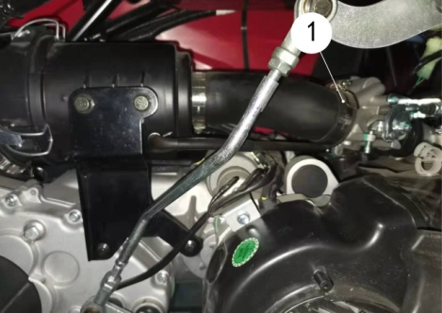
TORQUE
Gear Clamp:
8N.m
2.Install the plate ② and the fasteners ③ ④ that secure the air box to the engine. Torque fasteners to specification. | 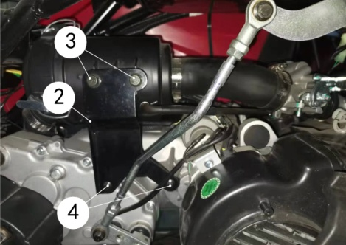
TORQUE
Air Box Fasteners:
15N.m
3.Install the side plate ⑤. | 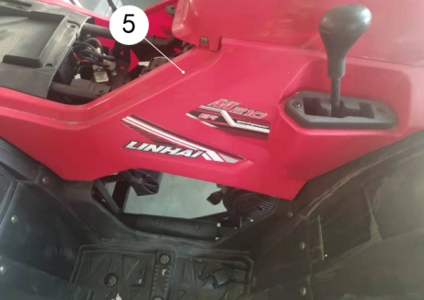

3.16 FUEL INJECTION SYSTEM

3.16.1 ECU

3.16.1.1 Description & Working Principle
The ECU continuously monitors the operating conditions of the engine through the system sensors. It also provides the necessary computation, adaptability, and output control in order to minimize the tailpipe emissions and fuel consumption, while optimizing vehicle drivability for all operating conditions. The ECU also provides diagnosis when system malfunctions occur.

3.16.1.2 Appearance
The SE08 ECU has a polyester header. The ECU is shown below. | 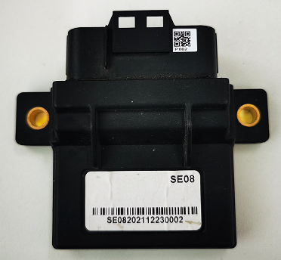

3.16.1.3 Handling –Don’ts & Do’s
ACTION | REASON
DO NOT: Place the ECU close to the exhaust pipe or Engine when removed. | High temperature might reduce the life of the ECU and also can damage the ECU.
DO NOT: Place the ECU close to or pour water, oil or any other liquids. | ECU is susceptible to water and liquids.
DO NOT: Allow mud or other debris to accumulate on the surface of the ECU. | Having mud or debris accumulated on the ECU casing reduces its heat dissipation efficiency.
DO NOT: Apply any voltage relative to any point to the ECU. | Drastically affects the performance of the ECU and may lead to ECU damage.
DO NOT: Clean ECU with any solvent or any corrosive liquid. | Can damage the housing of the ECU.
DO: Take extreme care that water droplets or excess moisture should not fall on ECU connectors. | ECU connectors can get short and may lead to ECU damage.
DO: Clean the ECU with a moist cloth and keep it dry. | Prevents ECU damage.

3.16.1.4 Installation requirements
The ECU shall be mounted using M6 machined screws with a torque of 8 Nm ±10%. The mounting surface should also be flat to avoid subjecting the base plate to unnecessary force and warping the PCB.

3.16.1.5 Power Requirements
●Operating Range: All planned functions are executed in this range. Battery and/or Ignition voltage: 9.0 to 16V DC. However, when the battery voltage is lower than 12.6 volts, the engine’s start speed may be low. Then, you should charger the battery with the charge.
●Reverse Voltage: The controller may suffer permanent damage: Battery and/or Ignition voltage < -13V DC

3.16.1.6 Operating Temperature
The controller shall operate in the ambient temperature from -20 ℃ to +85 ℃.

3.16.1.7 Maintenance service and Repair
ECU is a non-serviceable part. Once there are problems, it’s important to first determine if the problem is caused by software/calibration. If it is caused by software/calibration, please reflash the ECU by professional tools. In the event of ECU hardware failure or malfunction (during warranty period only) the ECU should be sent back to the vehicle manufacturer giving complete details of the ECU Part No, Serial number, Vehicle Model & Make, manufacturing Date, Total kms run on the vehicle, Location of use, Vehicle No, Date of return.
 | 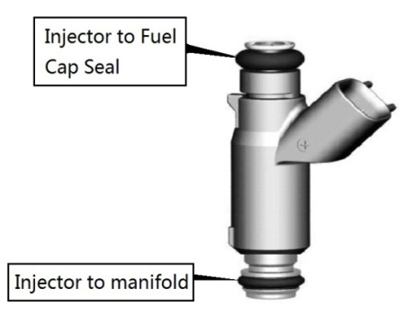

3.16.2 INJECTOR

3.16.2.1 Appearance
The figure below shows the standard MEV14-182 Fuel Injector appearance.

3.16.2.2 Temperature Requirements :
Typical injector temperature environments are defined below. The injector will not experience any loss of the ability to comply with the flow tolerance requirements after exposure to the following temperature environments. Also, they will not experience unacceptable external leakage, any type of physical degradation, or loss of service life during or after being exposed to these ambient conditions.
●Normal Operating Temperature Range: - 30℃ to 125℃
●Extreme Operating Temperature Range (some performance degradation): - 40℃ to 150℃

3.16.2.3 Fuel Contamination
The injector fuel inlet filter protects the fuel injector from initial build fuel contamination as well as from fuel system assembly contamination. Filtration is extremely important because particle contaminants can cause an injector to stick open, flow shift or tip leak. | 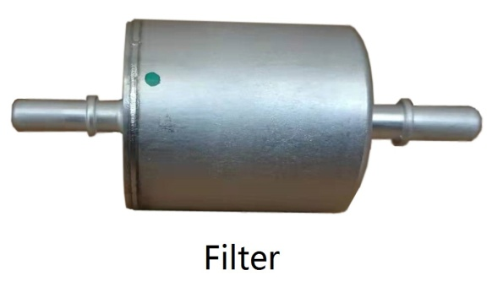
The injector inlet filter is not a serviceable component and is designed only to trap potential built-in contamination between the chassis fuel filter and injector.
Please replace the fuel filter regularly according to the usage. The filter is located above the tank.

3.16.2.4 Injector Installation
Follow these guidelines to prevent damage to the injector and its electrical interface during the replacement or re-installation process.
●Lubrication: Apply a light coating of lubricant to the lower injector seal ring. ISO 10 light mineral oil or equivalent is recommended.
●The preferred technique is to apply the lubricant to the sockets the injectors are being installed into, rather than directly to the seal ring itself. This will help minimize the possibility of injector contamination.
●Avoid applying lubricant over the director plate holes – this may restrict injector flow. Do not dip the injector tip in lubricant.
●The injectors come from the factory with the seal rings attached. The re-use of seal rings is not preferred when replacing an injector. If an injector is to be re-used, and no new seal rings are available, take care to inspect each seal ring for signs of damage. Even minor defects in the seal ring can lead to leakage. Take extra care in installing seal ring over flange of injector inlet.
●Carefully installing the harness connector will prevent terminal damage. Listen for a positive audible click from the connector retention device — this ensures that it is fully engaged.
●Avoid unnecessarily disconnecting / reconnecting the harness connector.
●Wires routed in a manner that can allow them to become pinched between components can result in a short circuit and a stuck open injector.
●For injectors that require orientation for spray pattern, do not rotate the injector in the fuel rail assembly to install the injector electrical connector. This may dislodge the retaining clip, and result in improper spray orientation.
The table is a list of lubricant oils that were tested and approved for O-ring lubrication. These lubricants have shown to have no effect on injector performance (plugging, sticking).
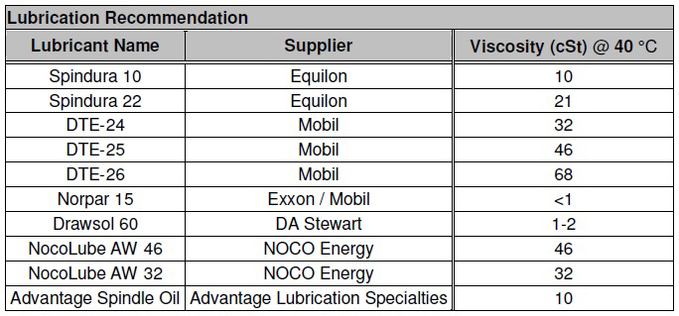

3.16.2.5 Replacement Techniques
The following procedure outlines standard the Injector removal and replacement.
Warning: The injector and all associated hardware may be extremely hot.
● Shut off ignition.
● Disconnect negative battery cable to avoid possible fuel discharge if an accidental attempt is made to start the engine.
● Disconnect the electrical connector from the injector wiring harness.
● Relieve fuel pressure.
● Remove the retaining clip from the fuel injector.
● Carefully clean debris from the interface surfaces. Do not damage seal mating surfaces.
● Remove the injector from the manifold.
● Apply a light coating of a lubricant to both the upper and lower injector seal ring of the replacement injector.
Check that the injector is installed in the original orientation to maintain proper spray targeting, and that the retaining clip is properly seated on the injector and the fuel line.
● Install the new injector into the manifold.
● Install the retaining clip after connecting the fuel line.
● Tighten the injector mounting to the desired torque as mentioned in the manufacturer manual.
● Tighten the fuel line.
● Re-install the injector electrical connector.
● Turn the key on and off to check if the fuel is leaking.
● Start engine and verify proper operation.

3.16.2.6 Interchange ability
The injector should be replaced in service only with an equivalent injector of the same part number. On occasion, a new part number may supersede part numbers. Consult the appropriate vehicle service manual and part number guide for the latest replacement injector part number information.

3.16.3 THROTTLE BODY ASSEMBLY

3.16.3.1 Description and Working Principle
The Throttle Body Assembly is an interactive system comprised of the following subsystems: the main casting body, bearing system, shaft and valve system, return spring system, cable interface system, throttle position sensing system, Intake Air Pressure and Temperature sensing system and the bypass air control system. The subsystems interact and support each other to provide all the functional requirements, which are mentioned below: | 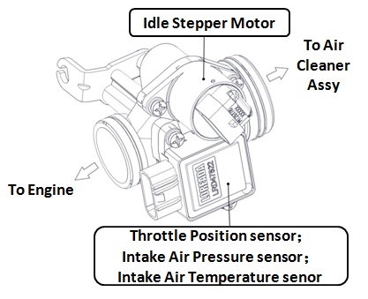
● Control intake air flow.
● Control idle air flow.
● Sense throttle position - Provide position feed-
-back to Engine Controller.
● Provide reactionary force to the throttle.

3.16.3.2 Throttle Body Removal
● Disconnect negative terminal of the battery.
●Disconnect electric lead wire of throttle position sensor coupler, stepper motor coupler and MAP/MAT sensor coupler ( if this sensor is mounted on the throttle body).
●Disconnect accelerator cable from throttle body.
● Remove air cleaner outlet hose and throttle body outlet hose.

3.16.3.3 Cleaning Procedure
It may be removed and cleaned using carburetor cleaner (3M make recommended). Once the throttle body cover is removed, spray the throttle-body cleaner inside the shipping air passage, and use the brushes to gently dislodge the dirt, gum and varnish that are present. Do not let the bye pass holes be blocked by dirt or foreign particles.

3.16.3.4 Throttle Body Installation
Reverse the procedure for installation noting the following:
● Adjust accelerator cable play.
● Check to ensure that all removed parts are back in place.
● Reinstall any necessary part which have not been reinstalled.

3.16.4 ENGINE TEMPERATURE SENSOR
3.16.4.1 Description and Working Principle | 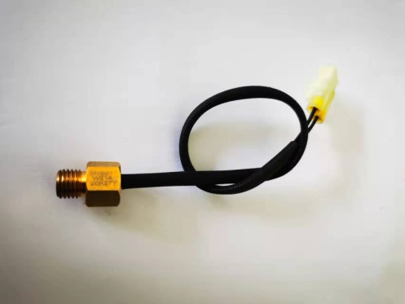
This sensor is used in air cooled engines. It provides a resistance that varies as a function of temperature within prescribed tolerance limits. The sensor has a negative temperature coefficient of resistance.

3.16.4.2 Installation Requirements
Dynamic Torque Requirement: The sensor shall be hand into the application and then driven by a driver with a maximum no load speed of 400 rpm or installed to the desired torque by a hand torque wrench (M14). The recommended installation torque is:
● Minimum: 10 N·m
● Maximum: 13 N·m
●Static Torque Requirement: The torque required to remove the sensor from the mating hole shall be within 200% of the installation torque mentioned above.

3.16.5 OXYGEN SENSOR

3.16.5.1 Description and Working Principle
This sensor is a device for monitoring the residual oxygen in the exhaust of an internal combustion engine. It is the feedback element for engine closed loop control. | 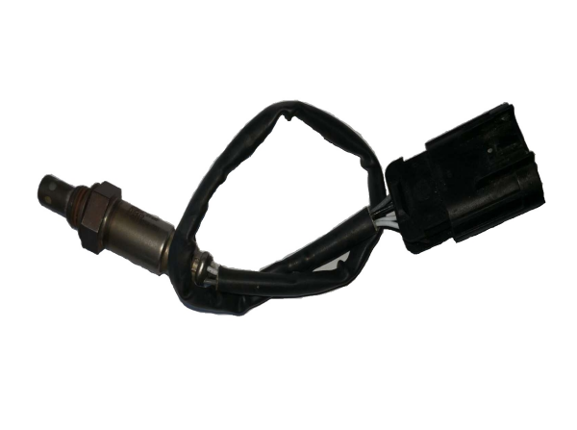

3.16.5.2 Technical Parameters
● A/F ratio rich threshold: ＞720 mVDC
● A/F ratio lean threshold: ＜120 mVDC
(These parameters as above are measured basing on 450°C (engine dyno), typically on 70% duty at 10Hz and under 13.5V)
●Heater part resistance:18±3Ω (This parameter is measured basing on 21°C)
● Operating temperature range: 260-850 °C

3.16.5.3 Fuel Quality Requirements
Pb≤0.005g/L
P≤0.0002g/L
S≤0.04% (weight proportion)x
MMT≤0.0085g/L
Si≤4ppm
3.16.6 IGNITION COIL | 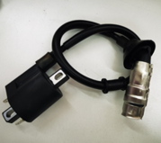

3.16.6.1 Description and Working Principle
This coil provides energy to the spark plug in the combustion chamber. The coil itself doesn’t have a driver. The high voltage tower of the coil is connected to the spark plug using a high voltage cable assembly.

3.16.6.2 Installation requirements
● The vehicle frame provides the mounting surface and mounting holes.
● Never route the coil wire with the same bundle as the Crank sensor wires. There is around 200 V peak potential between wire and engine ground. This voltage potential could cause a noise on sensor cables.

3.16.6.3 Do’s and Don’ts
ACTION | REASON
DO NOT: Install the low voltage connectors with the power applied. | This might cause an unwanted secondary firing, possibly leading to personal injury.
DO NOT: Use a screw driver to asset in removing secondary boots from the secondary tower. Use tools designed for secondary removal. | It is possible to damage a secondary lead in such a manner that creates an electrical path to outside the system permitting improper system operation misfire, or even possible personal injury if arcing occurs.
DO NOT: Use parts that have been dropped or display physical damage. | Damaged components can lead to premature failure.
DO NOT: Scratch or apply any non approved material to the surface of the high voltage tower which mates with the high voltage secondary leads. | This can jeopardize the seal integrity of the mating surfaces which in turn can create a secondary high voltage leak path.
DO NOT: Strike any part of the ignition system with a tool or other object. | This can lead to physical damage which can cause a system malfunction or failure.
DO NOT: Permit paint or other sprayed materials to be sprayed onto the electrical connectors. | Insulating type sprays can create a high resistance or open connection. And, a conductive type spray can create an electrical short condition.
ACTION | REASON
DO NOT: Support the ignition system by the wiring harness or plug wire. | These leads are not designed to support the weight of the ignition system. It can create a poor electrical connection Or become disconnected allowing the system to fall and be subjected to physical damage.
DO NOT: Pierce or probe the secondary leads. | This creates an electrical path to outside the system permitting improper system operation, misfire, or even possible personal injury if arcing occurs.
DO NOT: Operate without the spark plug attached. | If a technician or mechanic comes in contact with the high voltage generated during operation, personal injury may occur. Or, if the engine is operated under this condition, unburned fuel may fill the converter area creating a potential hazard.
DO NOT: Share ignition component wiring with other components, Dedicated wiring is required. | This prevents electrical cross talking between components which can lead to component malfunction.
DO NOT: Apply voltage to the ignition system other than vehicle system voltage for testing purposes. | This can cause reduced performance or an electrical malfunction of the ignition system.
DO NOT: Use high impact tools to apply the spark plug boot to the ignition secondary towers. Installation of the high voltage secondary leads by hand is preferred. | Damage to the coil tower, secondary boot, or mating connection surfaces might occur.
DO: Install the secondary leads before connecting the primary leads. | In the event the low voltage connection has been made and the power applied, unwanted secondary output might occur possibly resulting in injury, damage the ignition component, and test equipment.
DO: Take care when working around the ignition system. | The high voltage produced by the coil secondary circuit can cause personal injury and/or damage test equipment.
DO: Proper handling and shipping methods need to be in place to reduce the risk of damage due to impact, moisture, or contamination. | Damaged components can lead to premature failure.
DO: Avoid unnecessary disconnecting and connecting of the electrical components. | The electrical connections are not designed for repeated connection and disconnection.
DO: Insure the low voltage connectors are entirely seated and the locking mechanism is engaged. | This prevents intermittent electrical connections leading to an improper ignition system operation.
DO: Use approved connector breakouts when testing the ignition system. | Connector and/or component damage may occur.
ACTION | REASON
DO: Insure the appropriate seals are included in the connector system. | Liquid intrusion into the terminal connection area might occur causing an electrical intermittent or short condition. In the event of severe terminal corrosion, an open condition might occur.
DO: Operate with gasoline based internal combustion engines. | Other fuels or combustion designs may require additional design considerations.
DO: The power feed line should be fused. | This could protect the system in the event of an electrical short.
DO: The module heat sink and back plate must not be used as a connection point when jump starting the engine. | The high level of voltage and current which the module could be subjected to, could cause module performance degradation or failure.
DO: Connection of the module back plate to vehicle ground is desirable whenever possible. | This greatly reduces potential ground loops and acts as a heat transfer source from the module.
DO: The ignition system ground wire should be kept as short as possible. And, when permissible, should be grounded at the same engine block position as the engine controller. | This would greatly reduce the possible of unwanted electrical ground loops.
DO: The electrical wiring to the ignition system should be routed so that the conductors are protected from excessive heat, damage, and wear. | Helps prevent electrical intermittent, open or shorted operating conditions.
DO: Ignition secondary leads should not be routed with the ignition primary harness or any other electrical harness. | Voltage spikes can be transmitted from the secondary cables into other leads which are in close. This could create a component performance degradation or failure condition.
DO: Spark plug wires(secondary leads) & primary wiring:  - must not contact sharp surface.  - must not be under tension between fixed points.  - must be clear of moving parts (belts, fan, etc…).  - must be protected from or kept at least 125 mm away from radiant heat source exceeding 400 F.  - must be protected from environmental damage (dirt, splash, oils, fluids, etc….).  - must be retained, secured or insulated to prevent pinching, misrouting, rattles, and squeaks. | Spark plug wires carry very high voltage (30,000 volt). If the secondary lead loses its dielectric characteristics thru being nicked, cut , chaffed, then  an arc thru to a nearby ground could take place. This kind of condition could lead to misfire, no start, or premature failure of ignition system.
DO: Not all fasteners are designed for repeat use. Beware of fastener specifications. All harnesses should be supported within 6" of a mating connection. | Adequate retention force might not be achieved if the fastener is not designed to be reused. Mating connections are not designed to support the weight of the harness assembly.
ACTION | REASON
DO: For removing spark plugs follow the following  steps:  1- Grasp the spark plug boot and gently rotate 90°; and then pull the spark plug boot and cable away from the spark plug.  2- Before removing spark plug, brush or air blast dirt away from the well areas.  3- Use correct size deep socket wrench to loosen each spark plug one or two turns. | To remove spark plugs from Aluminum heads, allow the engine to cool. The heat of the engine, in combination with a spark plug that is still hot, may cause the spark plug threads to strip the cylinder head upon removal.  Use goggles to protect eyes from dirt when applying compressed air to spark plug wells.
DO: Cleaning a spark plug could be done as follow:  1- Wipe all spark plug surfaces clean….remove oil, water, dirt and moist residues.  2- If the firing end of spark plug has oily or wet deposit, brush the spark plug in an approved, non-flammable and non-toxic solvent. Then dry the spark plug thoroughly with compressed air.  3- Use a propane torch to dry wet-fuel fouled plugs. Allow the torch flame to enter up the center electrode insulator. Allow plug to cool down.  4- If the spark plug threads have carbon & scale deposits, clean with wire brush, taking care not to injure the electrode or the insulator tip. | Cleaning a spark plug will reduce the voltage required for an electrical arc(spark) across the electrodes.  Cleaning & re-gapping will not restore a used spark plug to a new condition. It may be more economical and efficient to replace used spark plugs with new plugs instead of cleaning.  Sooted plugs should be replaced.  Do not cool by using water or any liquid.  Clean threads permit easier installation and proper seating which will maximize transfer heat away from the plug.
DO: Regap spark plugs to the exact measurement specified by the engine manufacturer to keep the best fuel economy and proper engine performance:  1- Use round wire-type gauge for an accurate measure of gap on all used spark plugs.  2- When gapping a spark plug only the side electrode is moved. The center electrode must not be moved. | Too wide a gap could cause the plug to misfire (higher required ignition voltage).  Too narrow of a gap could affect idle stability.  A flat gauge can’t accurately measure the spark plug on used plugs.
DO: When replacing spark plugs with new ones, always use equivalent plugs with same heat range, thread, size, etc…. | Higher heat range plug (hotter plug) could lead to pre-ignition & possible piston damage.  Lower heat range (colder plug) could lead to cold fouling & emission problem.
ACTION | REASON
DO: For installing spark plugs follow the following steps:  1- Make sure the cylinder head threads and spark plug threads are clean. Make sure the spark plug thread is free of dings and burrs. If necessary, use a thread chaser and seat cleaning tool.  2- Make sure the spark plug gasket seat is clean, and then thread the gasket to fit flush against the gasket seat. Tapered seat plugs do not require gaskets.  3- Screw the spark plugs finger-tight into the cylinder head. Then, use a torque wrench to tighten spark plugs following manufacturer’s recommendation.  Torque is different for various plug type & cylinder head material. | If the thread is damage, it prevents a good heat transform from the shell to the cylinder head.  Do not use any type of anti-seize compound on spark plug threads. Doing this will decrease the amount of friction between the threads. The result of the lowered friction is that when the spark plug is torqued to the proper specification, the spark plug is turned too far into the cylinder head. This increases the likelihood of pulling or stripping the threads in the cylinder head.  Over tightening of a spark plug can cause stretching of the spark plug shell and could allow blow by to pass thru the gasket seal between the shell and insulator. Over-tightening also results in extremely difficult removal.

3.16.7 FUEL PUMP

3.16.7.1 Description and Working Principle
Fuel Pump supplies fuel to engine at system pressure. Fuel Pump is mounted to fuel tank at top and supplies fuel to engine through hoses. Fuel Pump consists of Fuel Pump to generate the fuel flow and pressure regulator to regulate the fuel pressure. | 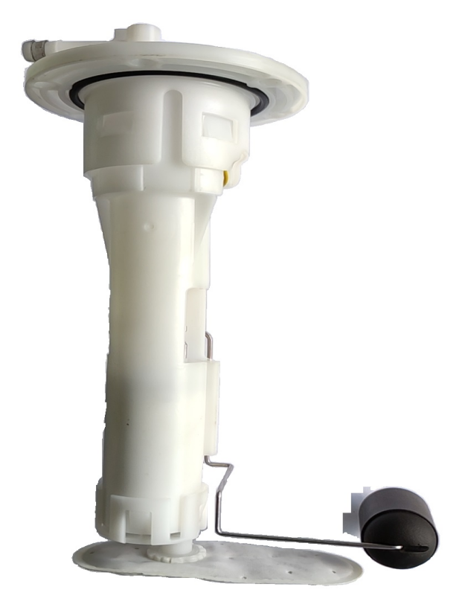
When power is supplied to fuel pump, motor in pump assembly rotates the impeller. Impeller in turn draws the fuel from strainer and pumps the flow to generate the system pressure.
Pressure Regulator is a diaphragm type mechanical device. Fuel flow from filter enters in the inlet of pressure regulator. Pressure regulator regulates the fuel pressure at a set pressure by releasing the excessive fuel flow to fuel tank.

3.16.7.2 Operating Conditions
● Fuel Pump needs to be mounted on Fuel Tank Top according to the installation instructions.
● Fuel Pump is intended to use with gasoline. However if the fuel contains ethanol, please contact vehicle manufacture to check whether the fuel pump module itself can survive or not.
● Make sure there is at least 3 liters of gasoline in the fuel tank before priming for first time (don’t run the pump dry).

3.16.7.3 Service Procedure
Precautions:
Before attempting any service on fuel system, following cautions should be always followed for personal safety and to avoid system damages.
● Disconnect negative cable at battery.
● DO NOT smoke, and place ‘No SMOKING” sign near work area.
● Make sure to have fire extinguisher handy.
● Make sure to perform work in well ventilated area and away from any open fire/flames.
● Wear Safety glasses.
● To relieve fuel vapor pressure in fuel tank, remove fuel filler cap fuel filler neck and then reinstall it.
● As fuel lines are at high pressures when the engine is stopped, loosening or disconnecting fuel line will cause dangerous spout of fuel. Before loosening/ disconnecting fuel lines, please follow the ‘Fuel Pressure Relief Procedure’ described in this section.
● Small amount of fuel may drip after the fuel lines are disconnected. In order to reduce the risk of personal injury, cover the pipe / hose ends with suitable blind with no rust or contamination.
● After servicing, make sure that the fuel hoses and clamps are connected according to the hose fitment instructions given in vehicle instruction manual.
● After servicing, please follow the ‘Fuel Leakage Check Procedure’ described in this section.
● After servicing make sure to fill at least 3 liters gasoline before pump is primed (ignition key should be turned on only after ensuring there is minimum 3 liters of fuel in the fuel tank)
Fuel Module Diagnosis:
Step | Action | Yes | No
1 | Switch on Ignition key. Fuel Pump primes for 3 seconds when the ignition key is ON.  Check for fuel pump running noise for  3 seconds after ignition key is ON. | If fuel pump running noise can be heard, go to step 4. | If fuel pump running noise cannot be heard, go to step 2.
2 | Disconnect Fuel Pump coupler. Check voltage at harness coupler. Is the voltage within 10-14V? | Go to step 3 | Check the electrical circuit from Ignition to Fuel Pump.
3 | Connect 12V DC power supply (battery) to Fuel Pump.  Make sure that enough fuel available in fuel tank to avoid fuel pump running dry.  Is the fuel pump running? | 1. Check electrical circuit from Fuel Pump to ECU.  2. Check ECU. | 1. Check Fuel Pump Harness integrity.  2. Check Fuel Pump.
4 | Check fuel system pressure at Injector inlet (with a T-joint) while engine is running in idle condition.  Is the pressure about 300 kPa? | Fuel Pump Operation Normal | Go to Step 5
5 | Is the Pressure below 300kPa too much? | 1. Check for leakages from  hoses, hose joints;  2. Check Fuel Pump;  3. Check Pressure Regulator; | 1. Clogged Filter;  2. Kink/ Blockage in Fuel Hoses;  3. Check Regulator.

3.16.7.4 Fuel Pump Removal
● Relieve fuel pressure in fuel lines referring to the ‘Fuel Pressure Relief Procedure’ provided in this section.
● Disconnect negative cable at battery.
● Disconnect Fuel Pump wire coupler.
● Drain the fuel in fuel tank thru fuel filler with help of hand pump (siphon). Collect the fuel in approved container for contamination and safety.
● Disconnect the fuel hoses from Fuel Pump by using standard tools.
● Remove the fuel tank from vehicle.
● Place the fuel tank with bottom up condition. Care to be taken not to cause any scratches/ damages on fuel tank.
● Open the Fuel Pump mounting bolts.
● Take out Fuel Pump assembly from fuel tank with care.

3.16.7.5 Fuel Pump Installation
● Replace the Fuel Pump gasket in Fuel Pump assembly with a new one. Old / Used gaskets can cause leakages. | 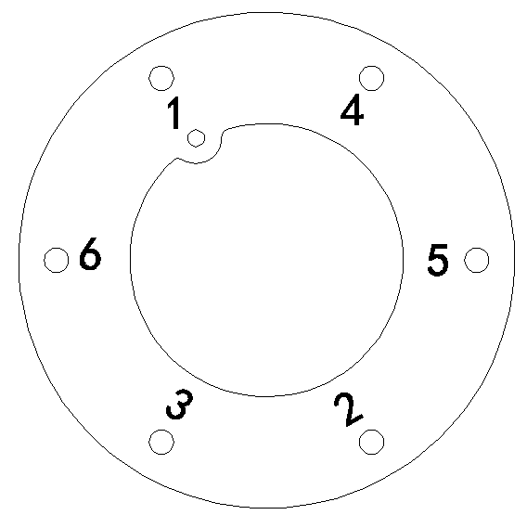
● Place the bolts on Fuel Pump cover and tighten the bolts gradually in 1-6 sequence to apply equal compression on gasket. It is shown as right.
Bolt Tightening Torque: 8 Nm. Fuel Pump is installed with the M5×12 bolts. Use designated bolts only. Follow the tightening torque and tightening sequence instruction. Over torque and miss-sequence can cause unequal compression of gasket and leakage.
● Install the Fuel Tank to vehicle.
● Connect for fuel hoses with suitable hose clamps.
● Connect Fuel Pump coupler.
● Follow ‘Fuel Leakage Check Procedure’ to check any leakage before the engine is started.

3.16.7.6 Fuel Pressure Relief Procedure
Caution: This work must not be done when engine is hot.
After making sure that engine is cold, relieve fuel pressure as follows.
● Place vehicle gear in ‘Neutral’.
● Disconnect Fuel Pump electrical coupler from vehicle harness.
● Start engine and run till it stops due to lack of fuel. Repeat ignition key ON and OFF for 2 ~ 3 times of about 3 seconds each time to relieve fuel pressure in lines. Fuel Connections are now safe for servicing.
● Upon the completion of servicing, Connect Fuel Pump Connector to Vehicle Harness.

3.16.7.7 Fuel Leakage Check Procedure:
After performing any service on fuel system, check to make sure that there are no fuel leakages as below.
● Fill about 3 ~ 5 liters of fuel in tank.
● Turn Ignition key to ON position for 3 seconds (to operate fuel pump) and then turn to OFF position. Repeat this for 3 ~ 4 times to apply fuel pressure in fuel lines.
● In this state, check to see that there are no fuel leakage from any part of fuel system (Fuel Tank, Hoses, Hose Joints, etc)
3.16.8 MOTOR SCANNER (For Motion SE08) | 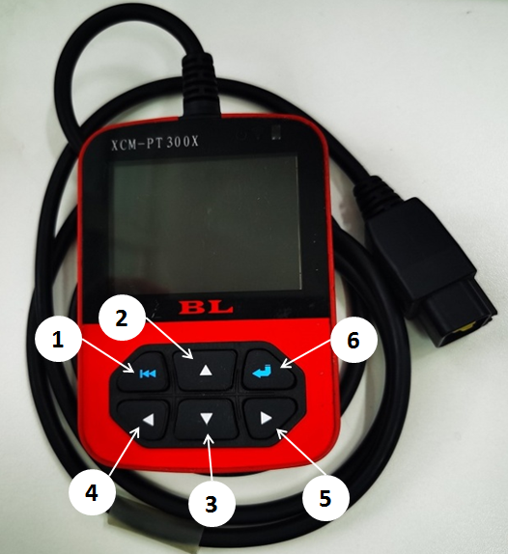  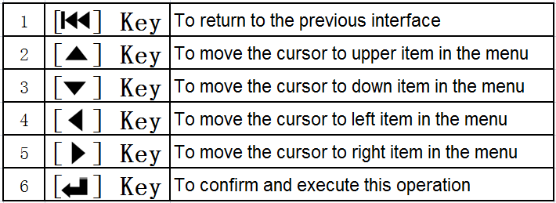

3.16.8.1 Precautions
● Motor-Scanner is a precision instrument and should be protected from vibration and impact.
● If the unit does not run correctly or the screen is unstable when first turned on, disconnect it from the vehicle and try again.
● Never test electrical signals that exceed the limit of specifications.
● Test cannot be performed by the person who is driving the car.
● This unit should be used and stored in the following conditions:
Ambient temperature: 0~50℃
Relative humidity: < 90%
Note: This instruction is only applicable to Motion Motor Scanner. For other Motor Scanner, please refer to the Instructions for it.

3.16.8.2 Preparations Connection
● Find the 6PIN diagnostic socket on the vehicle. | 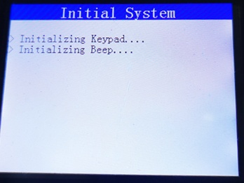
● Connect one end of the diagnostic main cable to the diagnostic socket on the vehicle. Turn on the key.
Normal Power – on Display
When power is on normally, the unit will display:
Seconds later, the unit will display: | 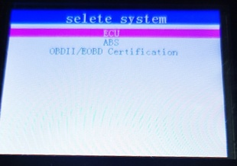

3.16.8.3 Functions
Motion Motor-Scanner can be used to diagnose Motion Engine Management System with functions: Read DTC, Clear DTC, Data Stream, Status Stream, and Record Data.
Operations
When the unit is powered up, the screen will display the interface as right.
Here, we take diagnostic function for demonstration.
Select ECU and presskey, it will display an interface for EFI system selection, as shown right.
 | 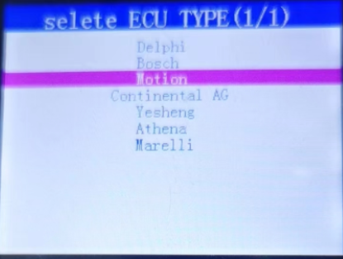
Select ‘Motion’ and press key, it will display information about the ECU version list, as shown right

Select ‘SE08 K’ and press key, it will display information about function list, as shown right | 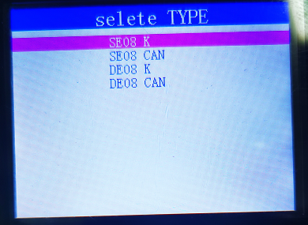
Available functions are as follows:
● Read DTC | 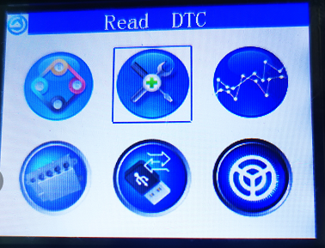
● Clear DTC
● Data Stream
● Record Data
Press  or or orkey to select function you needed, as shown right
1. Read DTC | 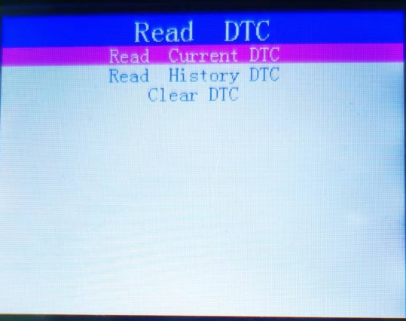
Select ‘Read DTC 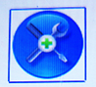 ’, and press , it will display function list as right.
Select ‘Read Current DTC’ and press,If there are some malfunctions with the vehicle's EFI system, the screen will display fault information as right. | 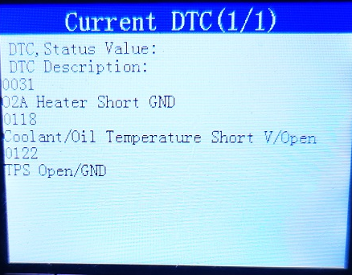
2. Clear DTC | 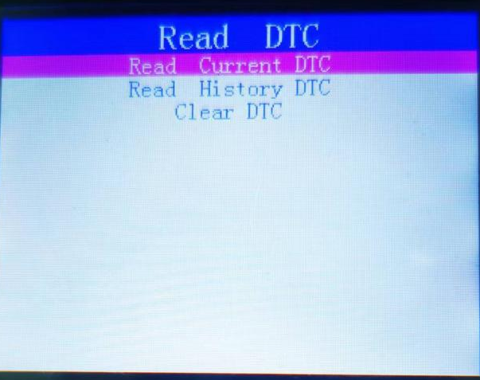
Select ‘Read DTC ’, and press , it will display function list as right.
Press key to select ‘Clear DTC ’ , the screen will display "SUCCESS", as shown right. This means the fault code has been removed successfully.
 | 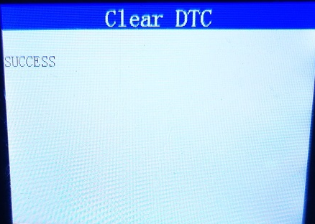
3. Data Stream | 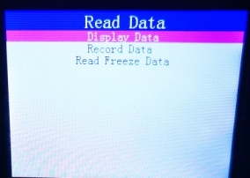

Select ‘Read Date ’, and press

it will display function list as right.
Select ‘Display Date’ , and press , it will display Engine information as right . | 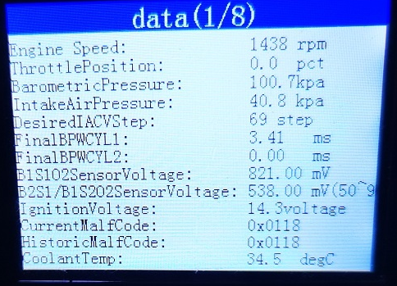
4. Data Record
Select ‘Read Date ’, and press , it will display function list as right.
 | 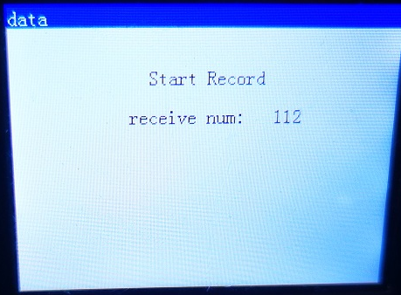
Press to select ‘Record Data ’ , it will display as right. (The recorded data can be used to analyze engine conditions)

3.16.8.4 SE08 ECU Malf Code
Malf code | Description
0107 | MAP Sensor Circuit Low Voltage or Open
0108 | MAP Sensor Circuit High Voltage
0112 | IAT Circuit Low Voltage
0113 | IAT Circuit High Voltage or Open
0117 | Coolant/Oil Temperature Sensor Circuit Low Voltage
0118 | Coolant/Oil Temperature Sensor Circuit High Voltage or Open
0122 | TPS Circuit Low Voltage or Open
0123 | TPS Circuit Short to High Voltage
0131 | O2S 1 Circuit Low Voltage
0132 | O2S 1 Circuit High Voltage or Open
0031 | O2S Heater Circuit High Voltage or open
0032 | O2S Heater Circuit Low Voltage
0650 | Engine fault indicator is faulty
0335 | CKP Sensor No Signal
0336 | CKP Sensor Noisy Signal
2300 | Cylinder 1 Ignition Coil "A" Short to Low Voltage/Open
0116 | Coolant/Oil Temperature Out of range
0116 | Coolant/Oil Temperature Sensor Signal Malfunction
0505 | Idle Speed Control Error
0562 | System Voltage Low
0563 | System Voltage High
1693 | Tachometer Circuit Low Voltage
1694 | Tachometer Circuit High Voltage
0459 | CCP Short to High Voltage
0458 | CCP Short to Low/Open
00D1 | Cylinder 1 Sensor Heater Circuit Low Current（Heater failure)
0232 | Fuel Pump Relay Short to High Voltage
0231 | Fuel Pump Relay Short to Low Voltage/Open
014D | Cylinder 1 Sensor Reaction Time From Thin to Thick Slow

Malf code | Description
014C | Cylinder 1 Sensor Reaction Time From Thick to Thin Slow
0601 | ECM Read-Only Memory Check Error
0262 | Cylinder 1 Fuel Injector Short to High Voltage
0261 | Cylinder 1 Fuel Injector Short to Low Voltage/Open
3106 | Steady State Intake Pressure Low
0105 | MAP Signal Stuck
0114 | IAT Signal Erratic change
0111 | IAT Signal Stuck
2195 | Cylinder 1 Sensor PE Thin
0300 | Misfire incident detected
0301 | Cylinder 1 Misfire
0500 | VSS No Signal
0850 | Park Neutral Switch Error
2257 | Secondary Air Supply Valve Open/Short to Low Voltage
2258 | Secondary Air Supply Valve Short to High Voltage

NOTES

